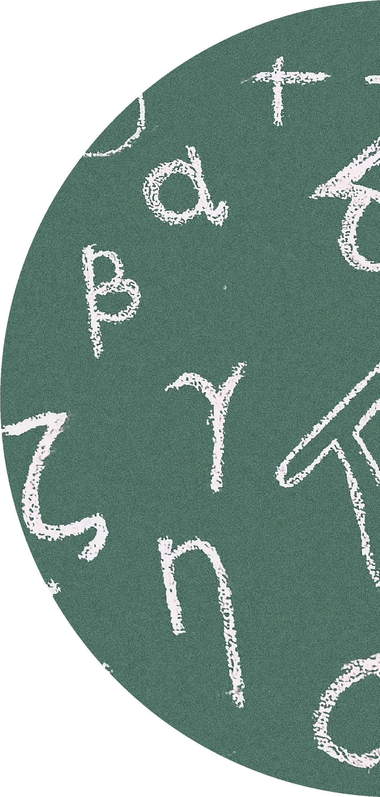


2023/2024

Target Booklet 2

Functional Skills Level 2

QUESTIONS TO GO WITH YOUR LESSONS

Name:

Content
Vocational Course:

Contents
Content 1
Target 3
Scale 5
Notes 11
Measurement 13
Notes 18
Percentages 20
Notes 24
Money 26
Notes 32
Compound Measurement 34
Notes 43
Area and Perimeter 45
Notes 52
Volume and Surface Area 54
Notes 64
Fractions, Decimals and Percentages 66
Notes 69
Co-ordinates 71
Notes 76
2D and 3D Shapes 78
Notes 86
Averages 88
Notes 98
Probability 100
Notes 106
Scatter Diagrams 108
Notes 118
QR Codes 120

Source | Target | Completion (Y/N)

Source | Target | Completion (Y/N)

Scale
Scale


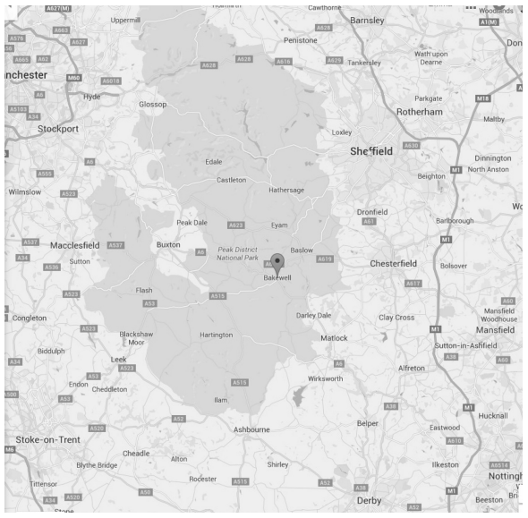
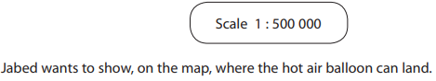
1)
Calculator questions

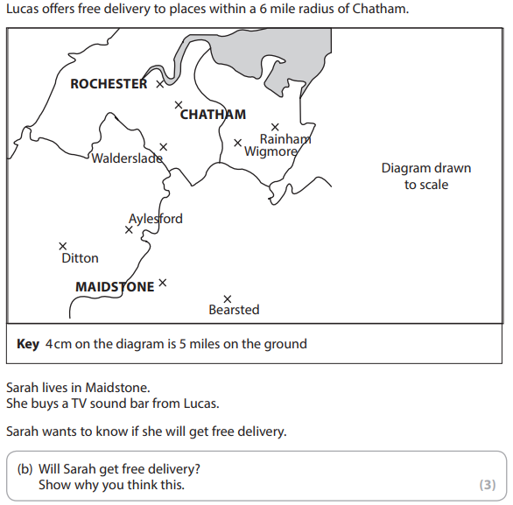
2)
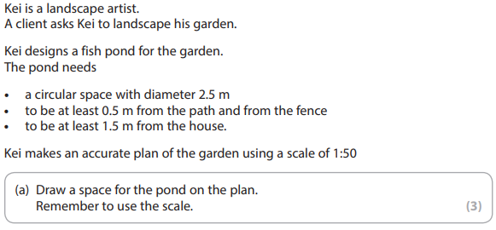
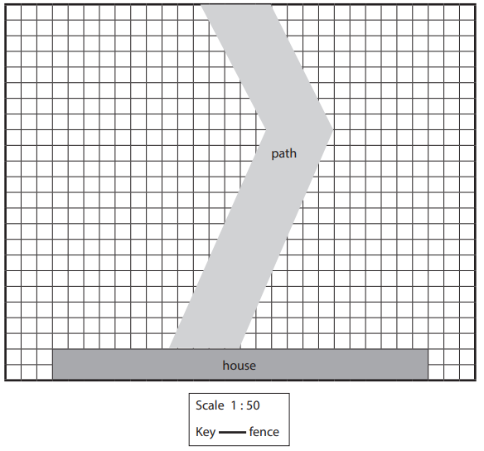
3)

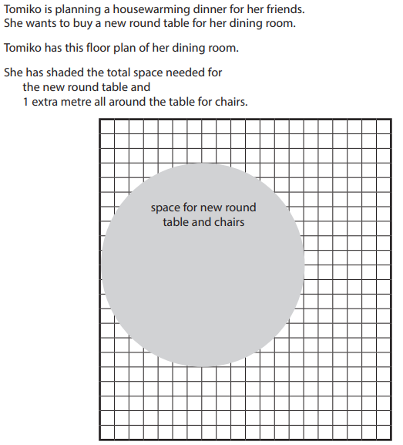
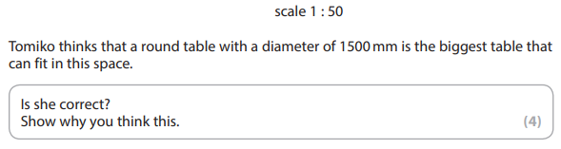
4)

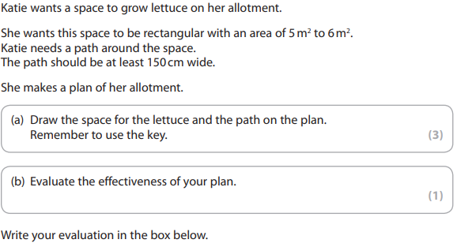
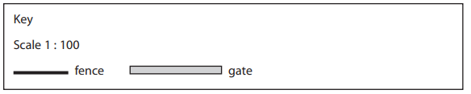
5)

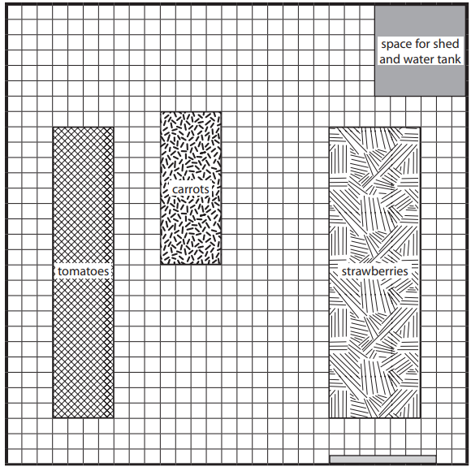

Notes
______________________________________________________________________________________________________________________________________________________________________________________________________________________________________________________________________________________________________________________________________________________________________________________________________________________________________________________________________________________________________________________________________________________________________________________________________________________________________________________________________________________________________________________________________________________________________________________________________________________________________________________________________________________________________________________________________________________________________________________________________________________________________________________________________________________________________________________________________________________________________________________________________________________________________________________________________________________________________________________________________________________________________________________________________________________________________________________________________________________________________________________________________________________________________________________________________________________________________________________________________________________________________________________________________________________________________________________________________________________________________________________________________________________________________________________________________________________________________________________________________________________________________________________________________________________________________________________________________________________________________________________________________________________________________________________________________________________________________________________________________________________________________________________________________________________________________________________________________________________________________________________________________________________________________________________________________________________________________________________________________________________________________________________________________________________________________________________________________________________________________________________________________________________________________________________________________________________________________________________________________________________________________________________________________________________________________________________________________________________________________________________________________________________________________________________________________________________________________________________________________________________________________________________________________________________________________________________________________________________________________________________________________________________________________________________________________________________________________________________________________________________________________________________________________________________________________________________________________________________________________________________________________________________________________________________________________________________________________________________________________________________________________________________________________________________________________________________________________________________________________________________________________________________________________________________________________________________________________________________________________________________

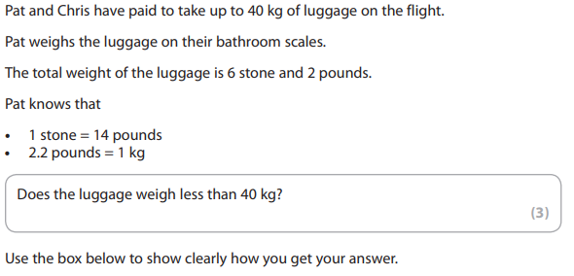
Measurement
1)
Calculator questions

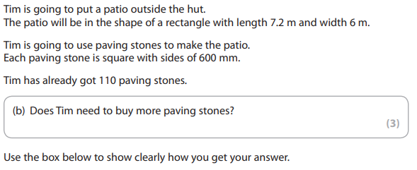
2)

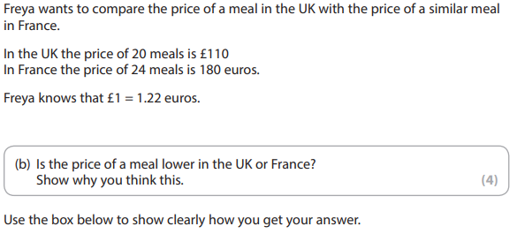
3)

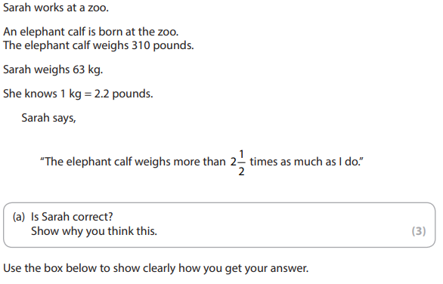
4)

5) Asta needs a spanner for a $\frac{5}{8}$ inch nut on her camping stove.
The shop sells 12 mm spanners, 14 mm spanners and 16 mm spanners.
Asta knows that 1 inch = 2.54 cm

What is the best size spanner for Asta to buy? (3)

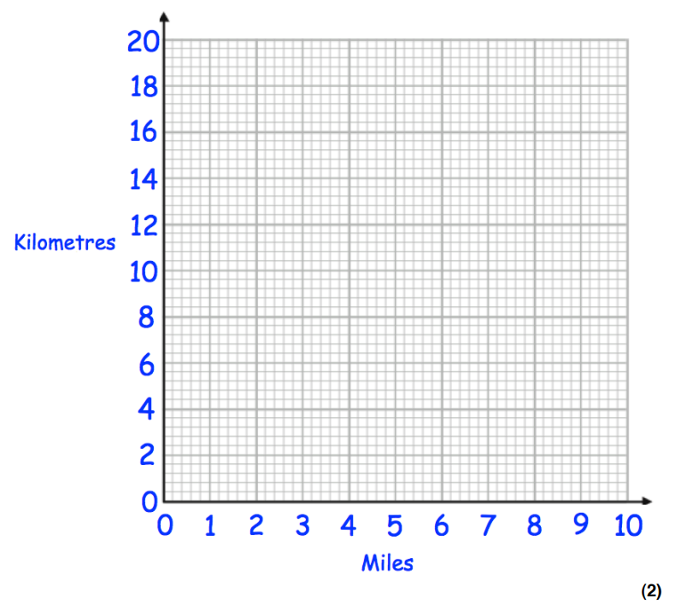
6 a) Use the fact “5 miles = 8 kilometres” to draw a conversion graph on the grid.
Use the graph to convert the following.
(b) 8 miles to kilometres (1)

(c) 6 kilometres to miles (1)

Miles

Notes
______________________________________________________________________________________________________________________________________________________________________________________________________________________________________________________________________________________________________________________________________________________________________________________________________________________________________________________________________________________________________________________________________________________________________________________________________________________________________________________________________________________________________________________________________________________________________________________________________________________________________________________________________________________________________________________________________________________________________________________________________________________________________________________________________________________________________________________________________________________________________________________________________________________________________________________________________________________________________________________________________________________________________________________________________________________________________________________________________________________________________________________________________________________________________________________________________________________________________________________________________________________________________________________________________________________________________________________________________________________________________________________________________________________________________________________________________________________________________________________________________________________________________________________________________________________________________________________________________________________________________________________________________________________________________________________________________________________________________________________________________________________________________________________________________________________________________________________________________________________________________________________________________________________________________________________________________________________________________________________________________________________________________________________________________________________________________________________________________________________________________________________________________________________________________________________________________________________________________________________________________________________________________________________________________________________________________________________________________________________________________________________________________________________________________________________________________________________________________________________________________________________________________________________________________________________________________________________________________________________________________________________________________________________________________________________________________________________________________________________________________________________________________________________________________________________________________________________________________________________________________________________________________________________________________________________________________________________________________________________________________________________________________________________________________________________________________________________________________________________________________________________________________________________________________________________________________________________________________________________________________________________

Percentages
- Jane wants to buy a barbecue.
She sees this offer

Work out the amount Jane will need to pay per month, round your answer to 2 decimal places. (3)
Barbecue £150 Deposit 12.5%
Remainder to be paid monthly over 6 months
Calculator questions

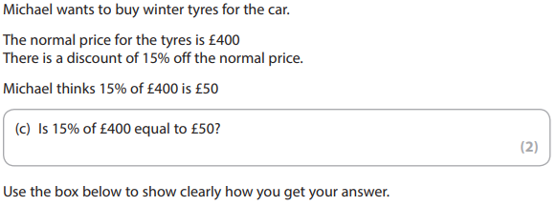

2)

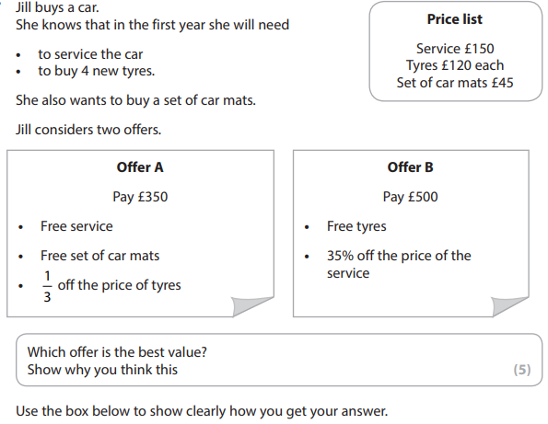
3)

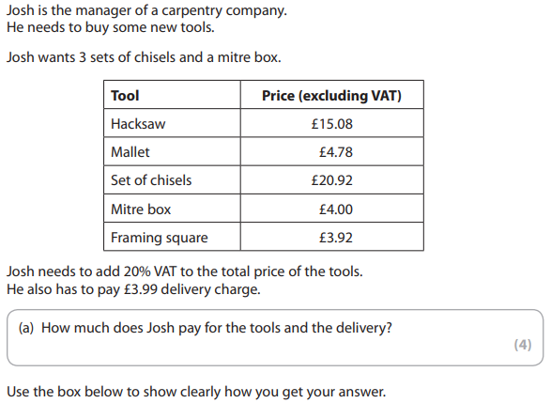
4)

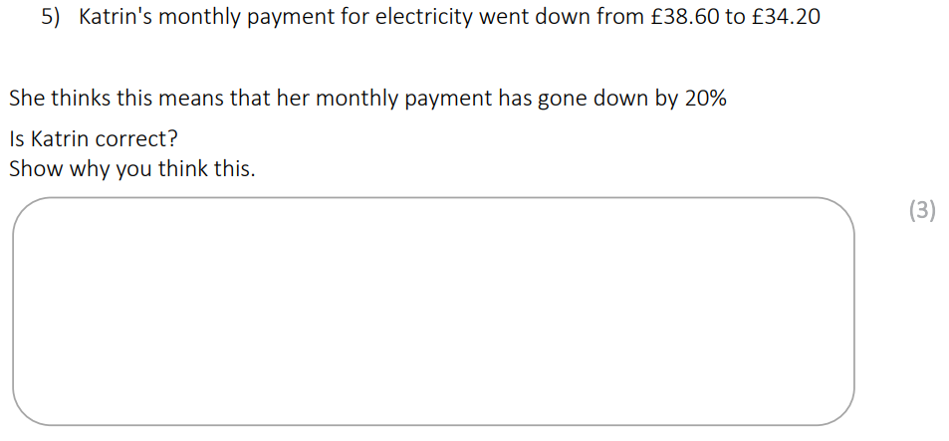
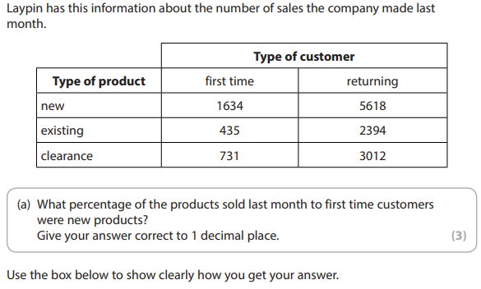
6)

Notes
______________________________________________________________________________________________________________________________________________________________________________________________________________________________________________________________________________________________________________________________________________________________________________________________________________________________________________________________________________________________________________________________________________________________________________________________________________________________________________________________________________________________________________________________________________________________________________________________________________________________________________________________________________________________________________________________________________________________________________________________________________________________________________________________________________________________________________________________________________________________________________________________________________________________________________________________________________________________________________________________________________________________________________________________________________________________________________________________________________________________________________________________________________________________________________________________________________________________________________________________________________________________________________________________________________________________________________________________________________________________________________________________________________________________________________________________________________________________________________________________________________________________________________________________________________________________________________________________________________________________________________________________________________________________________________________________________________________________________________________________________________________________________________________________________________________________________________________________________________________________________________________________________________________________________________________________________________________________________________________________________________________________________________________________________________________________________________________________________________________________________________________________________________________________________________________________________________________________________________________________________________________________________________________________________________________________________________________________________________________________________________________________________________________________________________________________________________________________________________________________________________________________________________________________________________________________________________________________________________________________________________________________________________________________________________________________________________________________________________________________________________________________________________________________________________________________________________________________________________________________________________________________________________________________________________________________________________________________________________________________________________________________________________________________________________________________________________________________________________________________________________________________________________________________________________________________________________________________________________________________________________________

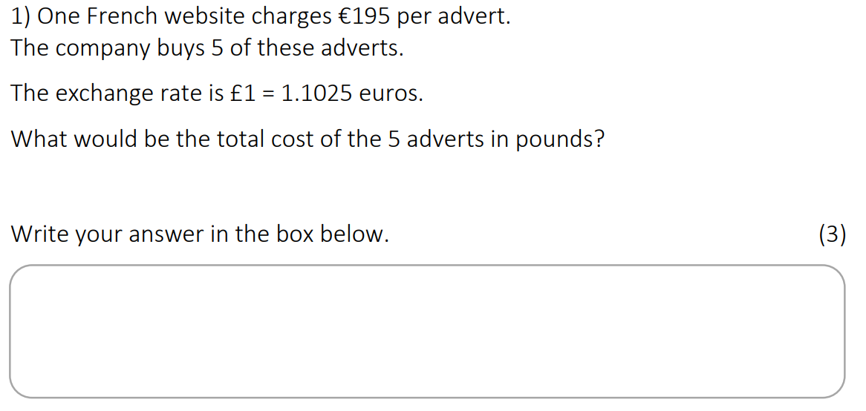
Money
Calculator questions

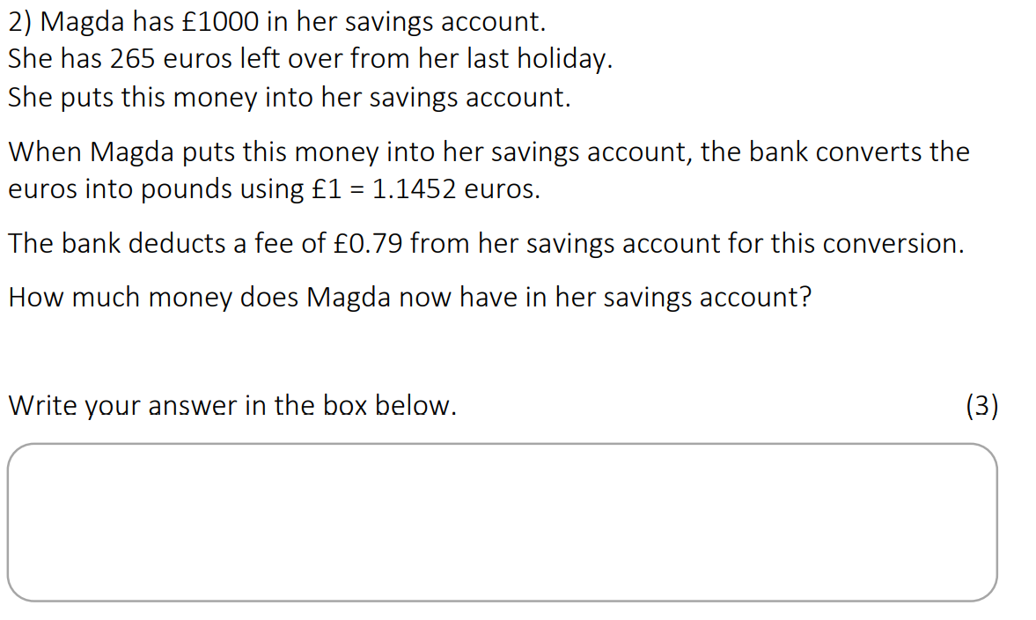

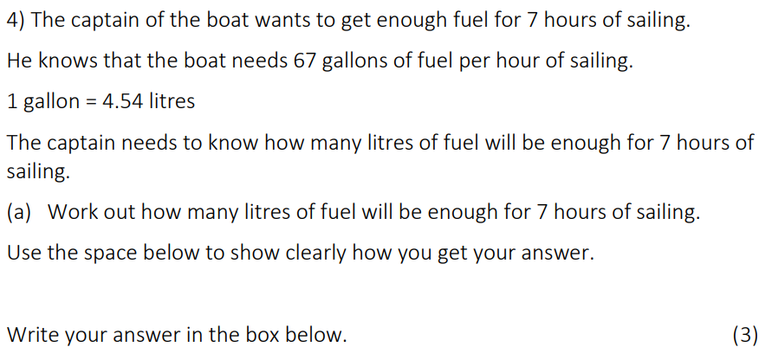
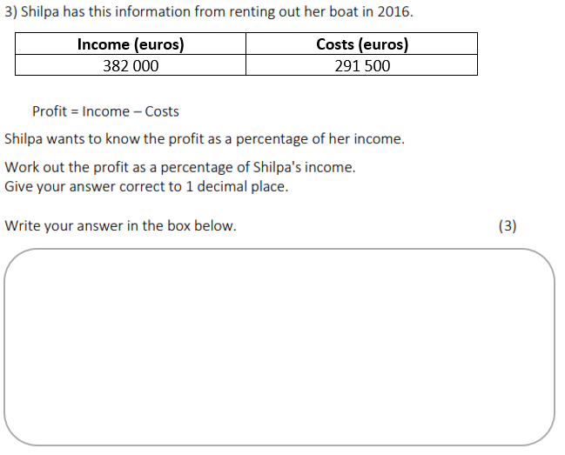

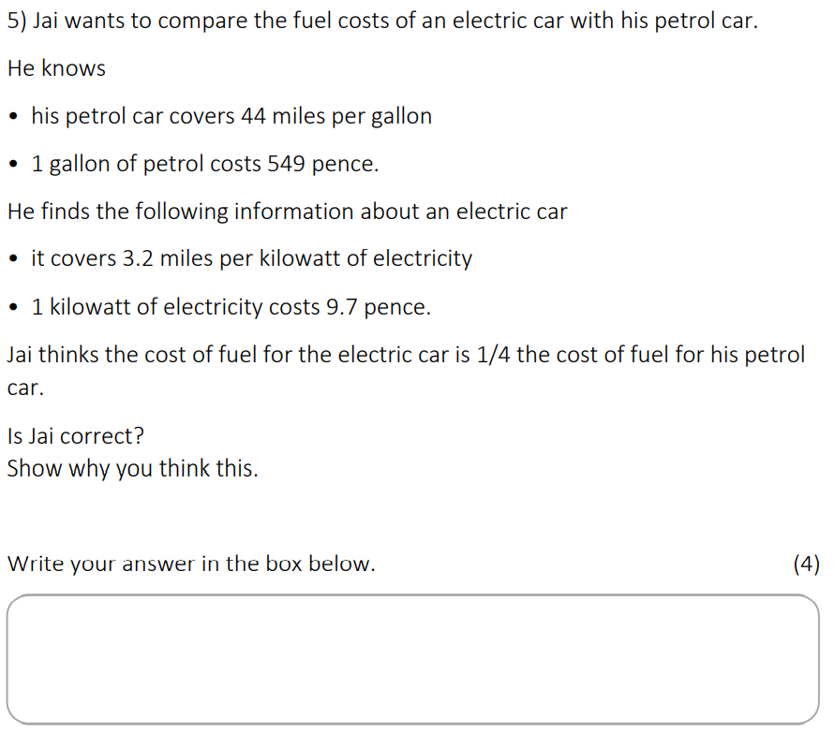
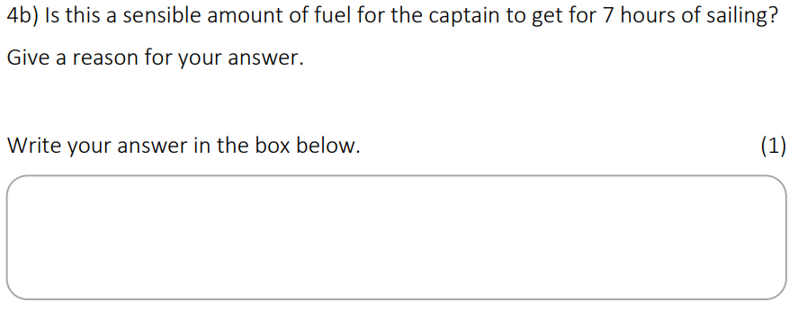

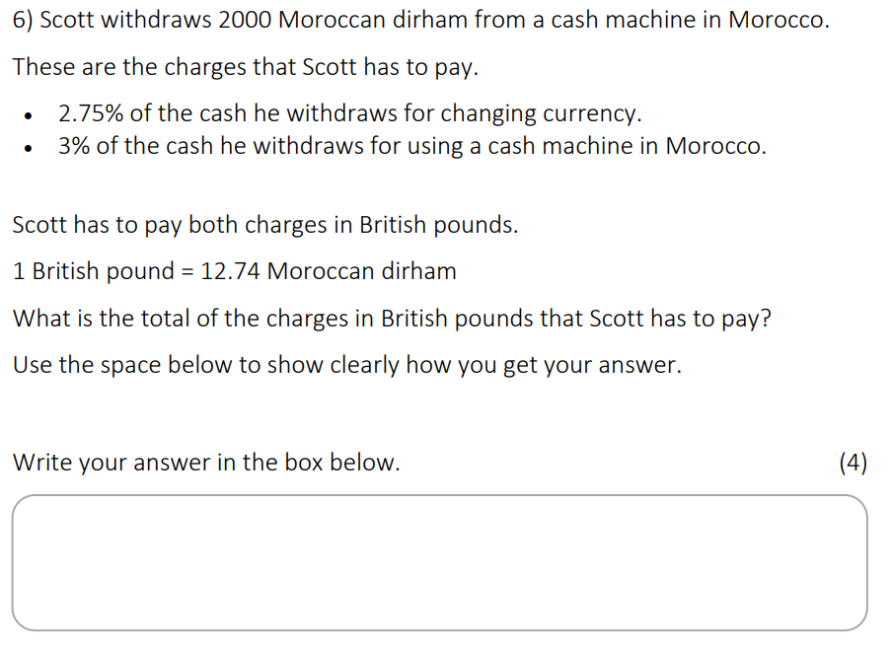

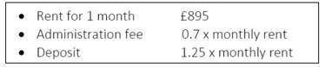
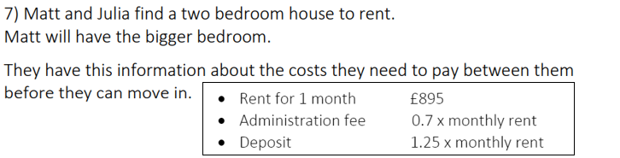
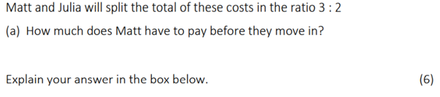

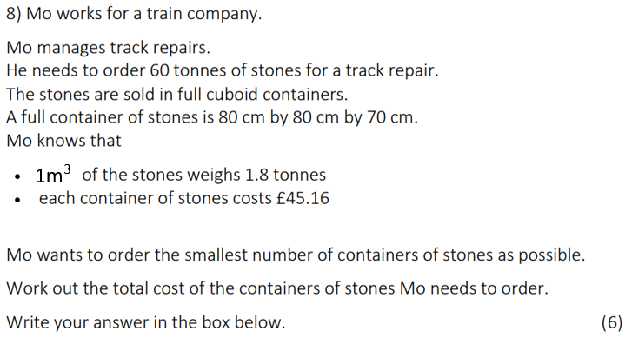

Notes
______________________________________________________________________________________________________________________________________________________________________________________________________________________________________________________________________________________________________________________________________________________________________________________________________________________________________________________________________________________________________________________________________________________________________________________________________________________________________________________________________________________________________________________________________________________________________________________________________________________________________________________________________________________________________________________________________________________________________________________________________________________________________________________________________________________________________________________________________________________________________________________________________________________________________________________________________________________________________________________________________________________________________________________________________________________________________________________________________________________________________________________________________________________________________________________________________________________________________________________________________________________________________________________________________________________________________________________________________________________________________________________________________________________________________________________________________________________________________________________________________________________________________________________________________________________________________________________________________________________________________________________________________________________________________________________________________________________________________________________________________________________________________________________________________________________________________________________________________________________________________________________________________________________________________________________________________________________________________________________________________________________________________________________________________________________________________________________________________________________________________________________________________________________________________________________________________________________________________________________________________________________________________________________________________________________________________________________________________________________________________________________________________________________________________________________________________________________________________________________________________________________________________________________________________________________________________________________________________________________________________________________________________________________________________________________________________________________________________________________________________________________________________________________________________________________________________________________________________________________________________________________________________________________________________________________________________________________________________________________________________________________________________________________________________________________________________________________________________________________________________________________________________________________________________________________________________________________________________________________________________________________

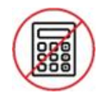
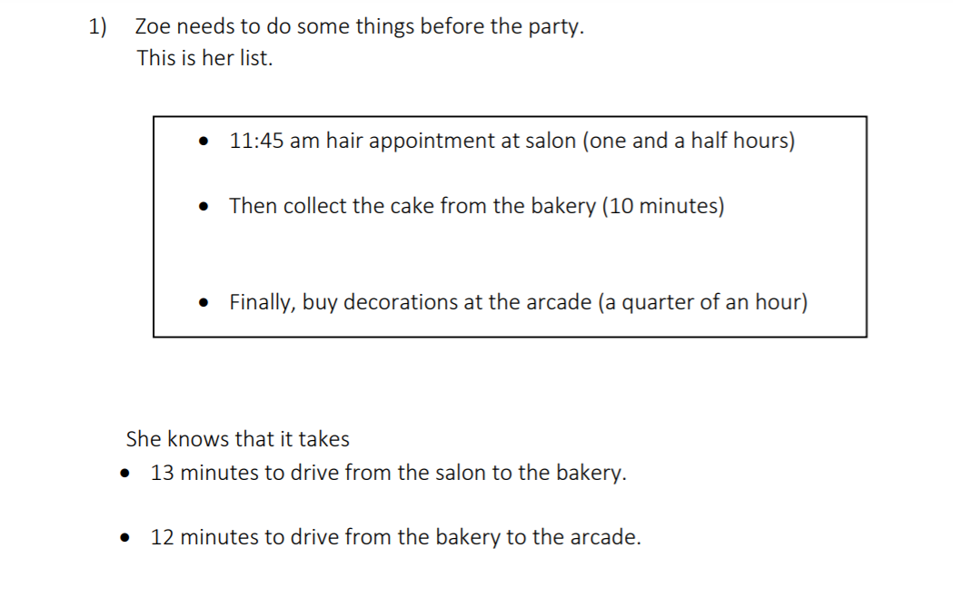
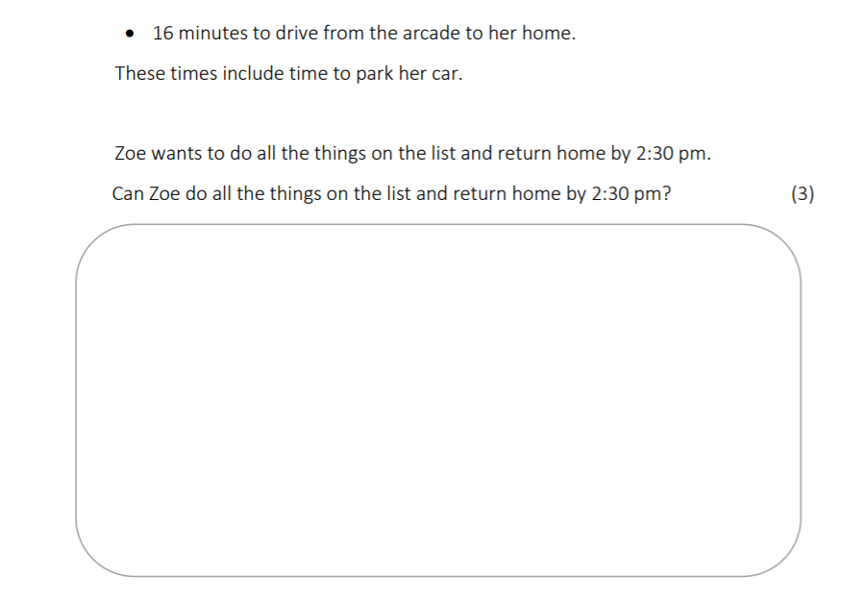
Compound Measurement
Non - Calculator questions

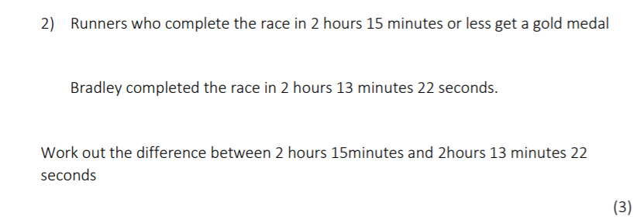

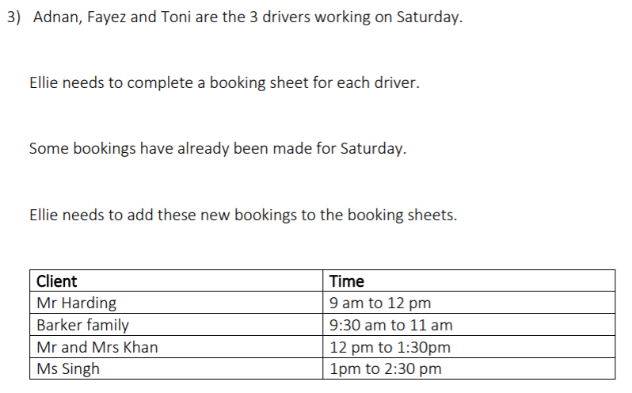
Calculator questions

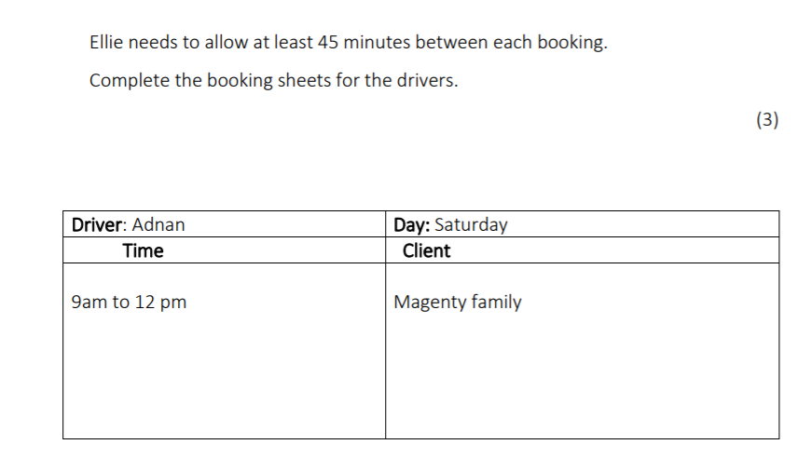

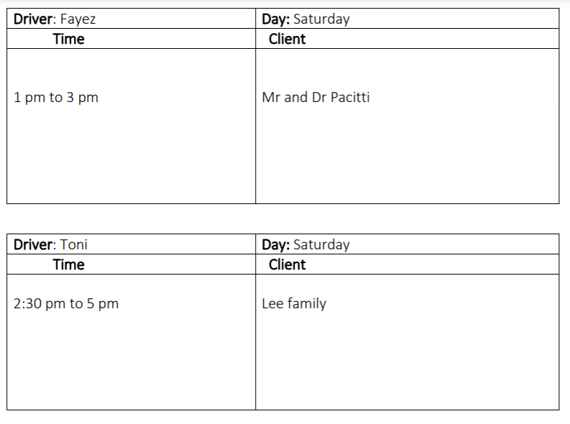

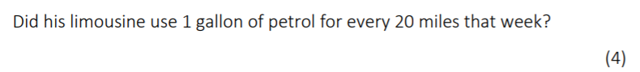
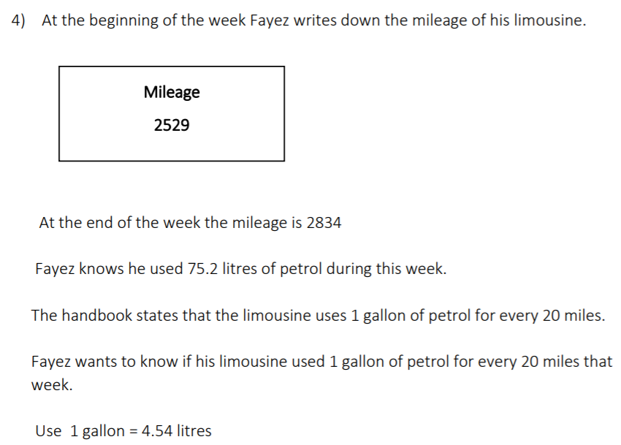

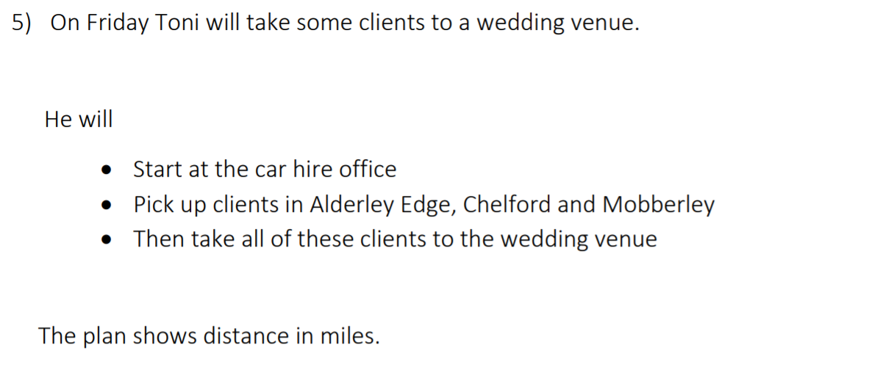
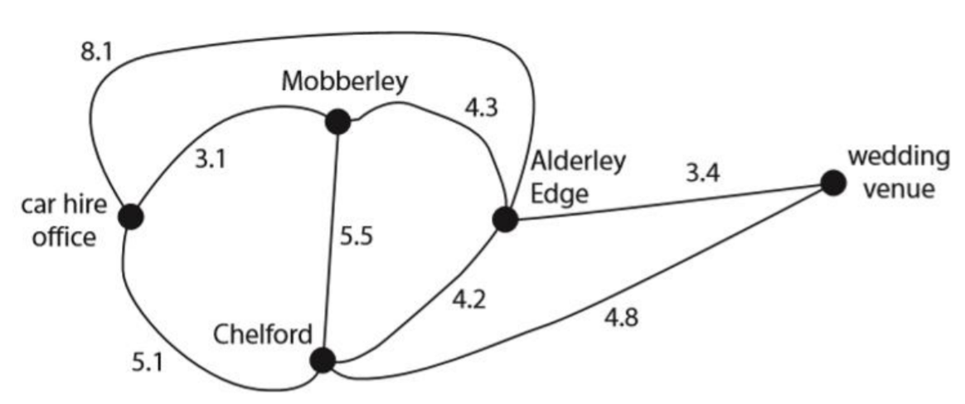
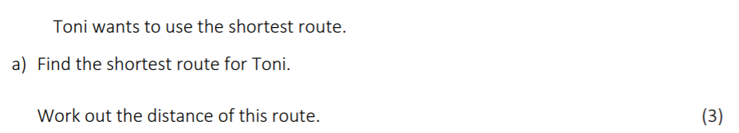

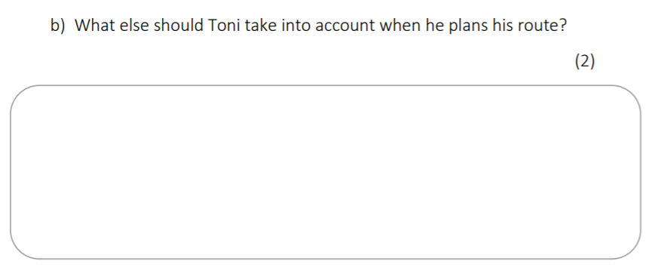
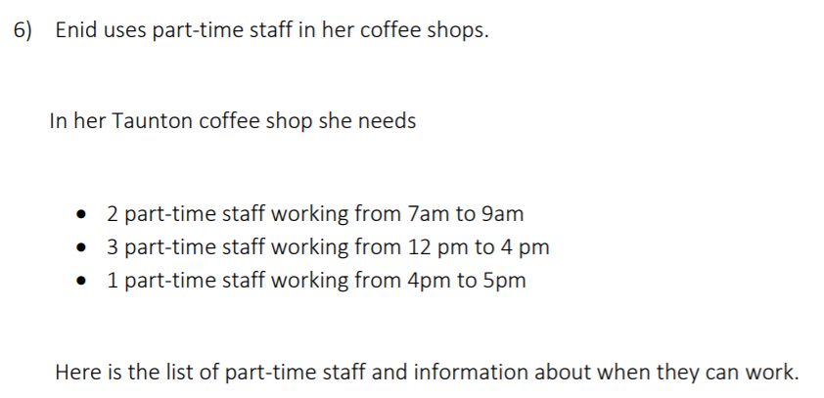
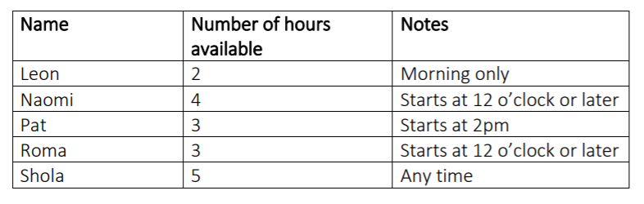

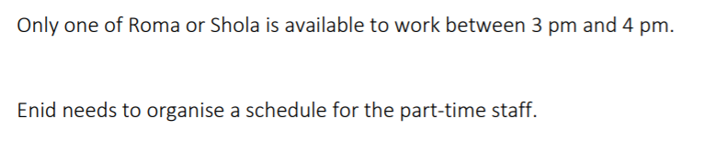
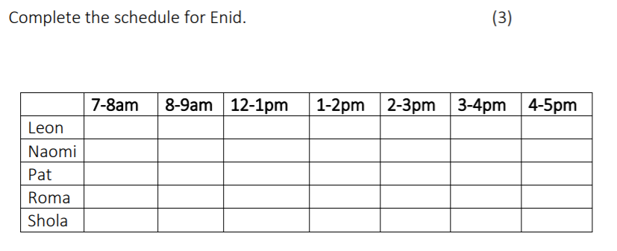
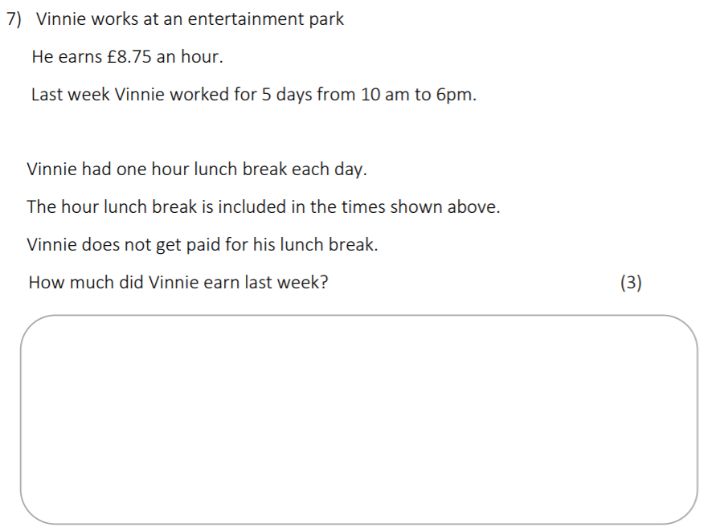

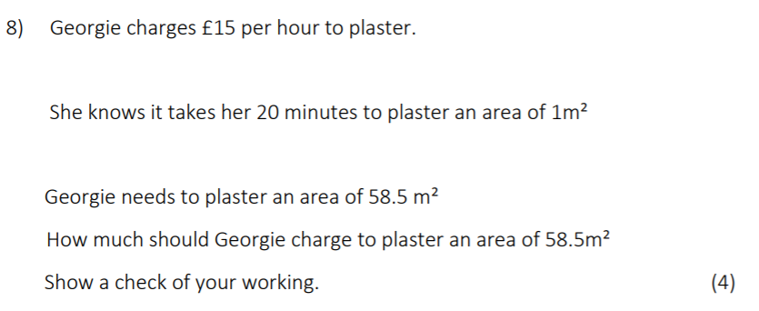

Notes

____________________________________________________________________________________________________________________________________________________________________________________________________________________________________________________________________________________________________________________________________________________________________________________________________________________________________________________________________________________________________________________________________________________________________________________________________________________________________________________________________________________________________________________________________________________________________________________________________________________________________________________________________________________________________________________________________________________________________________________________________________________________________________________________________________________________________________________________________________________________________________________________________________________________________________________________________________________________________________________________________________________________________________________________________________________________________________________________________________________________________________________________________________________________________________________________________________________________________________________________________________________________________________________________________________________________________________________________________________________________________________________________________________________________________________________________________________________________________________________________________________________________________________________________________________________________________________________________________________________________________________________________________________________________________________________________________________________________________________________________________________________________________________________________________________________________________________________________________________________________________________________________________________________________________________________________________________________________________________________________________________________________________________________________________________________________________________________________________________________________________________________________________________________________________________________________________________________________________________________________________________________________________________________________________________________________________________________________________________________________________________________________________________________________________________________________________________________________________________________________________________________________________________________________________________________________________________________________________________________________________________________________________________________________________________________________________________________________________________________________________________________________________________________________________________________________________________________________________________________________________________________________________________________________________________________________________________________________________________________________________________________________________________________________________________________________________________________________________________________________________________________________________________________________________________________________________

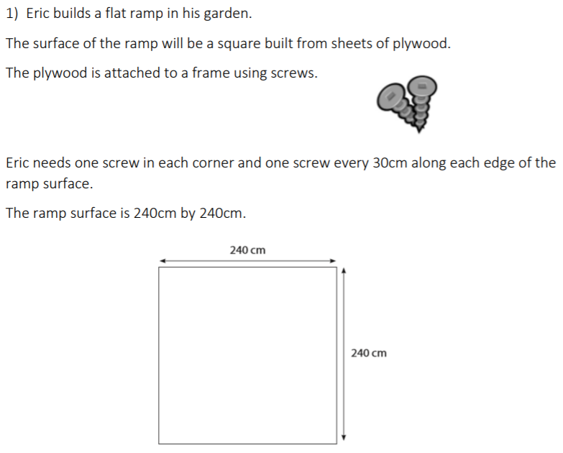
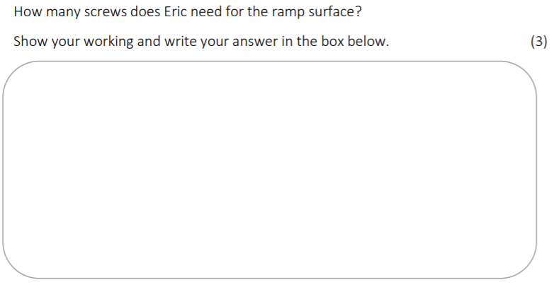
Area and Perimeter
Calculator questions

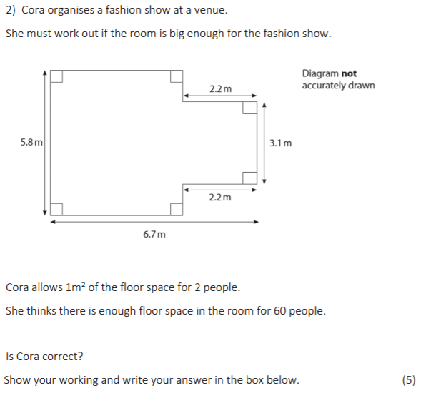

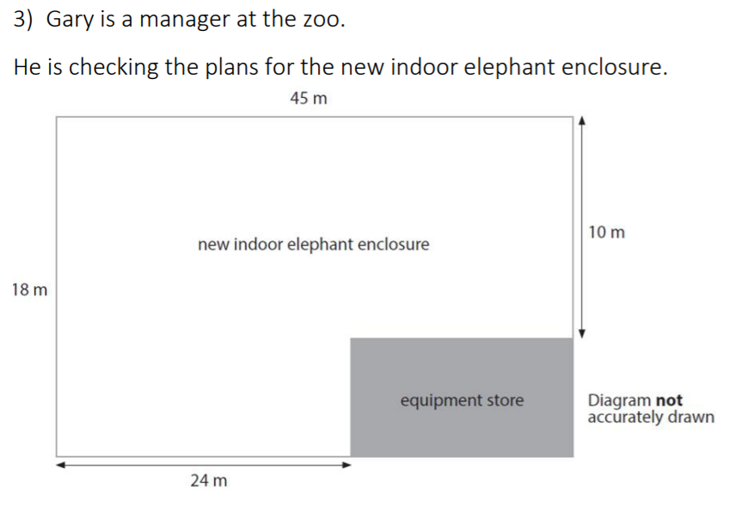
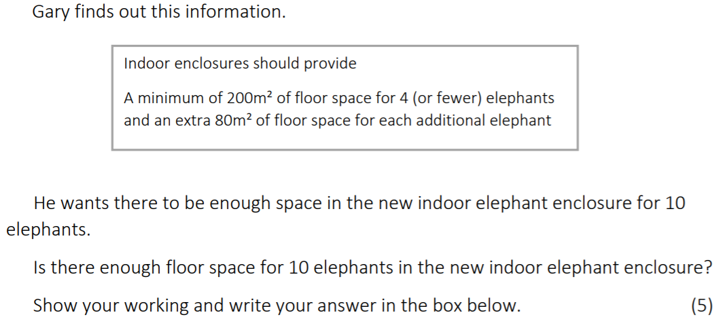

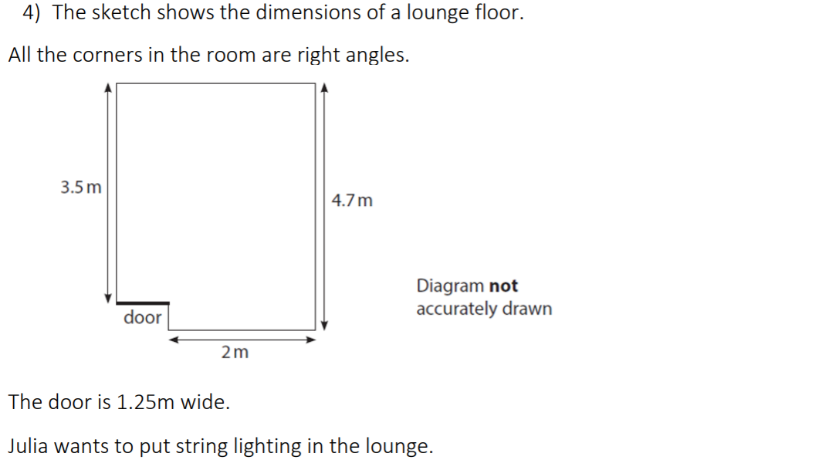
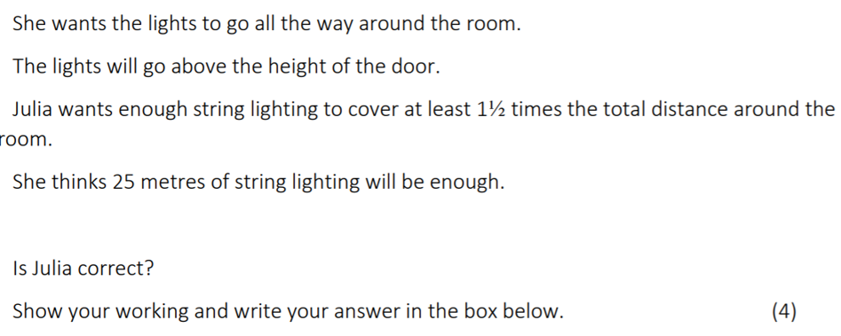

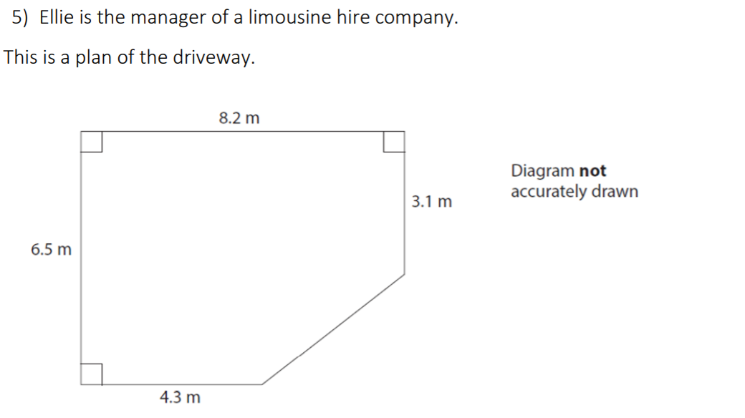
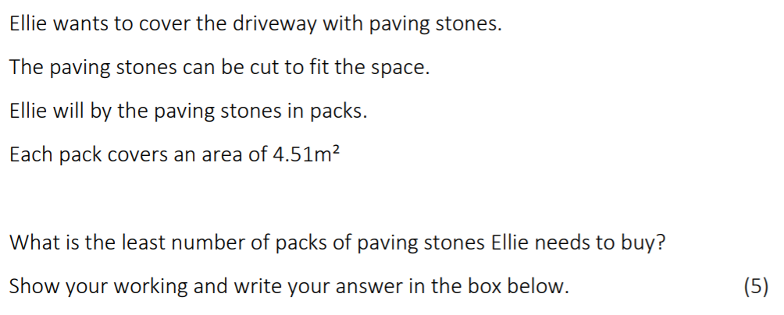

Notes
______________________________________________________________________________________________________________________________________________________________________________________________________________________________________________________________________________________________________________________________________________________________________________________________________________________________________________________________________________________________________________________________________________________________________________________________________________________________________________________________________________________________________________________________________________________________________________________________________________________________________________________________________________________________________________________________________________________________________________________________________________________________________________________________________________________________________________________________________________________________________________________________________________________________________________________________________________________________________________________________________________________________________________________________________________________________________________________________________________________________________________________________________________________________________________________________________________________________________________________________________________________________________________________________________________________________________________________________________________________________________________________________________________________________________________________________________________________________________________________________________________________________________________________________________________________________________________________________________________________________________________________________________________________________________________________________________________________________________________________________________________________________________________________________________________________________________________________________________________________________________________________________________________________________________________________________________________________________________________________________________________________________________________________________________________________________________________________________________________________________________________________________________________________________________________________________________________________________________________________________________________________________________________________________________________________________________________________________________________________________________________________________________________________________________________________________________________________________________________________________________________________________________________________________________________________________________________________________________________________________________________________________________________________________________________________________________________________________________________________________________________________________________________________________________________________________________________________________________________________________________________________________________________________________________________________________________________________________________________________________________________________________________________________________________________________________________________________________________________________________________________________________________________________________________________________________________________________________________________________________________________________

Volume and Surface Area
Calculator questions

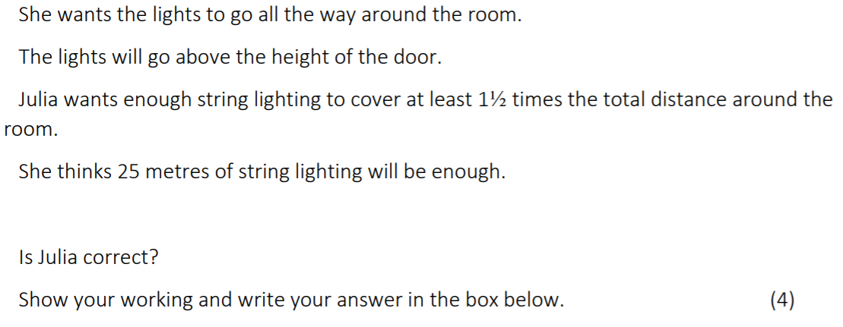
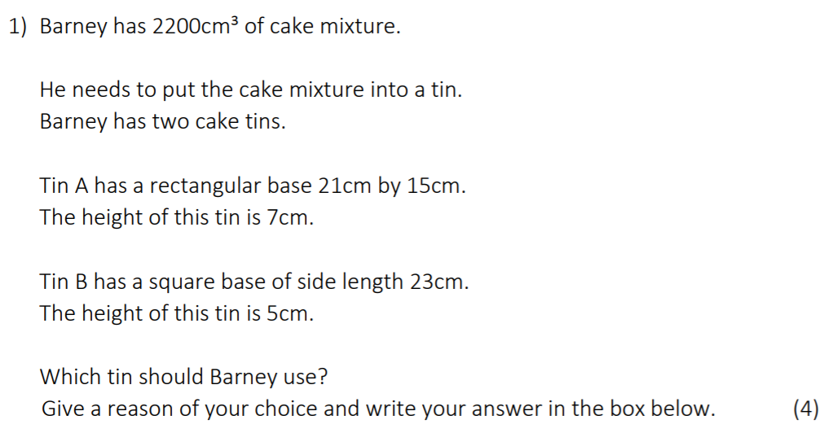
6)

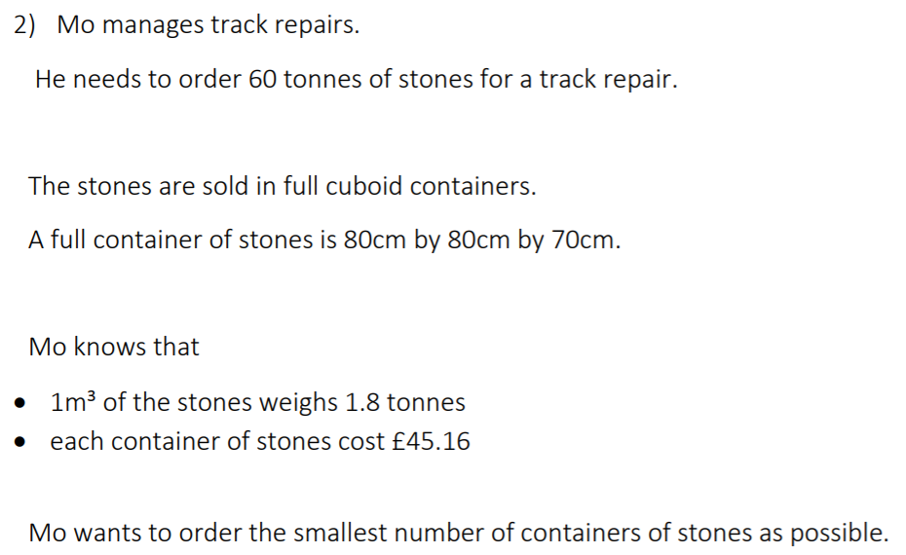
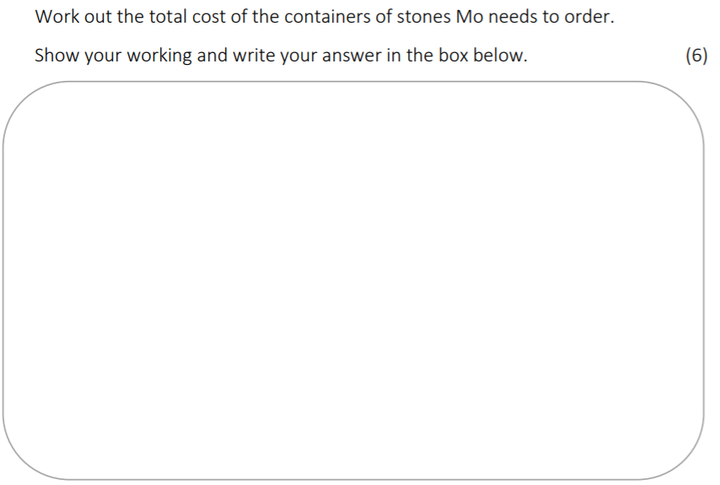
7)

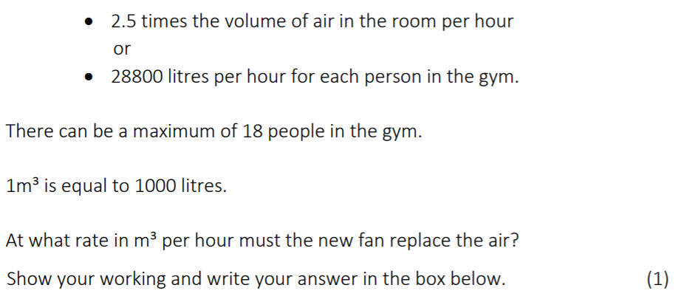
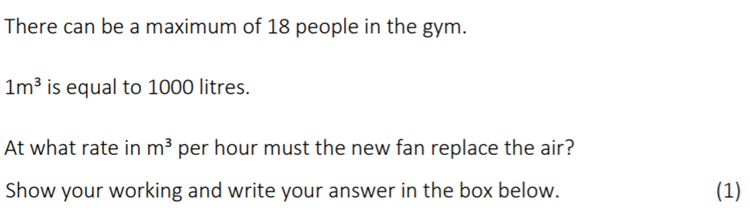
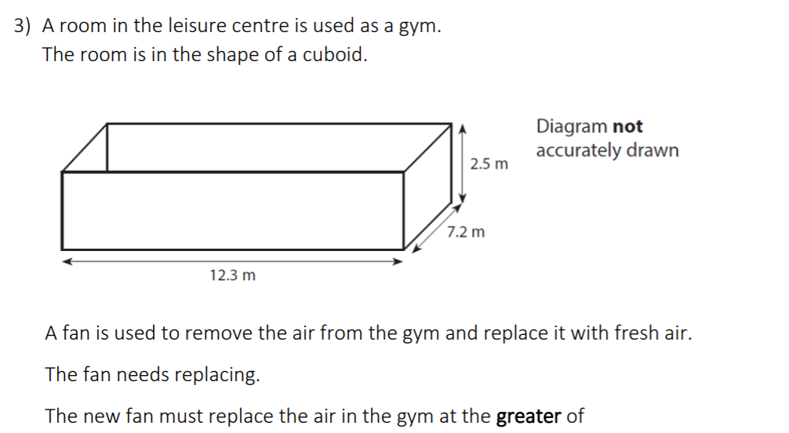
8)

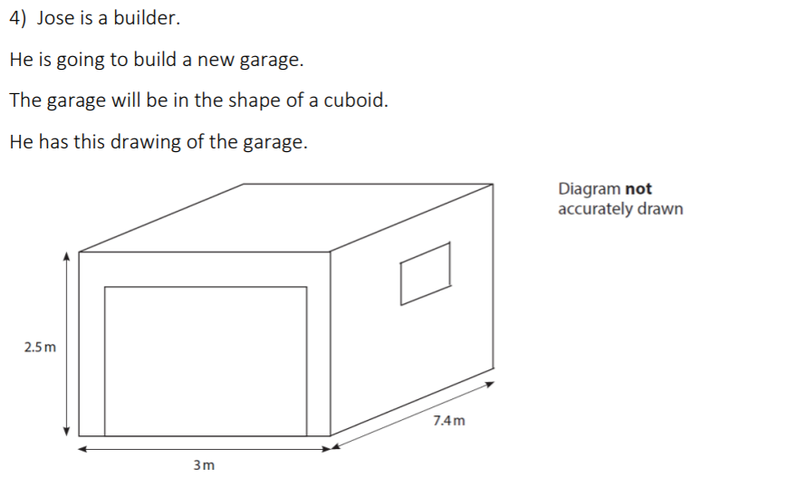
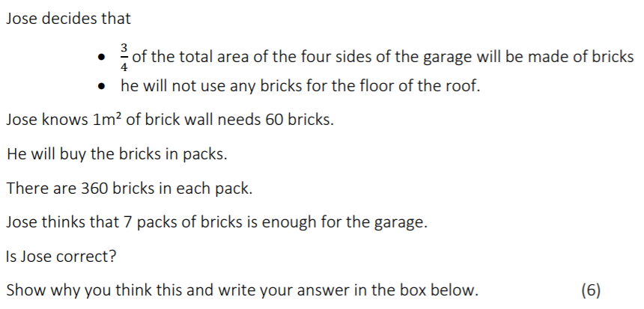
9)
8)
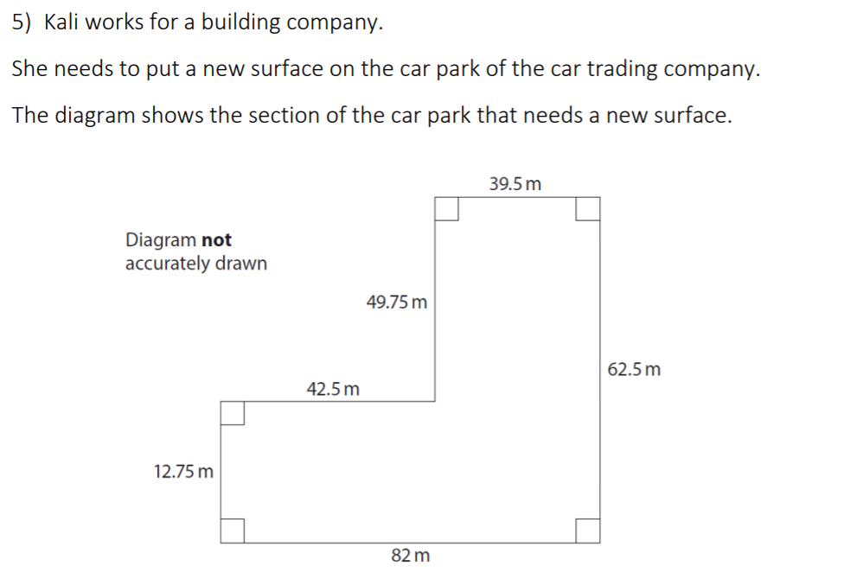
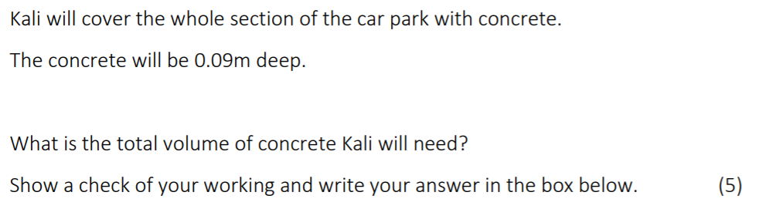
10)

Notes
____________________________________________________________________________________________________________________________________________________________________________________________________________________________________________________________________________________________________________________________________________________________________________________________________________________________________________________________________________________________________________________________________________________________________________________________________________________________________________________________________________________________________________________________________________________________________________________________________________________________________________________________________________________________________________________________________________________________________________________________________________________________________________________________________________________________________________________________________________________________________________________________________________________________________________________________________________________________________________________________________________________________________________________________________________________________________________________________________________________________________________________________________________________________________________________________________________________________________________________________________________________________________________________________________________________________________________________________________________________________________________________________________________________________________________________________________________________________________________________________________________________________________________________________________________________________________________________________________________________________________________________________________________________________________________________________________________________________________________________________________________________________________________________________________________________________________________________________________________________________________________________________________________________________________________________________________________________________________________________________________________________________________________________________________________________________________________________________________________________________________________________________________________________________________________________________________________________________________________________________________________________________________________________________________________________________________________________________________________________________________________________________________________________________________________________________________________________________________________________________________________________________________________________________________________________________________________________________________________________________________________________________________________________________________________________________________________________________________________________________________________________________________________________________________________________________________________________________________________________________________________________________________________________________________________________________________________________________________________________________________________________________________________________________________________________________________________________________________________________________________________________________________________________________________________________________________

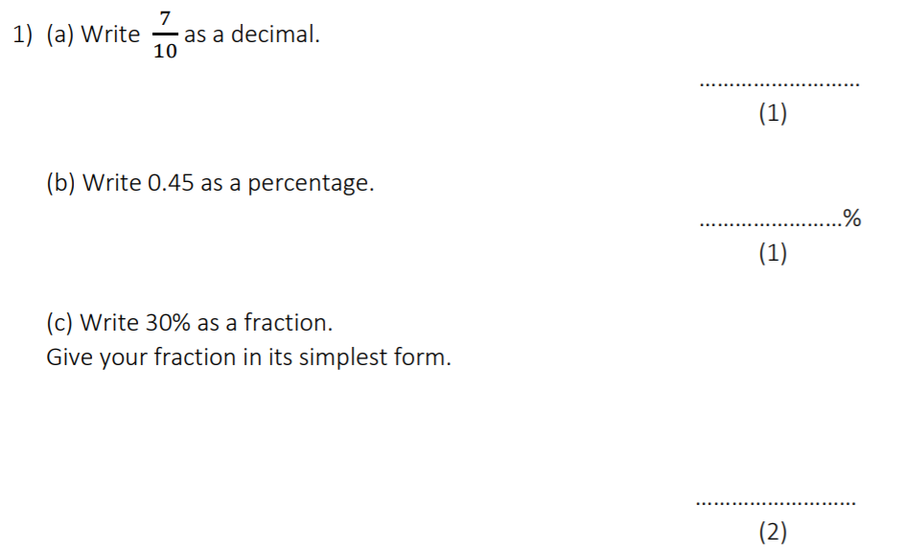
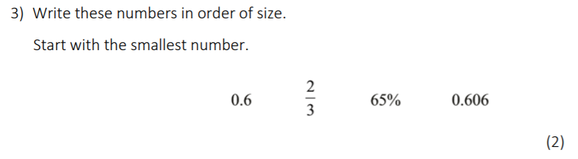
Fractions, Decimals and Percentages
Non calculator questions
2)

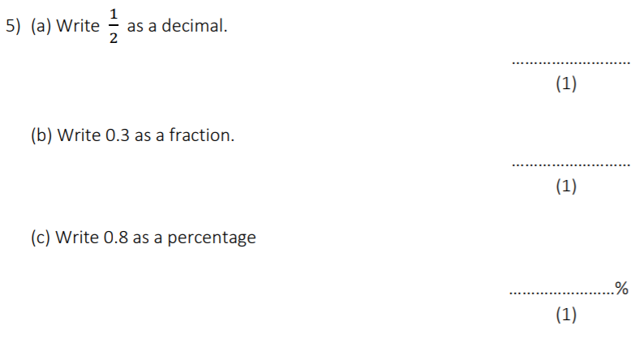
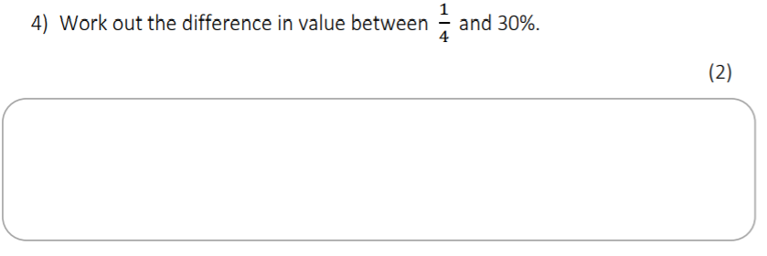
3)

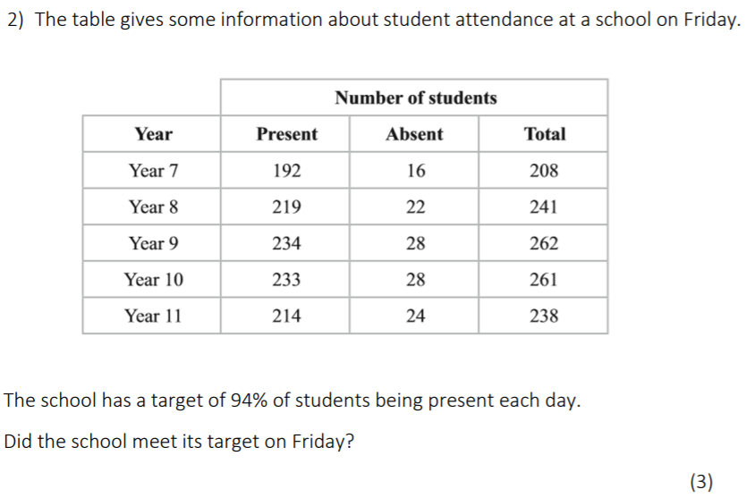
5)
Calculator questions

Notes
______________________________________________________________________________________________________________________________________________________________________________________________________________________________________________________________________________________________________________________________________________________________________________________________________________________________________________________________________________________________________________________________________________________________________________________________________________________________________________________________________________________________________________________________________________________________________________________________________________________________________________________________________________________________________________________________________________________________________________________________________________________________________________________________________________________________________________________________________________________________________________________________________________________________________________________________________________________________________________________________________________________________________________________________________________________________________________________________________________________________________________________________________________________________________________________________________________________________________________________________________________________________________________________________________________________________________________________________________________________________________________________________________________________________________________________________________________________________________________________________________________________________________________________________________________________________________________________________________________________________________________________________________________________________________________________________________________________________________________________________________________________________________________________________________________________________________________________________________________________________________________________________________________________________________________________________________________________________________________________________________________________________________________________________________________________________________________________________________________________________________________________________________________________________________________________________________________________________________________________________________________________________________________________________________________________________________________________________________________________________________________________________________________________________________________________________________________________________________________________________________________________________________________________________________________________________________________________________________________________________________________________________________________________________________________________________________________________________________________________________________________________________________________________________________________________________________________________________________________________________________________________________________________________________________________________________________________________________________________________________________________________________________________________________________________________________________________________________________________________________________________________________________________________________________________________________________________________________________________________________________________________

Co-ordinates
Non calculator questions
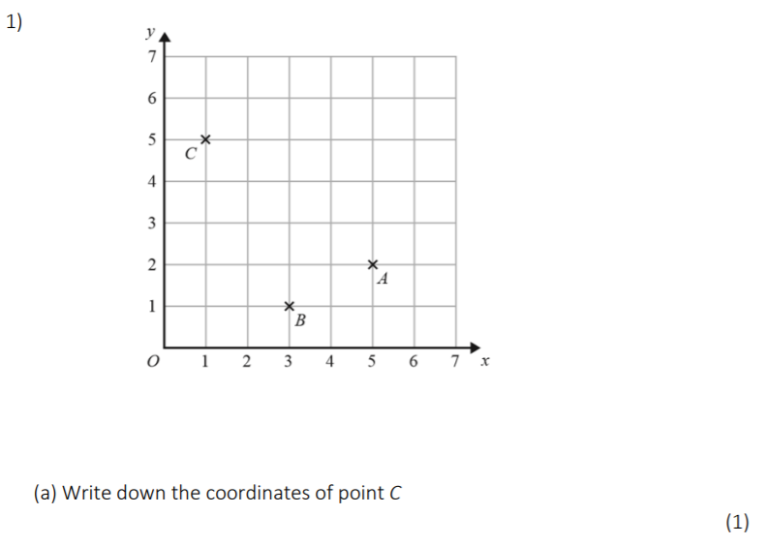
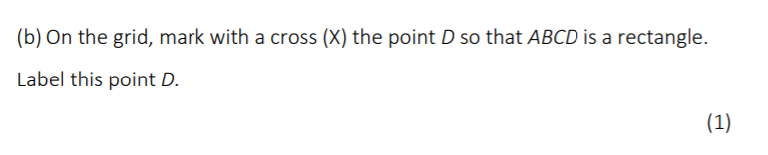
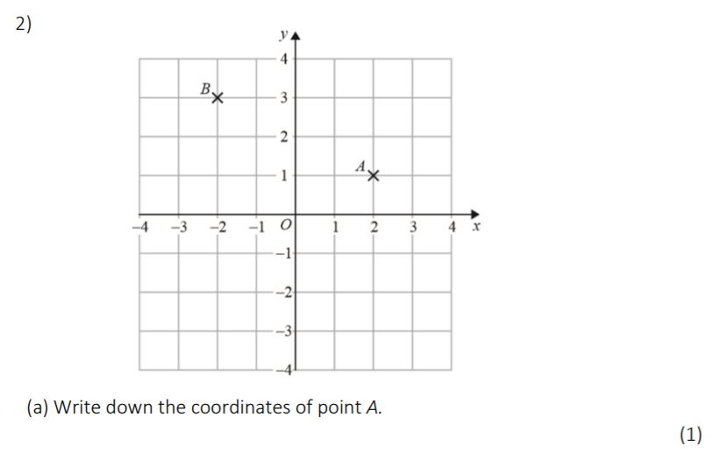
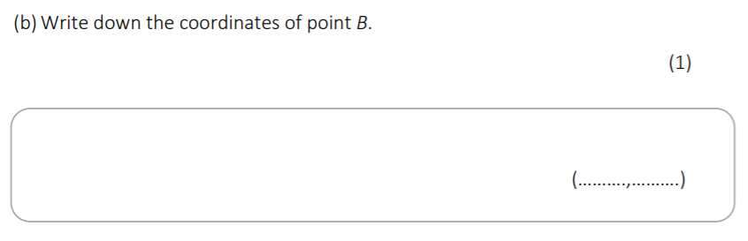
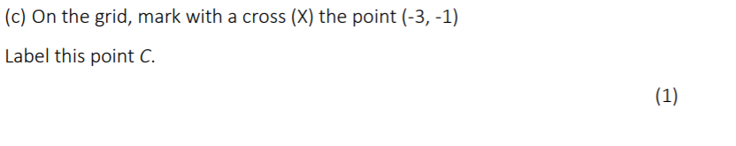

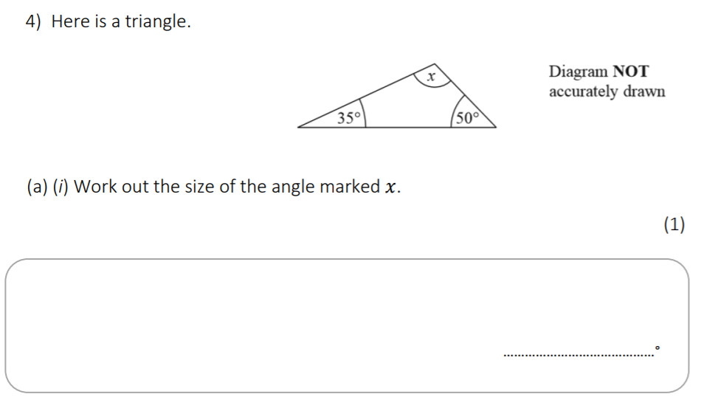
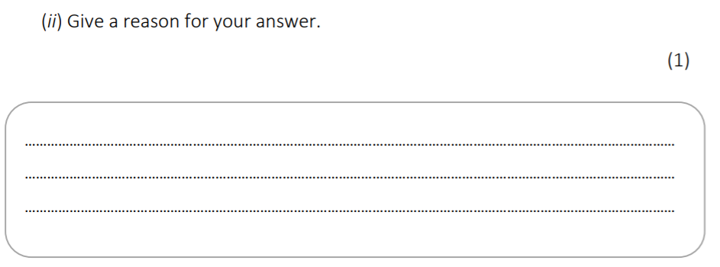
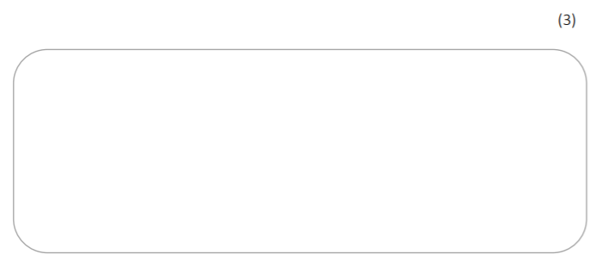

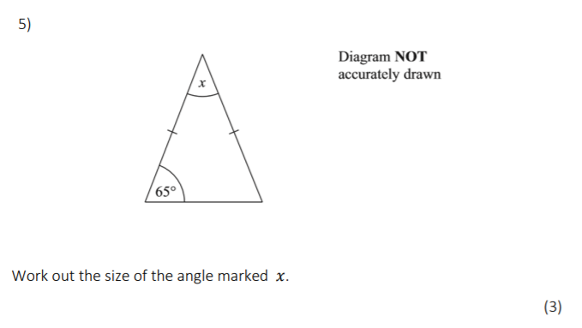

Notes
______________________________________________________________________________________________________________________________________________________________________________________________________________________________________________________________________________________________________________________________________________________________________________________________________________________________________________________________________________________________________________________________________________________________________________________________________________________________________________________________________________________________________________________________________________________________________________________________________________________________________________________________________________________________________________________________________________________________________________________________________________________________________________________________________________________________________________________________________________________________________________________________________________________________________________________________________________________________________________________________________________________________________________________________________________________________________________________________________________________________________________________________________________________________________________________________________________________________________________________________________________________________________________________________________________________________________________________________________________________________________________________________________________________________________________________________________________________________________________________________________________________________________________________________________________________________________________________________________________________________________________________________________________________________________________________________________________________________________________________________________________________________________________________________________________________________________________________________________________________________________________________________________________________________________________________________________________________________________________________________________________________________________________________________________________________________________________________________________________________________________________________________________________________________________________________________________________________________________________________________________________________________________________________________________________________________________________________________________________________________________________________________________________________________________________________________________________________________________________________________________________________________________________________________________________________________________________________________________________________________________________________________________________________________________________________________________________________________________________________________________________________________________________________________________________________________________________________________________________________________________________________________________________________________________________________________________________________________________________________________________________________________________________________________________________________________________________________________________________________________________________________________________________________________________________________________________________________________________________________________________________________

2D and 3D Shapes

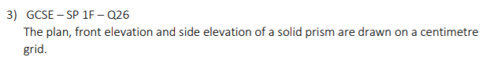
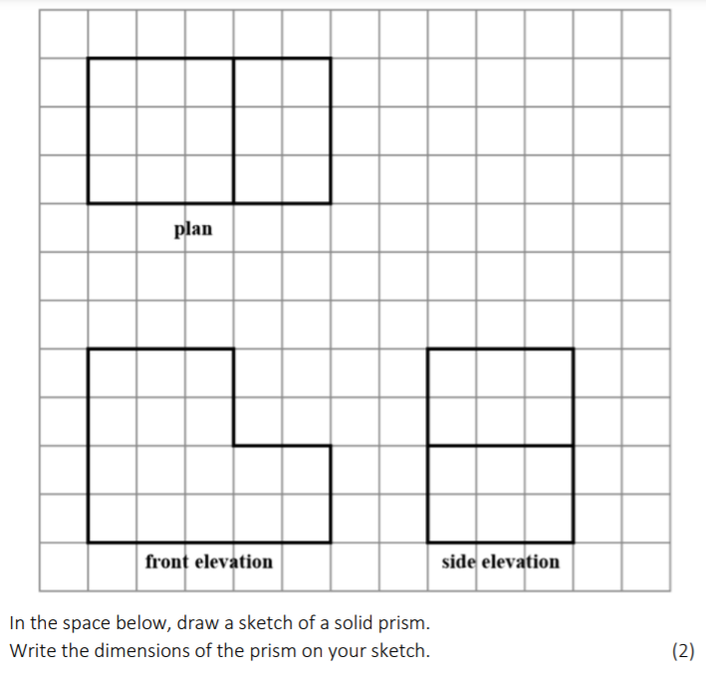

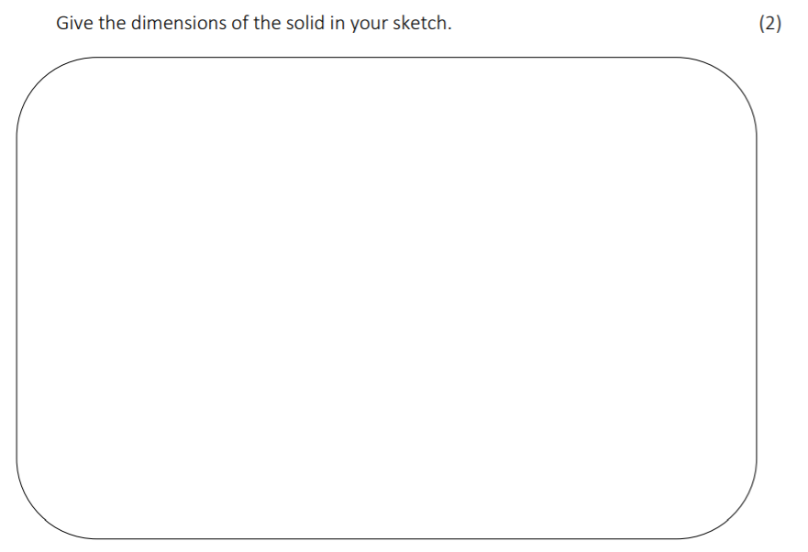

Notes
______________________________________________________________________________________________________________________________________________________________________________________________________________________________________________________________________________________________________________________________________________________________________________________________________________________________________________________________________________________________________________________________________________________________________________________________________________________________________________________________________________________________________________________________________________________________________________________________________________________________________________________________________________________________________________________________________________________________________________________________________________________________________________________________________________________________________________________________________________________________________________________________________________________________________________________________________________________________________________________________________________________________________________________________________________________________________________________________________________________________________________________________________________________________________________________________________________________________________________________________________________________________________________________________________________________________________________________________________________________________________________________________________________________________________________________________________________________________________________________________________________________________________________________________________________________________________________________________________________________________________________________________________________________________________________________________________________________________________________________________________________________________________________________________________________________________________________________________________________________________________________________________________________________________________________________________________________________________________________________________________________________________________________________________________________________________________________________________________________________________________________________________________________________________________________________________________________________________________________________________________________________________________________________________________________________________________________________________________________________________________________________________________________________________________________________________________________________________________________________________________________________________________________________________________________________________________________________________________________________________________________________________________________________________________________________________________________________________________________________________________________________________________________________________________________________________________________________________________________________________________________________________________________________________________________________________________________________________________________________________________________________________________________________________________________________________________________________________________________________________________________________________________________________________________________________________________________________________________________________________________________________

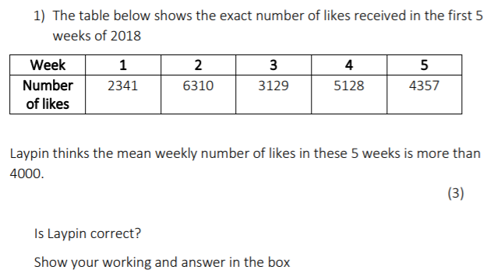
Averages
Calculator questions

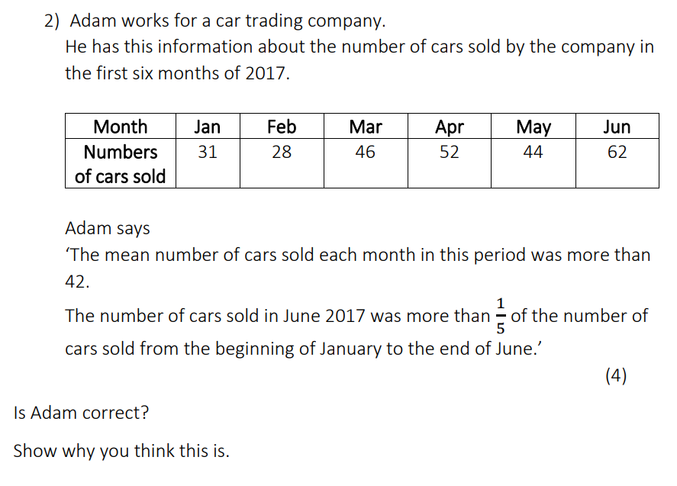

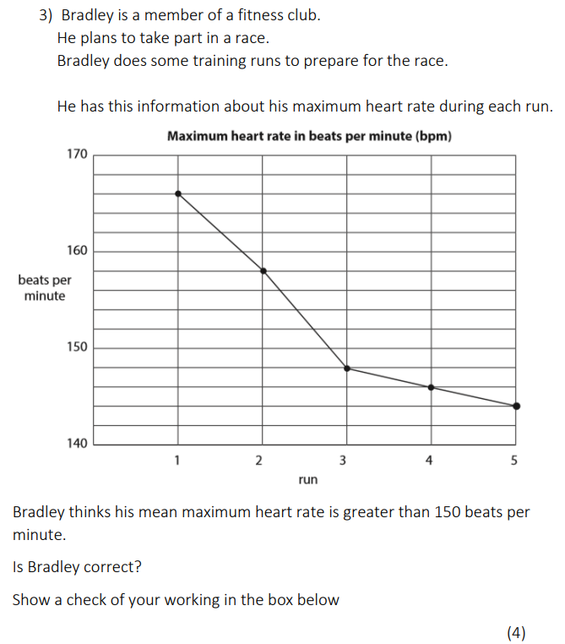
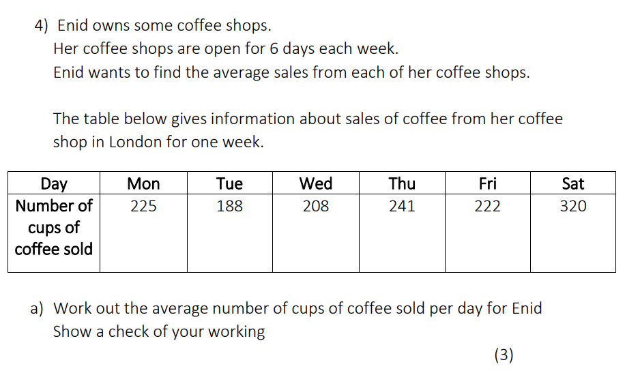

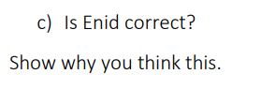
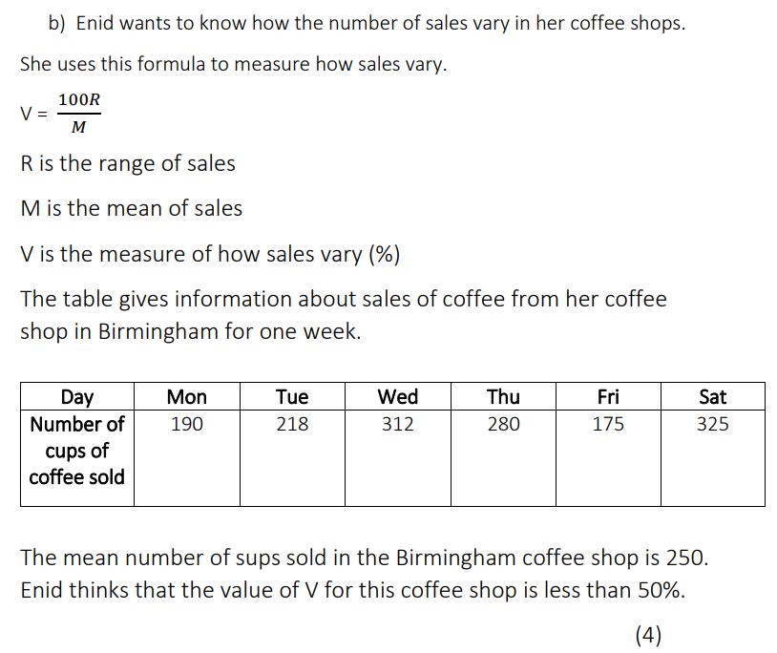

For her Derby coffee shop, Enid uses the formula to work out the value of V using figures for:
One week of Sales
One Month of sales
d) Which value of v is the most reliable (2)
Give a reason for your answer
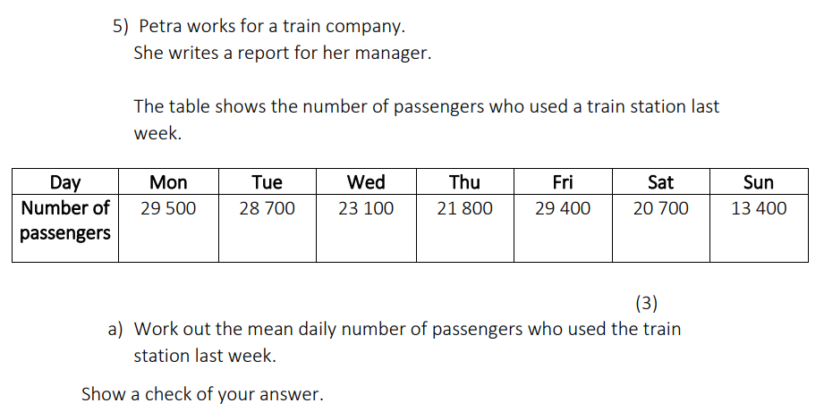
5) Petra works for a train company.
She writes a report for her manager.
The table shows the number of passengers who used a train station last week.

Work out the mean daily number of passengers who used the train last week (3)
Show a check of your answer

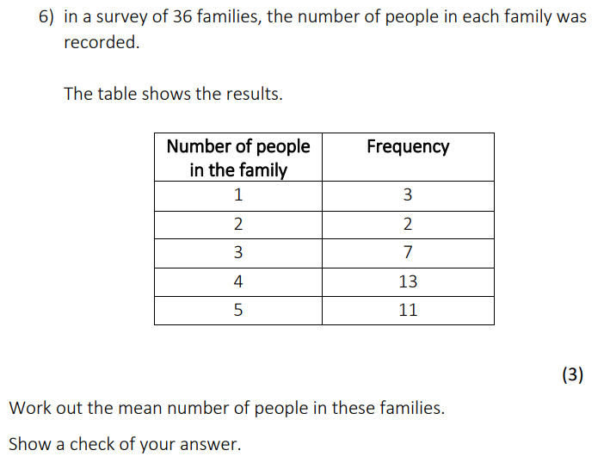

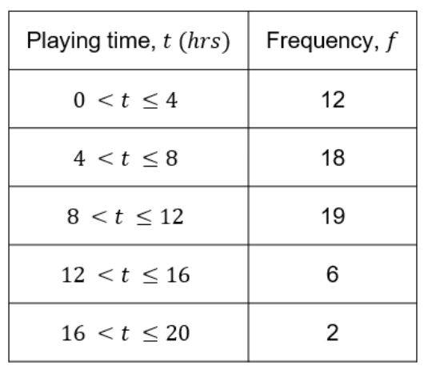
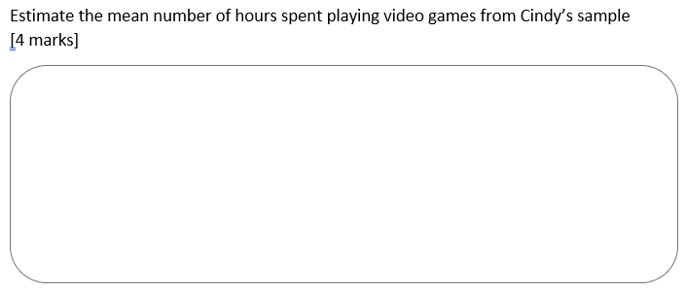
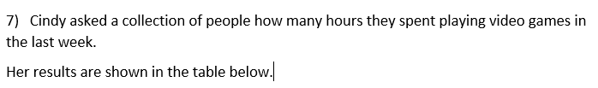

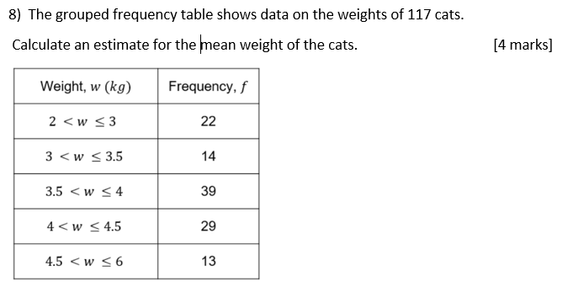

Notes
______________________________________________________________________________________________________________________________________________________________________________________________________________________________________________________________________________________________________________________________________________________________________________________________________________________________________________________________________________________________________________________________________________________________________________________________________________________________________________________________________________________________________________________________________________________________________________________________________________________________________________________________________________________________________________________________________________________________________________________________________________________________________________________________________________________________________________________________________________________________________________________________________________________________________________________________________________________________________________________________________________________________________________________________________________________________________________________________________________________________________________________________________________________________________________________________________________________________________________________________________________________________________________________________________________________________________________________________________________________________________________________________________________________________________________________________________________________________________________________________________________________________________________________________________________________________________________________________________________________________________________________________________________________________________________________________________________________________________________________________________________________________________________________________________________________________________________________________________________________________________________________________________________________________________________________________________________________________________________________________________________________________________________________________________________________________________________________________________________________________________________________________________________________________________________________________________________________________________________________________________________________________________________________________________________________________________________________________________________________________________________________________________________________________________________________________________________________________________________________________________________________________________________________________________________________________________________________________________________________________________________________________________________________________________________________________________________________________________________________________________________________________________________________________________________________________________________________________________________________________________________________________________________________________________________________________________________________________________________________________________________________________________________________________________________________________________________________________________________________________________________________________________________________________________________________________________________________________________________________________________________________

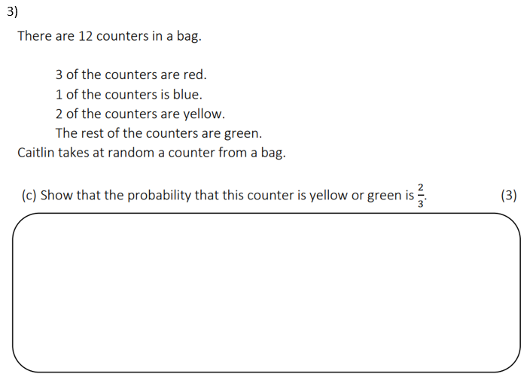
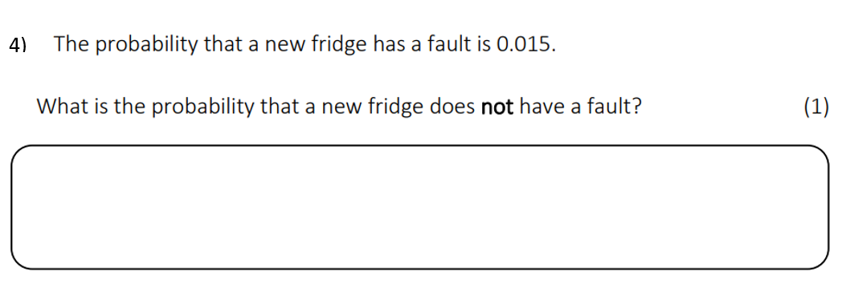
Probability
Non calculator questions
1)

2)

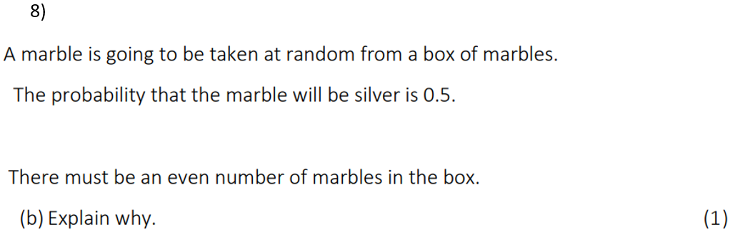
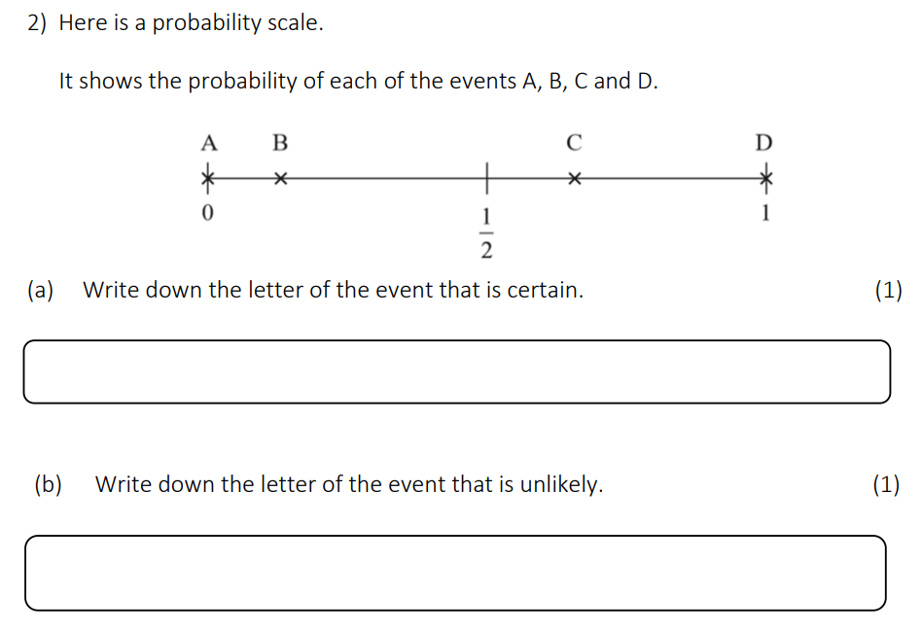
3)

4)

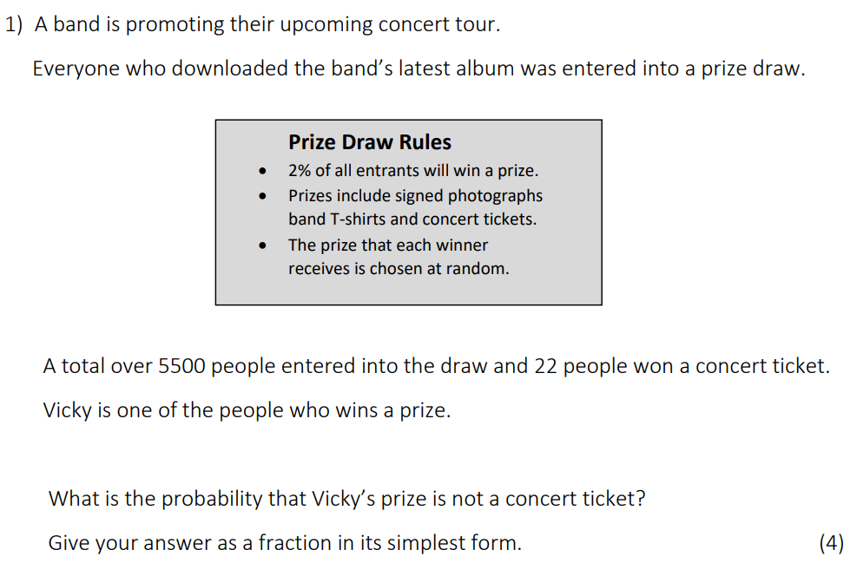
Calculator questions

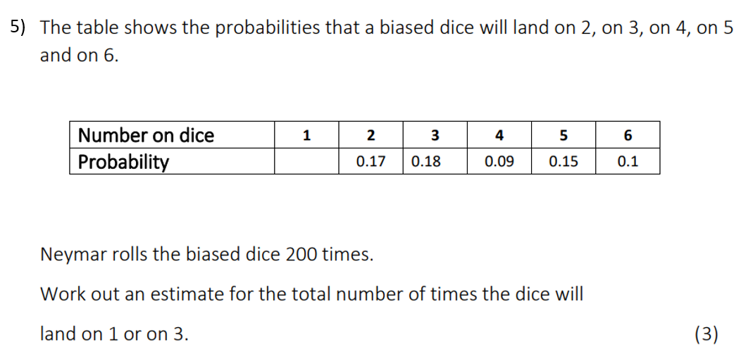
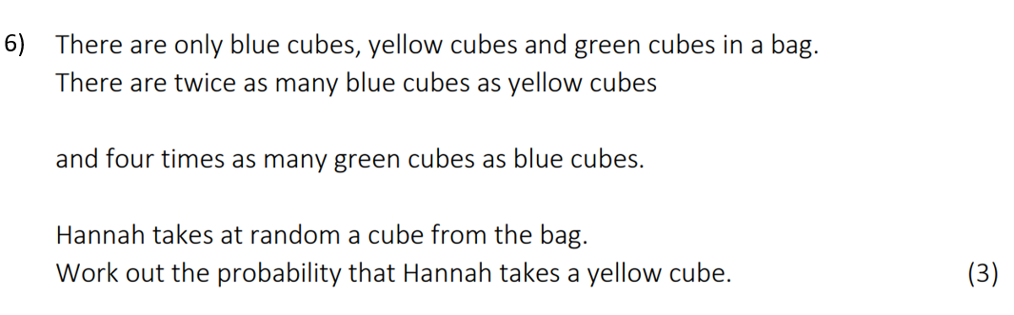
2)
3)

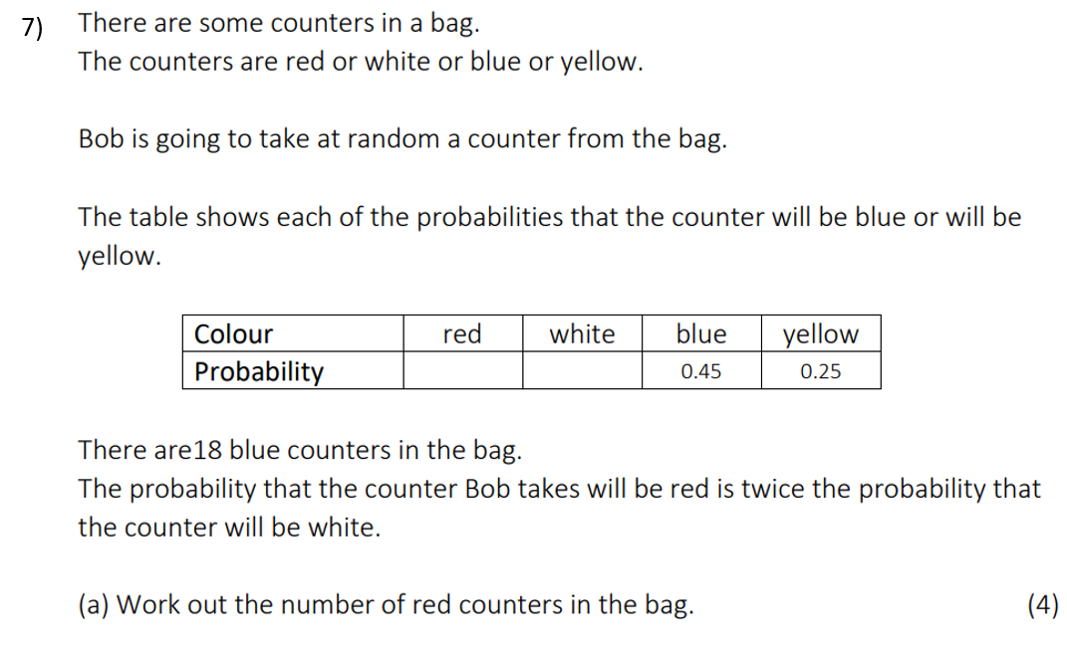
4)

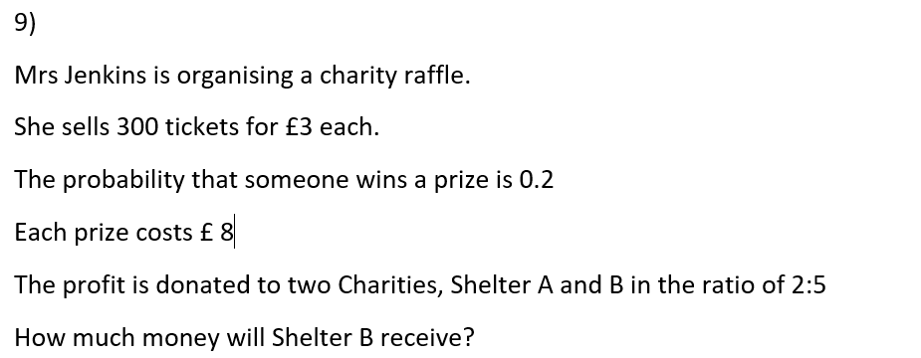
5)

Notes
____________________________________________________________________________________________________________________________________________________________________________________________________________________________________________________________________________________________________________________________________________________________________________________________________________________________________________________________________________________________________________________________________________________________________________________________________________________________________________________________________________________________________________________________________________________________________________________________________________________________________________________________________________________________________________________________________________________________________________________________________________________________________________________________________________________________________________________________________________________________________________________________________________________________________________________________________________________________________________________________________________________________________________________________________________________________________________________________________________________________________________________________________________________________________________________________________________________________________________________________________________________________________________________________________________________________________________________________________________________________________________________________________________________________________________________________________________________________________________________________________________________________________________________________________________________________________________________________________________________________________________________________________________________________________________________________________________________________________________________________________________________________________________________________________________________________________________________________________________________________________________________________________________________________________________________________________________________________________________________________________________________________________________________________________________________________________________________________________________________________________________________________________________________________________________________________________________________________________________________________________________________________________________________________________________________________________________________________________________________________________________________________________________________________________________________________________________________________________________________________________________________________________________________________________________________________________________________________________________________________________________________________________________________________________________________________________________________________________________________________________________________________________________________________________________________________________________________________________________________________________________________________________________________________________________________________________________________________________________________________________________________________________________________________________________________________________________________________________________________________________________________________________________________________________________________________________

Scatter Diagrams
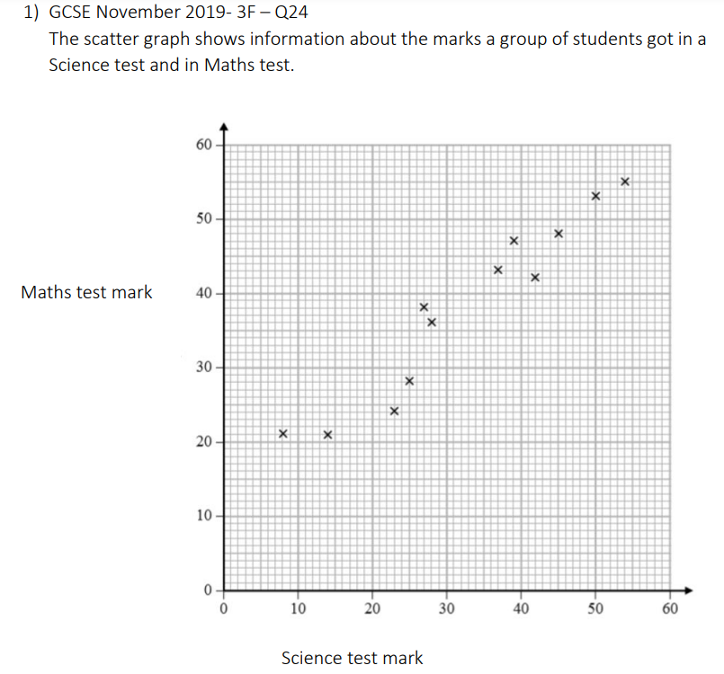

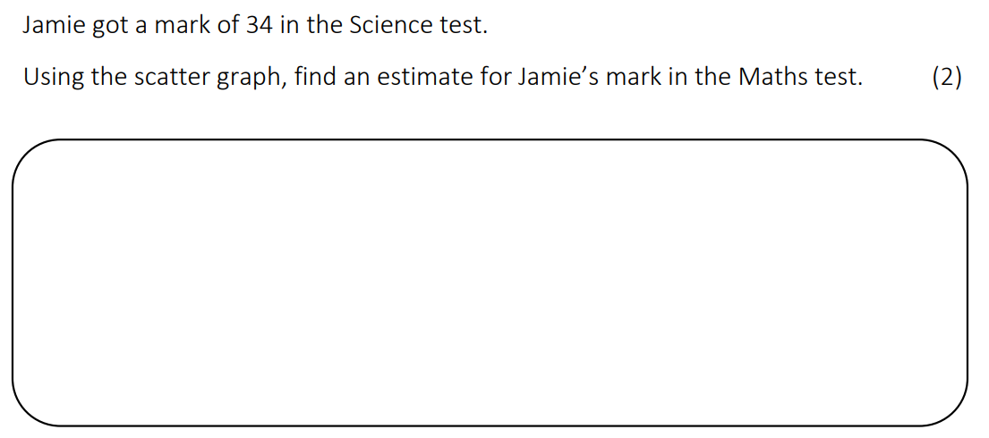

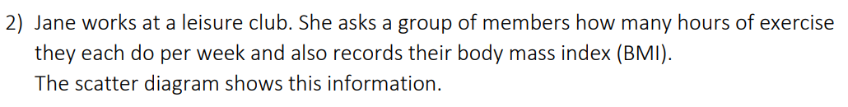
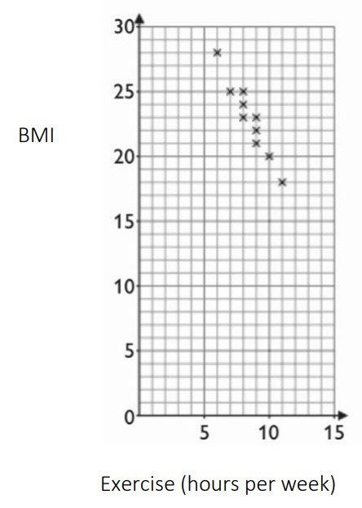
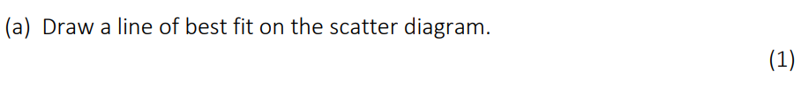

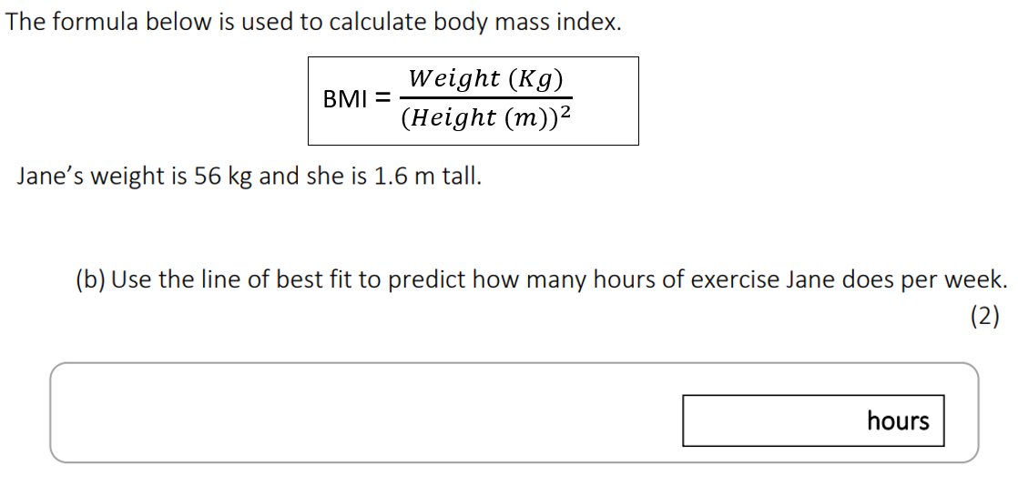

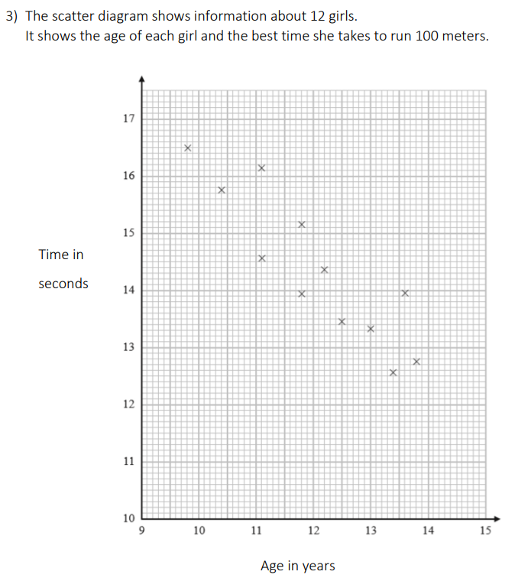
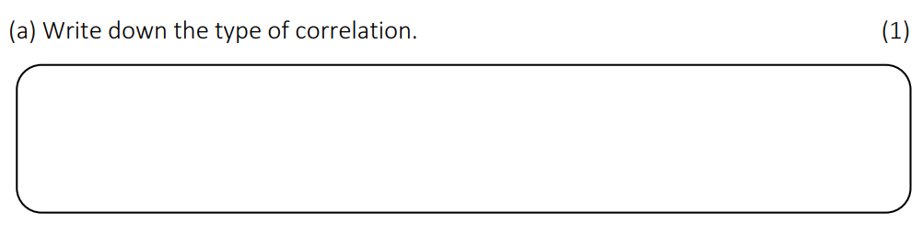
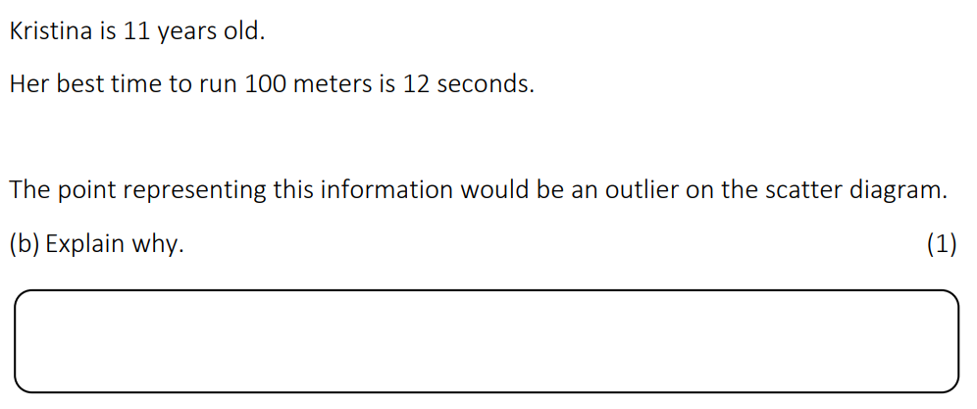
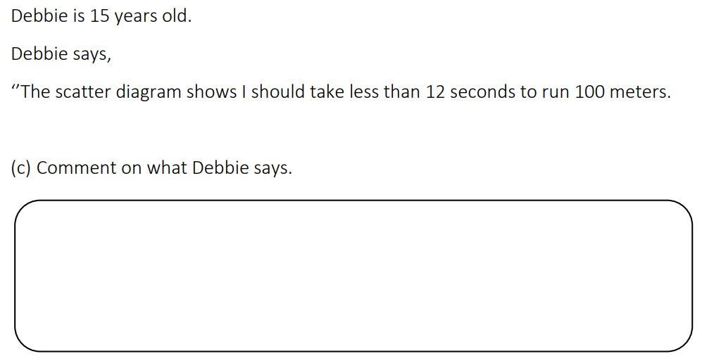

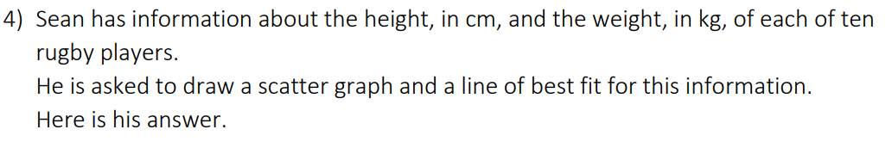
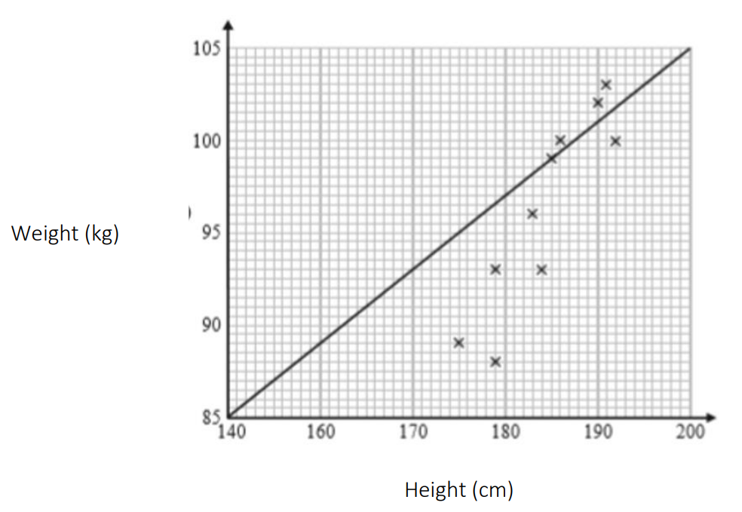
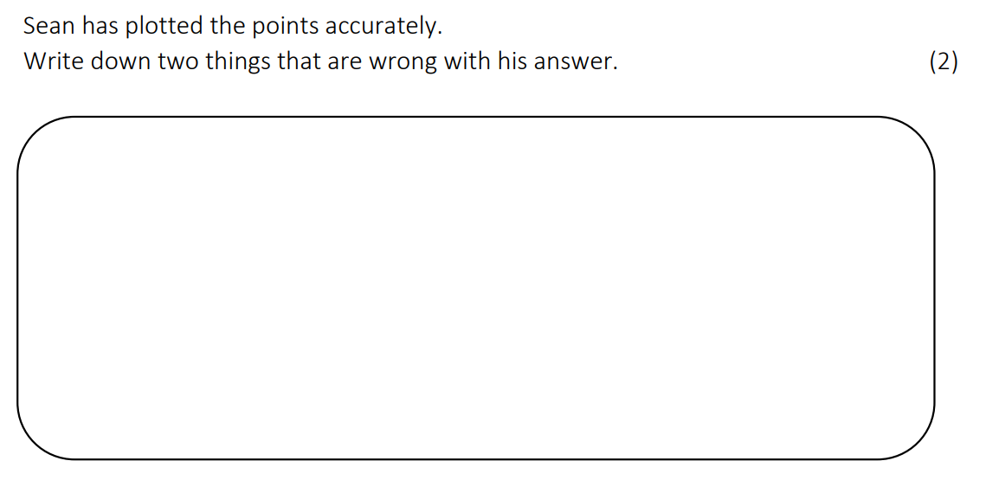
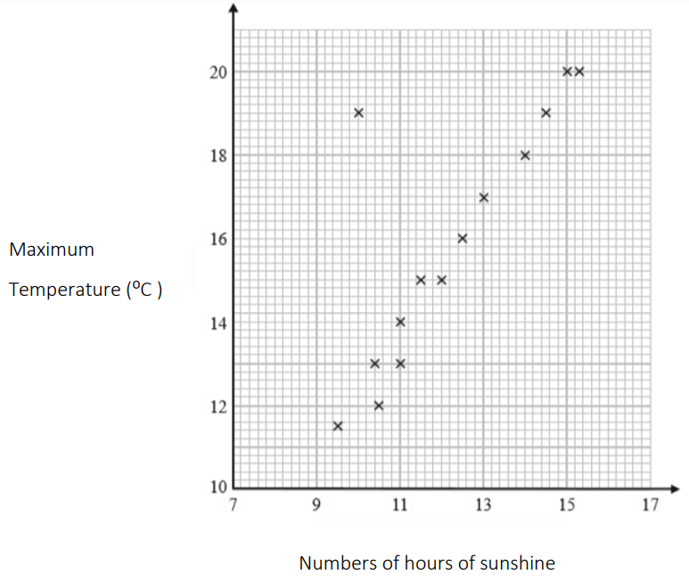
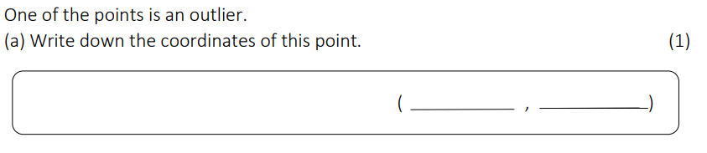

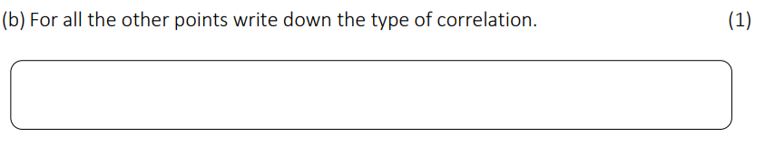
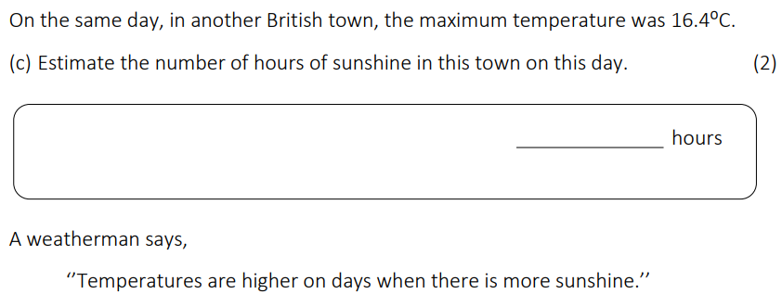
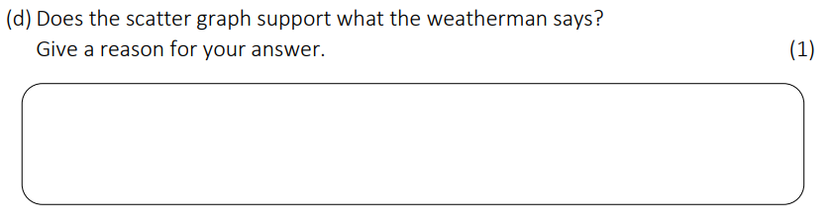
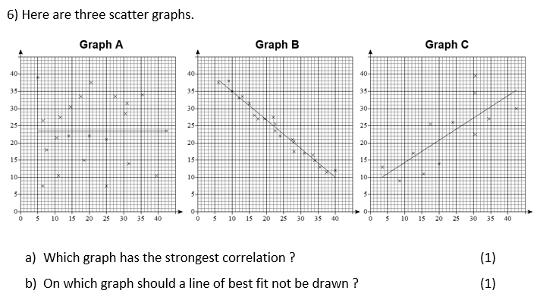

Notes
____________________________________________________________________________________________________________________________________________________________________________________________________________________________________________________________________________________________________________________________________________________________________________________________________________________________________________________________________________________________________________________________________________________________________________________________________________________________________________________________________________________________________________________________________________________________________________________________________________________________________________________________________________________________________________________________________________________________________________________________________________________________________________________________________________________________________________________________________________________________________________________________________________________________________________________________________________________________________________________________________________________________________________________________________________________________________________________________________________________________________________________________________________________________________________________________________________________________________________________________________________________________________________________________________________________________________________________________________________________________________________________________________________________________________________________________________________________________________________________________________________________________________________________________________________________________________________________________________________________________________________________________________________________________________________________________________________________________________________________________________________________________________________________________________________________________________________________________________________________________________________________________________________________________________________________________________________________________________________________________________________________________________________________________________________________________________________________________________________________________________________________________________________________________________________________________________________________________________________________________________________________________________________________________________________________________________________________________________________________________________________________________________________________________________________________________________________________________________________________________________________________________________________________________________________________________________________________________________________________________________________________________________________________________________________________________________________________________________________________________________________________________________________________________________________________________________________________________________________________________________________________________________________________________________________________________________________________________________________________________________________________________________________________________________________________________________________________________________________________________________________________________________________________________________________________________________________________________________________________________________





QR Codes
Percentage of Amount
Percentage Change
Compound interest
Reverse Percentages





Best Buys
Exchange rates
Basic Area
Area of Compound





Angles in a Triangle
Basic Perimeter
Volume
Surface Area





Probability
Probability Tables
Scatter Graphs
Averages





Pie Charts
Frequency Tables
Speed & Density
Similar Shapes

