What 2D shapes do you see in the patterns on the wall/wrapping paper/clothing etc?

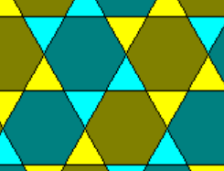
Method: you may need to look up the names of 2D shapes and match them to the patterns you see. You need to state shape names and properties in your exam so learn them!

Measure the angles in the shapes on any of the patterns. What angles do the shapes need to make them ‘tessellate’ ?

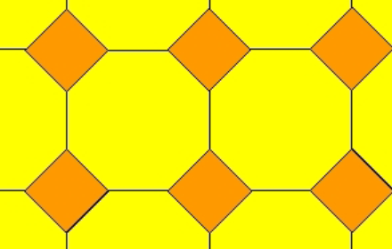

Method: If shapes connect together without gaps they are said to ‘tessellate’. Consider angles required to make them connect without gaps

Your text here
Can you find and draw on one of the patterns any:
Alternate angles
Corresponding angles
Reflex angles
Right angles Obtuse etc..

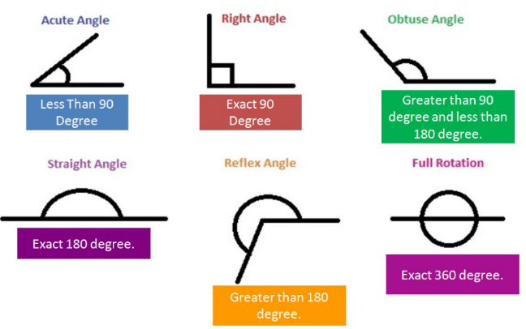

Method: look up the definition of each of the angles and terminology and identify them in the patterns…

Draw around the outside of a shape in one of the patterns. Draw on the interior angles and sizes. What do these add up to? Why? What about other shapes in the pattern?

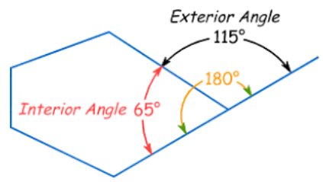

Method: measure the inside angle using a protractor placing zero line along one edge. Read off the angle then add them all up.

Wrap a 3D object such as a box (cuboid) in wrapping paper on all sides. Find the ‘Surface Area’ of the 3D object (amount of wrapping paper used in cm²)




Method: Think about each side as a separate area. Area is length x width. Add up all the separate areas once found.

Look at any of the patterns. Place a mirror on the pattern at an angle, draw a mirror line and then ACCURATELY draw the reflected pattern.

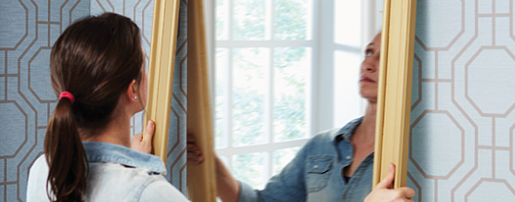

Method: use the mirror to guide you. Objects in mirrors are the same distance into the mirror as out so MEASURE points on the shape (corners) and reflect the same distance on the image.

