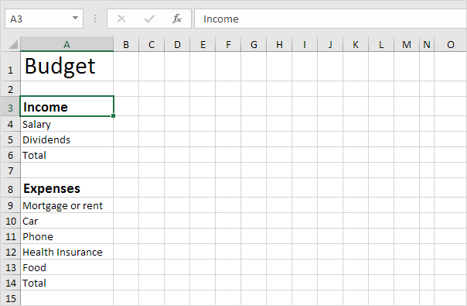

Questions

- What information needs to go into a personal or company budget?

- Which incomes/expenses are subject to Percentage Change?

- Can you create a chart/graph to visually show how money is divided up, which should you choose?

- What formulae could be used for calculations within the spreadsheet?

- Can you use the ‘Average..’ Function, or the ‘Sum..’ Function?

- How many ‘Decimal Places’ do you need to work with? How do you change them?

