INSTRUCTIONS

Take a look at this FRACTIONS GENERATOR
It creates different fractions questions, add, subtract, multiply and divide
By double clicking any number, new questions are created

Discuss / Experiment

Take each type of fraction sum and look at how it is being solved

- How is it being solved?
- What formulae are being used by EXCEL to solve the questions?
- Do you know how this generator is put together?
- Can you write your own one?.. or even part of what you see..?
- Can you solve any of the sums before looking at the answers?

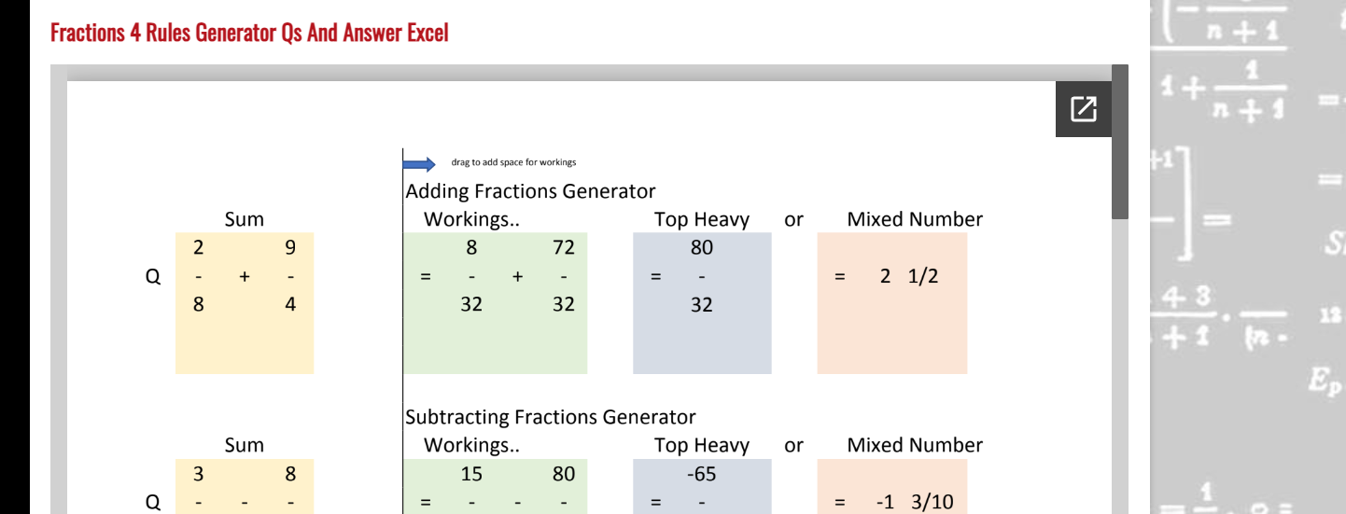
INSTRUCTIONS

