Level 2 Functional Skills - End of Term Assessment 2

Fractions, Formulae, Ratio and Proportion and Decimals

- Order, add, subtract and compare amounts or quantities using proper and improper fractions and mixed numbers
- Express one number as a fraction of another
- Evaluate expressions and make substitutions in given formulae in words and symbols
- Understand and calculate using ratios, direct proportion and inverse proportion
- Order, approximate and compare decimals
- Add, subtract, multiply and divide decimals up to three decimal places

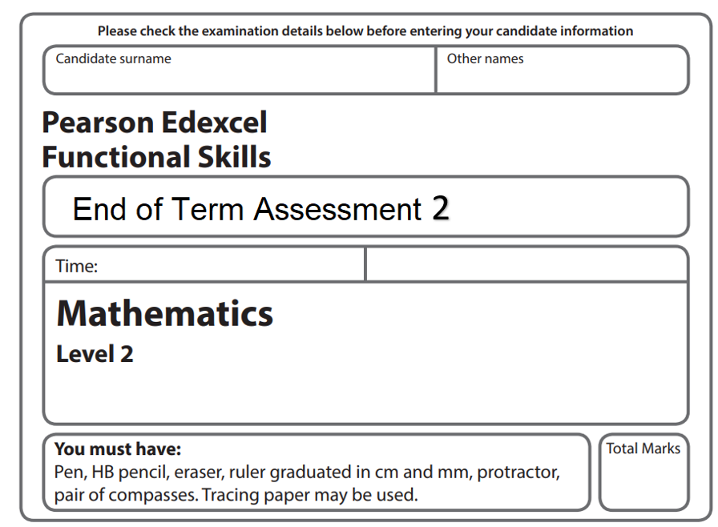

20 minutes then 30 minutes

41


Non-Calculator Section

1) Find $\frac{7}{9} - \frac{5}{6}$ (3)

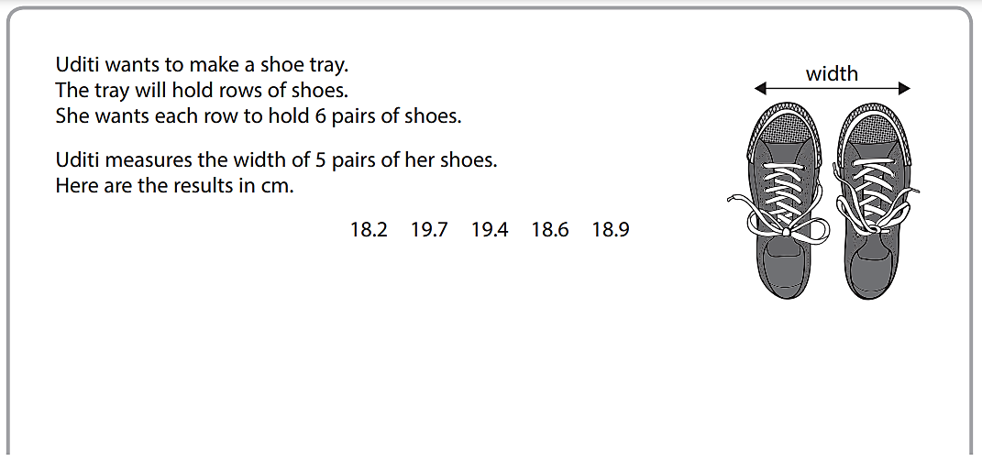


2) a) Find the ratio between the largest and smallest shoe pair. (3)
Write your answer in its simplest form.

b) Total the widths of pairs of shoes to find the width of the shoe tray. Show if this is over one metre in length 100cm = 1m (3)

3) Replace y with 2 and t with 4 then complete the formula (3)

6y + t - 4 ( 10 – yt )

4) Order, highest first, the following values.

$\frac{8}{5}$ 0.85 1 $\frac{5}{8}$

You must show your workings. (3)


Calculator Section

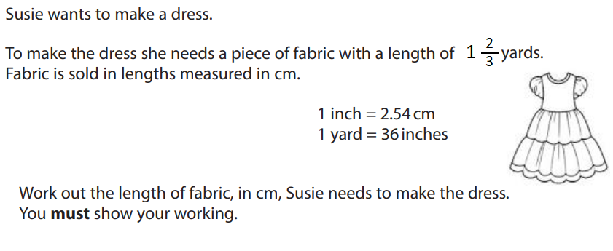
1)

(3)

2) Jim wants to paint his living room. He mixes two colours and thinner in the ratio:
Red: Yellow: thinner (3)
20 : 15 : 7

He has 300ml of thinner. What is the maximum amount of paint he can make? Write your answer to 2dps.

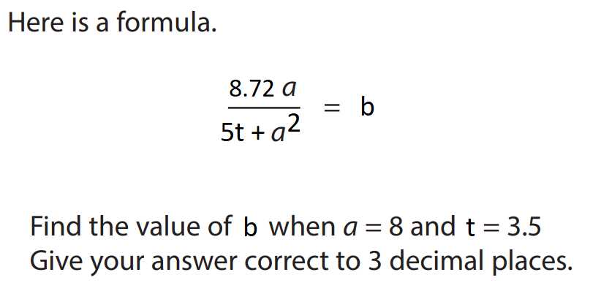
3)

(5)

4) Race results are shown below showing the total time to complete the race for the top five competitors.

Jane 23.849 mins
Ranit 21.064 mins
Steve 22.553 mins
Sheena 20.110 mins
Tim 24.989 mins
(3)
Find the ratio of competitors than ran slower than 0.36hrs to those that took longer.


5) An Estate agent finds house price changes for their website.
A


B
a) For house A Find.. 5/7 of £420,000

(2)

b) For house B Find.. 2/3 of £390,000

(2)

c) To compare these two new houses prices, the estate agent finds house A as a fraction of house B (using the prices you found in parts a) and b) ). Complete this comparison calculation and write your answer in its simplest terms using a mixed number if required.

(3)

6) Multiply 0.4328 x 1.6029 writing your answer to three decimal places.

(2)

7) Complete the sum on a calculator

1 $\frac{1}{2}$ divided by 2 $\frac{2}{3}$

(1)

8) The number of fruit pickers is inversely proportional to the amount of time taken to pick fruit. A greenhouse employs 18 pickers which take 36 hours to complete a job. Find the time taken when the greenhouse employs 12 pickers.

(2)

