
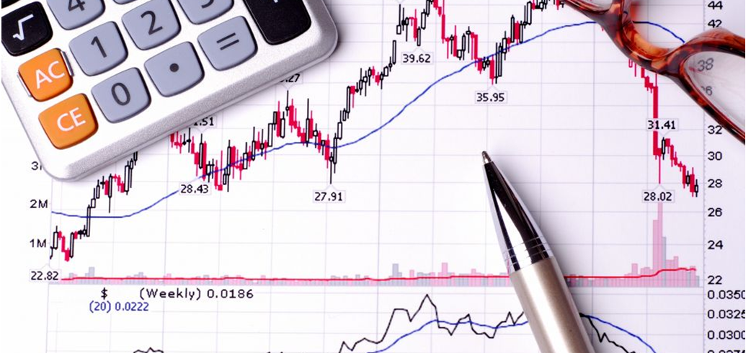

1) Create a list of ‘Income’ and ‘Expenditure’ items
PASS SHEET ‘ONE’ TO ANOTHER GROUP WHEN COMPLETED

2) Select suitable data and present in a graphical form
PASS COMPLETED GRAPH WITH SHEET ‘ONE’ TO ANOTHER GROUP

3) Analyse the data and look for trends quoting your findings and presenting some form of ‘Average’
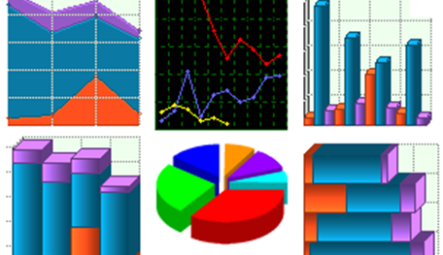
COMPLETE A PRESENTATION TO THE WHOLE GROUP

