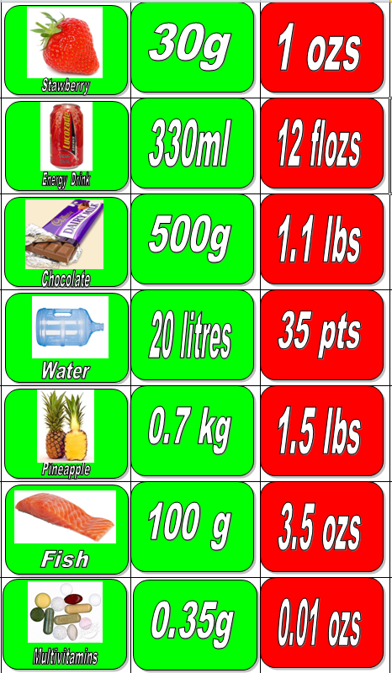
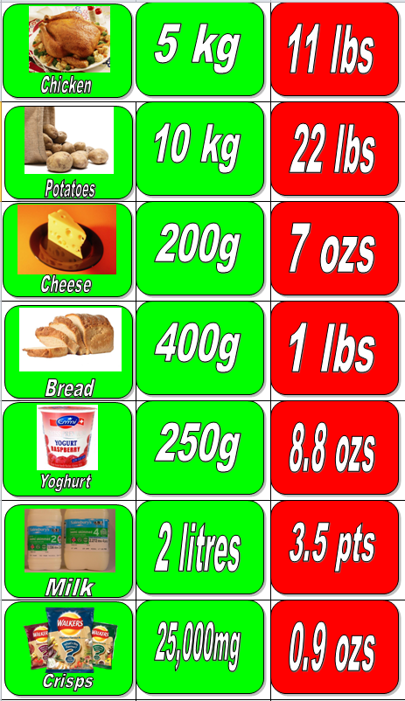
ANSWERS
0.02 kl, 20K ml
0.03 kg, 30K mg
350 mg
0.1 kg
700 g
0.5 kg
0.33 litres
25 g
2000 ml
0.25 kg
0.4 kg
0.2 kg
10,000 g
5000 g

