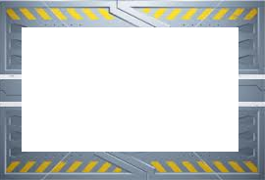
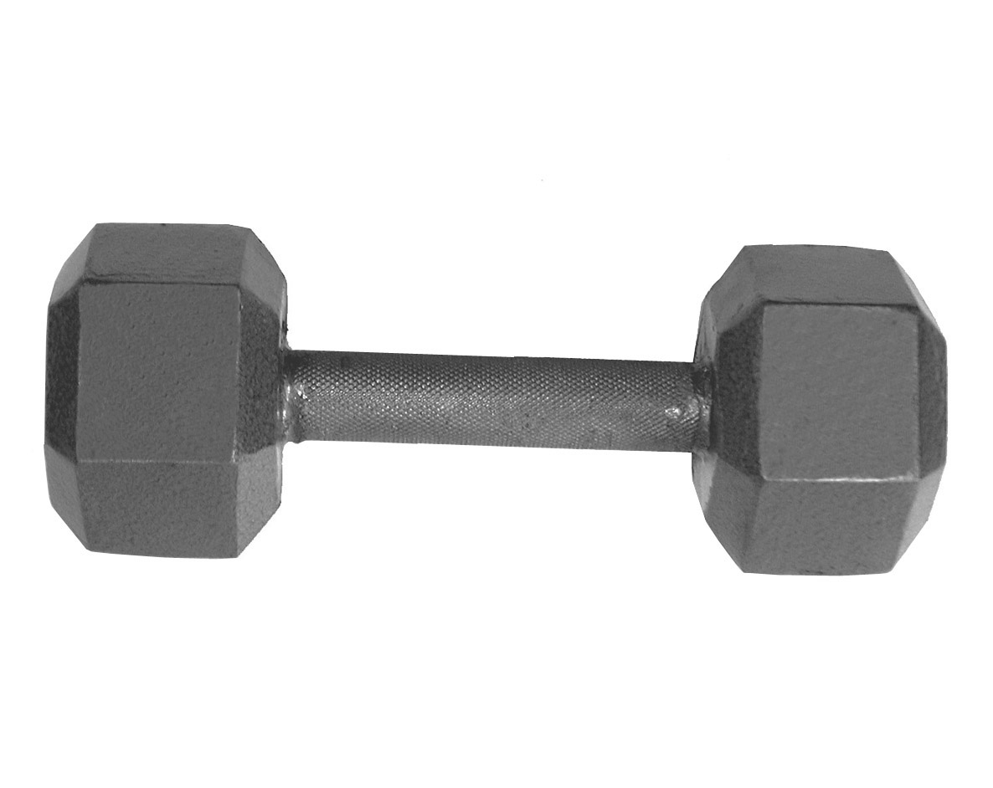
Level two
Level two

17kg
10kg

Level two
Level two
create your
own value
? kg
7 kg

