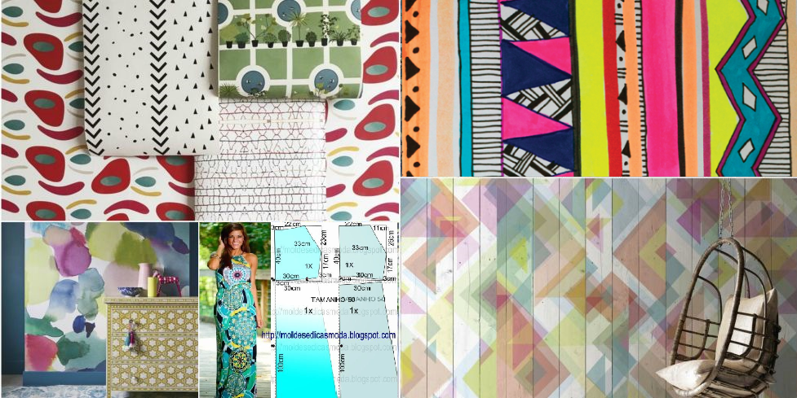
Angles
Tessellation
Shapes
Symmetry

