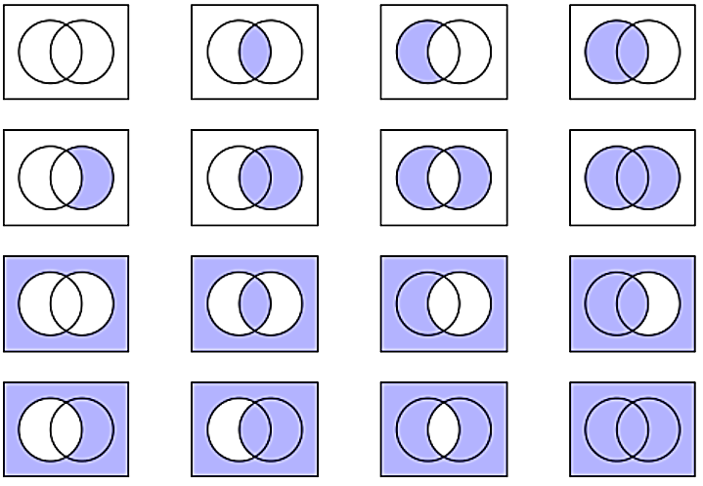
everything outside of the overlap of A and B
Everything not in set A but include things in both set A and B
Everything, except items only in set B
Only items in A or B but not where they overlap
All outside of set A and B but include elements for where A and B join
Nothing form set A
All that is not in A or B
All from set A and B
In set B but not if in set A
only if in both set A and B
In set A but not if in set B
All possible
Nothing from set B
Everything from set B
Everything from set A
not in any set

