
ASSIGNMENT Wk10
GCSE Maths

Preparatory Sheet
Required preparation for the session on……
Congruency, Triangles and Pythagoras Theorem

Aims of this session: Review your abilities in each of these areas, Green (feel confident...G), Amber (need to work more on…A), Red (Feel weaker at this...R)
G A R
- Become familiar with the Pythagoras Theorem and find missing lengths in a right
angled triangle.
- Prove a triangle contains a right angle using the sides given.
- Problem solve questions involving the Pythagoras Theorem
- Recognise a ‘Congruent’ triangle

MOSTLY GREEN MOSTLY AMBER MOSTLY RED

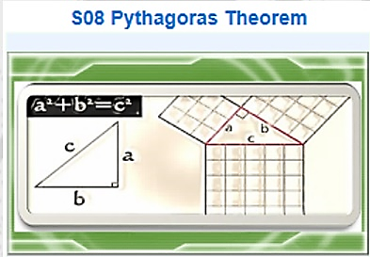

START https://padlet.com/mathsman230774/kfya2f3kkup3
Watch the video/s, read and practice
using the online materials. Read your GCSE maths AQA book

Write a comment about what you learned from the videos / materials below

- Become familiar with the Pythagoras Theorem and find missing lengths in a right angled triangle
Q….Have you heard of the ‘Pythagoras Theory’?? This is a famous theory that is very useful in triangulating positions and helps with communication systems as well as a multitude of other modern applications. Given below is the equation that Pythagoras discovered about the lengths of the sides of right angled triangles. Can you replace the letters ‘a’ and ‘b’ to find the length ‘c’ ? a=3 b=4
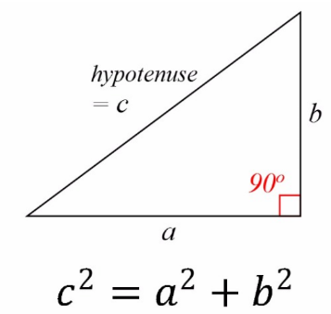
a²+b² = c²

Hint: This is a special case of the Pythagoras triangle where the numbers work out exactly. You should find that the value of ‘c’ is a small whole number. Make sure you take the square root of c² to get the length of ‘c’.

2.

Prove a triangle contains a right angle using the sides given
Q… If the sides of a triangle are given, then using the formula we can find missing sides. But can we also use this formula to CHECK if a triangle is right angled or not? Well if it is right angled then the Pythagoras theory will work and if it is not right angled then the rule that a² + b² is the same as c² will not work. Check for following two examples to see if they are right angled or not.
a=9
b=8
c=12.05
a=2
b=7
c=8.2

? Right angle?

? Right angle?

Hint…Just have to try both of them. Put the values of a and b into the equation. If the ‘c’ value is the same as the one you calculated then the triangle will be right angled, if not it isn’t...simple right!! You’ll need your calculator to take square roots of some values.

3.
Problem solve questions involving the Pythagoras Theorem
Q… In real life and possibly in your exam, you can get problems to solve with triangles and their lengths. You may get questions like the following. Give it a go and see if you can solve. You will need a²+b²=c²
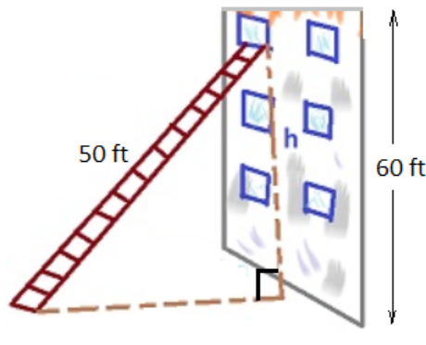
Find how far is the base of the ladder from the wall?

40ft

Hint…For this problem you know the value of ‘c’ and will need to work backwards to find either ‘a’ or ‘b’ depending on how you labelled the triangle. Start with the standard a²+b²=c² and put the values in you know.

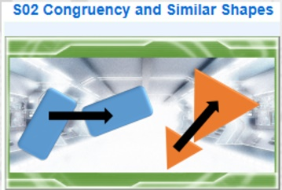
https://padlet.com/mathsman230774/60whix6btt6e
https://padlet.com/mathsman230774/10kyu48pdn3f

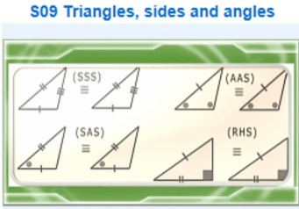
4.
Recognise a ‘Congruent’ triangle

Q… Congruent triangles are those that fit directly on top of another after any kind of moving and rotating etc so that they are exactly the same. The only thing you cannot do to the triangle to get it to be congruent to another is to ‘Enlarge’ it (remember enlarge can mean make smaller too in maths !). Often in questions you will see that the sides of the triangles have been marked with lines to show they are the same length as others. Also if sides are the same and/or angles the same then ‘S’ and ‘A’ can be simply written down to show the similarity of two triangles as ‘SAS’ (eg. both triangles has two sides the same and one angle the same). Tick the pairs of congruent triangles below.

Hint… if it is bigger or smaller its NOT CONGRUENT !! If you need to then measure the size of the lengths and angles.

END OF PREPATORY ASSIGNMENT
What to do now….
- Ensure you have marked in each box if you feel confident in each topic or not (this will inform you and your tutor which activities you should do in the session)
- Bring this yellow assignment with you to your next session and check with your tutor answers given
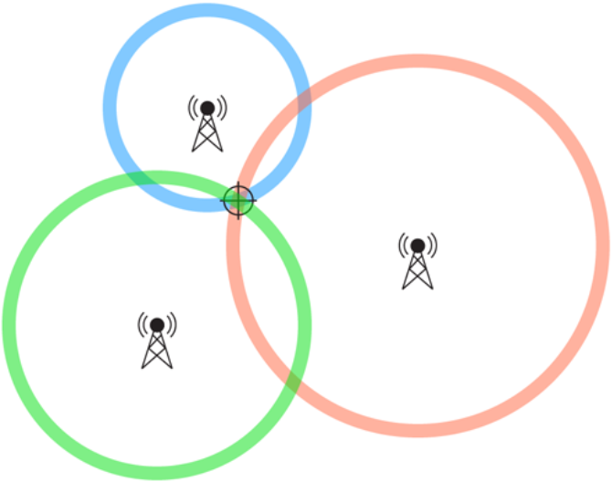
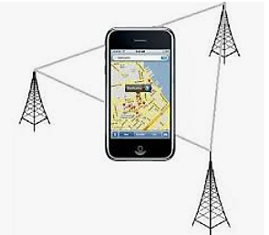
- Add this to your folder of work IN ORDER YELLOW…GREEN… (and any BLUE you achieve)!

