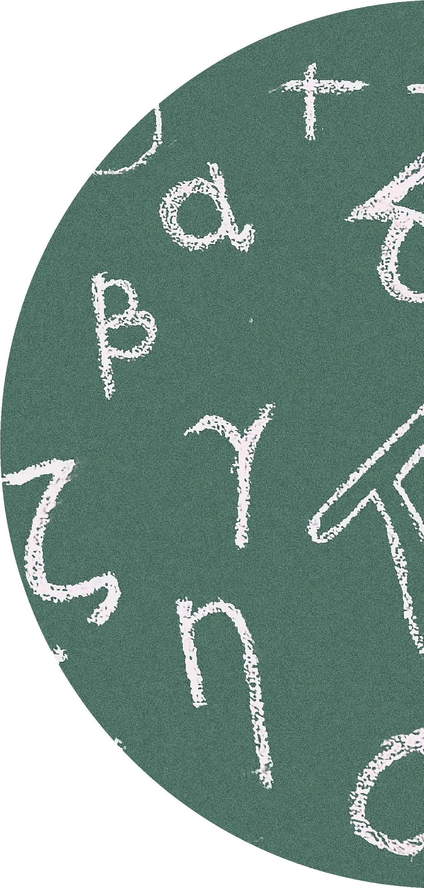

2023/2024
Q
U
E
S
T
I
O
N
S

T
O

G
O

W
I
T
H

Y
O
U
R
L
E
S
S
O
N
S
Functional Skills Level 2
Target Booklet
Name:
Vocational Course:

Contents
Target 3
Number 5
Notes 10
BIDMAS 13
Notes 21
Fractions 24
Notes 37
Formulae 40
Notes 52
Ratio and Proportion 55
Notes 60
Decimals 63
Notes 80
QR Codes 83

Source | Target | Completion (Y/N)

Source | Target | Completion (Y/N)

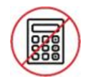
Number
Non calculator

- Put these numbers in order of size starting with the smallest (1)
9303 8481 8999 999 1011

- Writ 1. Write numbers in increasing order starting with the smallest. (1)
10010 11010 10001 11100 11011

- Ireland Wales Scotland England
9223 8029 9301 8803

Put the points scored in order, starting with the lowest (1)

b) Find the difference in points scored between the highest and lowest amounts. (1)
- Write these numbers in order of size. Start with the smallest number.
(1)
a) 9, -4, -7, 2, -5

- Using the information that
42 x 31 = 1302
write down the value of
42 x 62 (1)

- Using the information that
84 x 264 = 22176

write down the value of
8.4 x 26.4 (1)

7. a) Write the number 3804 in words (1)
b) Write the number ‘Ten thousand, two hundred and fifty-one’ in
figures. (1)

8. At a Bath rugby match, there were 13,912 spectators. (1)

Write 13,912 in words

9. Arrange these numbers in order of size, starting with the smallest. (2)
One Billion

Half a million

Six hundred and ten thousand

Ninety-seven thousand

Two million

10. Write these numbers in order of size. Start with the largest number.
(1)
9 -5 1 -13 12

Notes
____________________________________________________________________________________________________________________________________________________________________________________________________________________________________________________________________________________________________________________________________________________________________________________________________________________________________________________________________________________________________________________________________________________________________________________________________________________________________________________________________________________________________________________________________________________________________________________________________________________________________________________________________________________________________________________________________________________________________________________________________________________________________________________________________________________________________________________________________________________________________________________________________________________________________________________________________________________________________________________________________________________________________________________________________________________________________________________________________________________________________________________________________________________________________________________________________________________________________________________________________________________________________________________________________________________________________________________________________________________________________________________________________________________________________________________________________________________________________________________________________________________________________________________________________________________________________________________________________________________________________________________________________________________________________________________________________________________________________________________________________________________________________________________________________________________________________________________________________________________________________________________________________________________________________________________________________________________________________________________________________________________________________________________________________________________________________________________________________________________________________________________________________________________________________________________________________________________________________________________________________________________________________________________________________________________________________________________________________________________________________________________________________________________________________________________________________________________________________________________________________________________________________________________________________________________________________________________________________________________________________________________________________________________________________________________________________________________________________________________________________________________________________________________________________________________________________________________________________________________________________________________________________________________________________________________________________

BIDMAS
Non- Calculator
- a) Calculate 16 – 5 x 2
Write your answer in the box below. (1)
b) 10 – 3²
Write your answer in the box below. (1)
c) 5 x (2 + 3)
Write your answer in the box below. (1)

2. a) Calculate 10 + 3 x 2
Write your answer in the box below. (1)
b) 8 ÷ 2 + 12 ÷ 4
Write your answer in the box below. (1)
c) 3 x 10 ÷ 5 – 1
Write your answer in the box below. (1)

3. a) Calculate 6 + 6 ÷ 3
Write your answer in the box below. (1)
b) 8 + 3(5 – 1)
Write your answer in the box below. (1)
- 9 x 2 + 20 ÷ 2
Write your answer in the box below. (1)

4. Put brackets in the following statements to make them true.

- 6 x 7 + 3 – 8 = 52 (1)

- 4 + 3 x 7 – 1 = 42 (1)

5. a) Work out 14 + 12 ÷ 2
Write your answer in the box below. (1)

6. a) Work out 2³ + 3²
Write your answer in the box below. (1)

b) Work out 6 x 4 – 7 x 3
Write your answer in the box below. (1)

b) 2² x 3³
Write your answer in the box below. (2)
7. Work out (2 + 5)² (1)
Write your answer in the box below

8. a) Work out (9 + 4) x (100 ÷ 25)
Write your answer in the box below. (1)
- 5 + 3 x 6
Write your answer in the box below. (1)

- 30 – 5 x 2
Write your answer in the box below. (1)

9. Joey thinks the answer to 16 + 4 x 2 is 40.
Albert thinks the answer to 16 + 4 x 2 is 24.
Who is correct?
Explain your answer in the box below. (2)

10. a) Work out 4 x (3 + 17)
Write your answer in the box below. (1)

- 22 – 14 ÷ 2

Write your answer in the box below. (1)
- 10 – 2 x 5
Write your answer in the box below. (1)

Notes

________________________________________________________________________________________________________________________________________________________________________________________________________________________________________________________________________________________________________________________________________________________________________________________________________________________________________________________________________________________________________________________________________________________________________________________________________________________________________________________________________________________________________________________________________________________________________________________________________________________________________________________________________________________________________________________________________________________________________________________________________________________________________________________________________________________________________________________________________________________________________________________________________________________________________________________________________________________________________________________________________________________________________________________________________________________________________________________________________________________________________________________________________________________________________________________________________________________________________________________________________________________________________________________________________________________________________________________________________________________________________________________________________________________________________________________________________________________________________________________________________________________________________________________________________________________________________________________________________________________________________________________________________________________________________________________________________________________________________________________________________________________________________________________________________________________________________________________________________________________________________________________________________________________________________________________________________________________________________________________________________________________________________________________________________________________________________________________________________________________________________________________________________________________________________________________________________________________________________________________________________________________________________________________________________________________________________________________________________________________________________________________________________________________________________________________________________________________________________________________________________________________________________________________________________________________________________________________________________________________________________________________________________________________________________________________________________________________________________________________________

Fractions
- Write down the largest of these fractions.
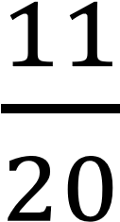

Show your working and write your answer in the box below. (2)

2. Write these fractions in order of size
Start with the smallest number.
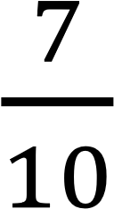

Show your working and write your answer in the box below. (2)

- Arrange these fractions in order, smallest first.
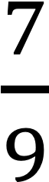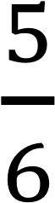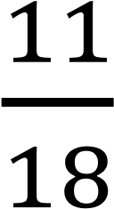

Show your working and write your answer in the box below. (2)

- A football team wins 3/8 of their matches in a season.
The same team loses 1/3 of their matches.
Show that the team win more matches than they lose in the box below. (2)

- Work out, as a simplified fraction.
$\frac{3}{4}$ - $\frac{2}{5}$

Show your working and write your answer in the box below. (2)

6. Work out, as a mixed number

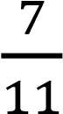 + 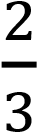

Show your working and write your answer in the box below. (2)

7. _{Work out} 1 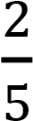 + 2 

Give your answer as a mixed number.

Show your working and write your answer in the box below. (3)

,

8. Work out 4 $\frac{1}{3}$ - 3 $\frac{4}{9}$
Give your answer as a fraction.
Show your working and write your answer in the box below. (3)

- Matthew is training for a race.
He runs 3 days in one week.

Matthew runs 1 miles on Monday.

Then he runs 1 miles on Thursday.

Finally, he runs 2 miles on Sunday.

Work out how far Matthew ran in total.
Show your working and write your answer in the box below (3)

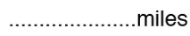
10. Out of 500 people, 100 wear glasses.
Write the number of people who do not wear glasses as a fraction of the total number of people.
Give your answer in its simplest form.

Show your working and write your answer in the box below. (2)
- There are 400 pupils in a primary school.

Of the 400 pupils, 88 play a musical instrument.

Express the number of pupils who play a musical instrument as a fraction of the 400 pupils.
Give your answer in its simplest form.
Show your working and write your answer in the box below. (2)

- Express 50p as a fraction of £4.
Give your answer in its simplest form.
Show your working and write your answer in the box below. (2)

- Express 50p as a fraction of £4.
Give your answer in its simplest form.
Show your working and write your answer in the box below. (2)

14. In a bag there are 80 beads
There are 35 yellow beads.
There are 17 red beads.
The rest of the beads are white.
Work out what fraction of the beads are white.
Give your answer in its simplest form.
Show your working and write your answer in the box below. (2)

Notes
________________________________________________________________________________________________________________________________________________________________________________________________________________________________________________________________________________________________________________________________________________________________________________________________________________________________________________________________________________________________________________________________________________________________________________________________________________________________________________________________________________________________________________________________________________________________________________________________________________________________________________________________________________________________________________________________________________________________________________________________________________________________________________________________________________________________________________________________________________________________________________________________________________________________________________________________________________________________________________________________________________________________________________________________________________________________________________________________________________________________________________________________________________________________________________________________________________________________________________________________________________________________________________________________________________________________________________________________________________________________________________________________________________________________________________________________________________________________________________________________________________________________________________________________________________________________________________________________________________________________________________________________________________________________________________________________________________________________________________________________________________________________________________________________________________________________________________________________________________________________________________________________________________________________________________________________________________________________________________________________________________________________________________________________________________________________________________________________________________________________________________________________________________________________________________________________________________________________________________________________________________________________________________________________________________________________________________________________________________________________________________________________________________________________________________________________________________________________________________________________________________________________________________________________________________________________________________________________________________________________________________________________________________________________________________________________________________________________________________________________________________________________________________________________________________________________________________________________
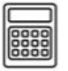

Formulae
- Leo is an artist.
He needs to produce a painting for the opening of a new housing estate.
Leo is going to construct a symmetrical canvas for his painting. He makes a sketch of the frame for the canvas.
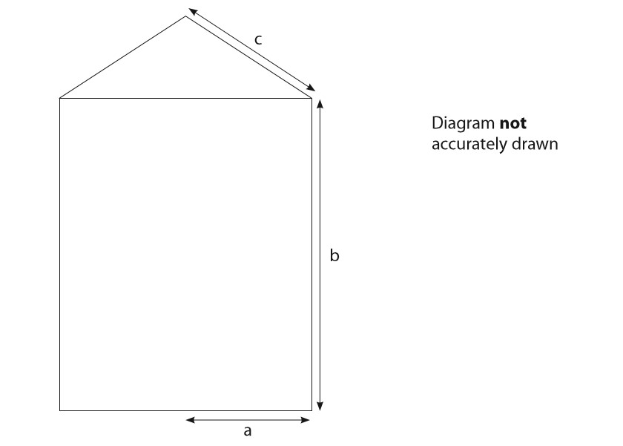
Leo uses this formula to work out the total length, L mm, of the wood he needs for the frame.
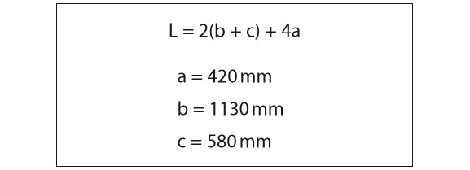
He has a 4.8m length of wood for the frame.
Is 4.8m enough wood for the frame?
Show why you think this. (4)

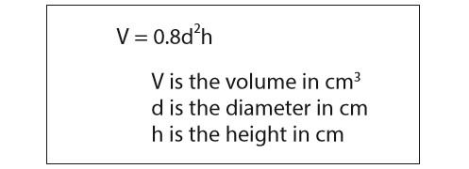
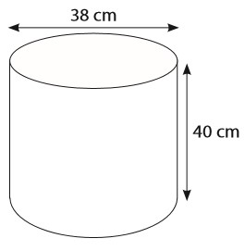
- Jane plans to make some improvements to her garden.
She has a plant pot in the shape of a cylinder. The pot has diameter 38cm and height 40cm.
Jane wants to completely fill the pot with compost. Compost is sold in 20 litre bags.
Jane uses this formula for the volume of the cylinder.

1 litre = 1000cm³
Jane thinks she needs 2 bags of compost to completely fill the pot.
Are 2 bags of compost enough to fill the pot?
Show a check of your working. (5)

- Amir visits the gym.

He wants to find out his Body Mass Index (BMI).
Amir uses this formula to work out his BMI.
BMI = $\frac{M}{H²}$
where M is mass (kg), H is height (m)
Amir has mass 83.3kg and height 1.75m.
A healthy BMI is between 18.5 and 25.0
Does Amir have a healthy BMI?
Show why you think this. (3)

- Freya wants to compare food storage methods between the UK and the USA.
She compares the temperature at which frozen meals are stored in the UK with the temperature at which they are stored in the USA.
Temperature is measured in degrees Fahrenheit in the USA.
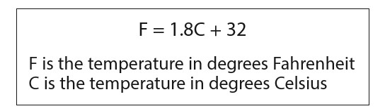
Freya knows this formula.

Frozen meals are stored at −20℃ in the UK.
Convert −20℃ to degrees Fahrenheit.

Show a check of your working. (3)

- Companies can rent the units in the commercial centre for 3, 6 or 12 months.

Jill has this data about the units rented in 2016
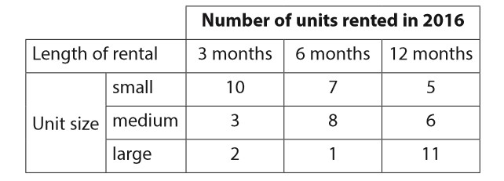
Jill needs to work out the yearly rental rate for the large units in 2016 She uses this formula
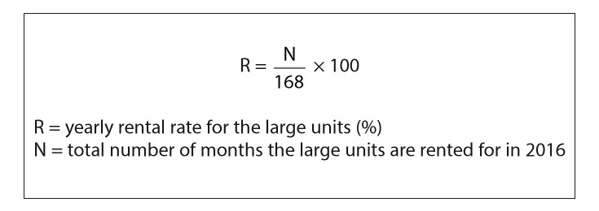
Jill thinks the yearly rental rate for the large units in 2016 was more than 85%.
Is Jill correct?
Show why you think this. (3)

- Barney has a gas oven.

He sets the temperature of the oven by using gas marks.
Barney uses this formula to convert 180℃ to the gas mark required.
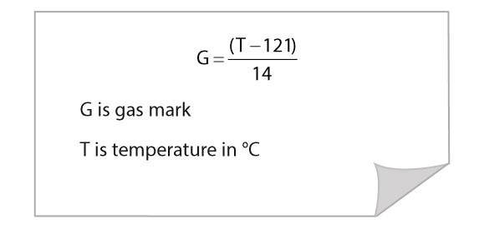
Barney thinks gas mark 6 is the same as 180℃.
Is Barney correct?
Show why you think this. (2)

- Manraj works as a lifeguard at the pool.
The manager at the pool uses this formula to work out the total pay for Manraj.
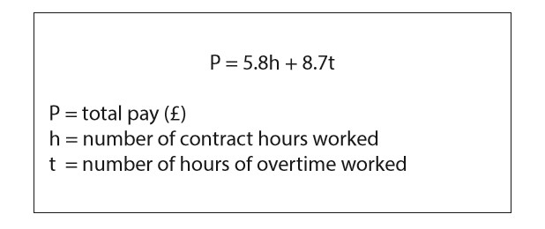
Manraj works at the pool for 112 contract hours and 28 hours of overtime in
July.
He always puts 1/3 of his total pay in a savings account each month.
Manraj thinks he needs to put over £300 of his total pay in his savings account in July.
Is Manraj correct?
Show why you think this. (4)

- Tomas has built a raised flower bed in his garden.
He is going to fill the flower bed with compost.

Tomas uses this formula to work out the amount of compost he needs to fill the flower bed.
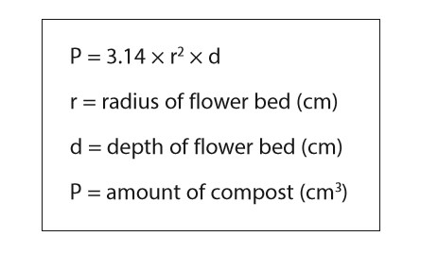
The flower bed has
  - radius 80cm
  - depth 28cm.
He sees this special offer.
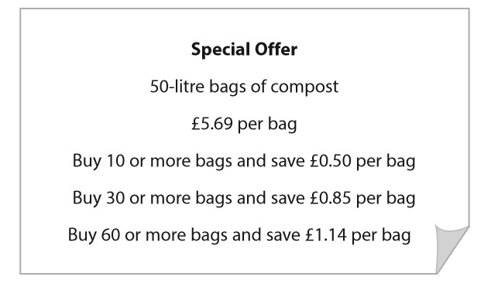
Tomas knows that 1 litre = 1000cm³.
Work out how much it will cost Tomas to buy all the bags of compost he needs. (6)

Notes
________________________________________________________________________________________________________________________________________________________________________________________________________________________________________________________________________________________________________________________________________________________________________________________________________________________________________________________________________________________________________________________________________________________________________________________________________________________________________________________________________________________________________________________________________________________________________________________________________________________________________________________________________________________________________________________________________________________________________________________________________________________________________________________________________________________________________________________________________________________________________________________________________________________________________________________________________________________________________________________________________________________________________________________________________________________________________________________________________________________________________________________________________________________________________________________________________________________________________________________________________________________________________________________________________________________________________________________________________________________________________________________________________________________________________________________________________________________________________________________________________________________________________________________________________________________________________________________________________________________________________________________________________________________________________________________________________________________________________________________________________________________________________________________________________________________________________________________________________________________________________________________________________________________________________________________________________________________
____________________________________________________________________________________________________________________________________________________________________________________________________________________________________________________________________________________________________________________________________________________________________________________________________________________________________________________________________________________________________________________________________________________________________________________________________________________________________________________________________________________________________________________________________________________________________________________________________________________________________________________________________________________________________________________________________________________________________________________________________________________________________________________________________________________________________________________________________________________________________________________________________________________________________________________________________________________________________________

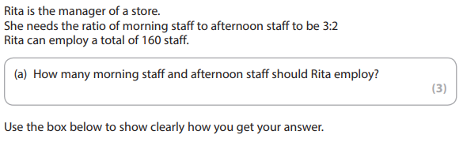
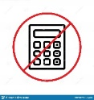
Ratio and Proportion
1.
Non calculator questions

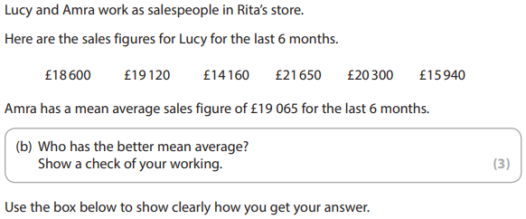

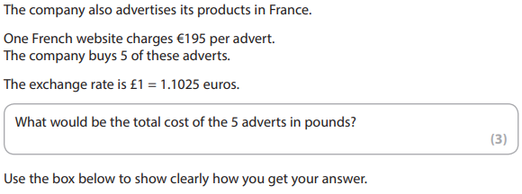
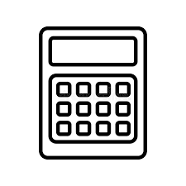
2.
Calculator questions

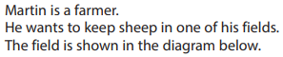
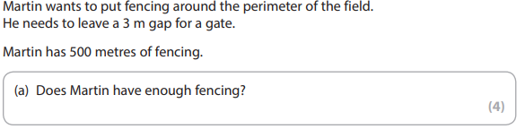
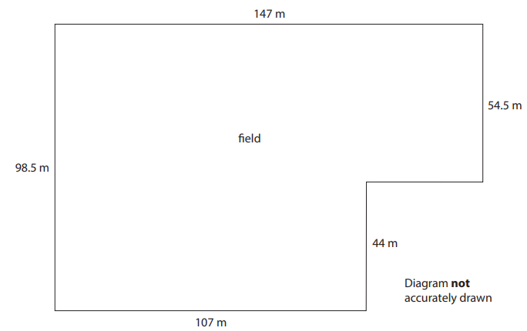
3.

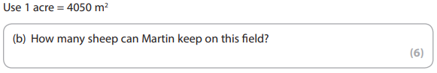
b)

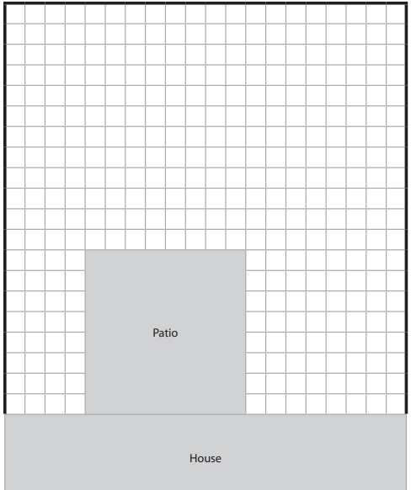
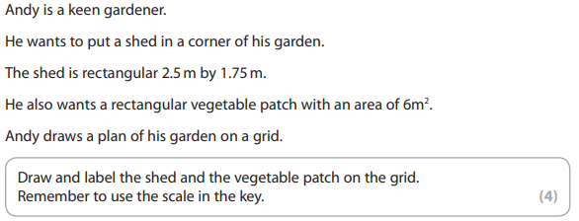
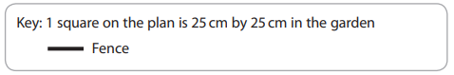
4.

Notes
_______________________________________________________________________________________________________________________________________________________________________________________________________________________________________________________________________________________________________________________________________________________________________________________________________________________________________________________________________________________________________________________________________________________________________________________________________________________________________________________________________________________________________________________________________________________________________________________________________________________________________________________________________________________________________________________________________________________________________________________________________________________________________________________________________________________________________________________________________________________________________________________________________________________________________________________________________________________________________________________________________________________________________________________________________________________________________________________________________________________________________________________________________________________________________________________________________________________________________________________________________________________________________________________________________________________________________________________________________________________________________________________________________________________________________________________________________________________________________________________________________________________________________________________________________________________________________________________________________________________________________________________________________________________________________________________________________________________________________________________________________________________________________________________________________________________________________________________________________________________________________________________________________________________________________________________________________________________________________________________________________________________________________________________________________________________________________________________________________________________________________________________________________________________________________________________________________________________________________________________________________________________________________________________________________________________________________________________________________________________________________________________________________________________________________________________________________________________________________________________________________________________________________________________________________________________________________________________________________________________________________________________________________________________________________________________________________________________________________________________________________________________________________________________________________________________________________________________________________________________________________________________________________________________________________________________________

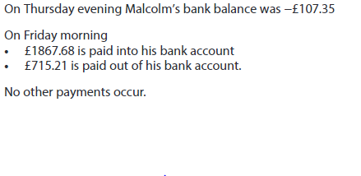
Decimals
1)
Non Calculator questions
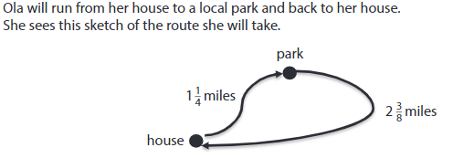
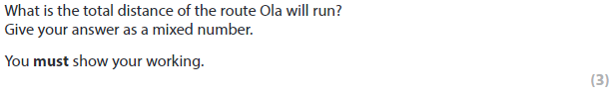
2.
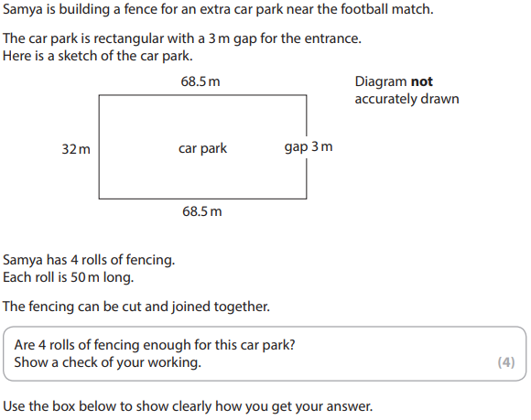
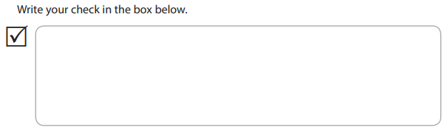
1.
Calculator questions

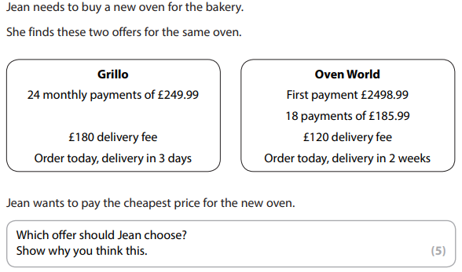
2.

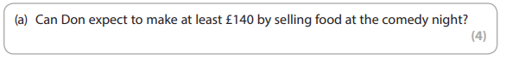
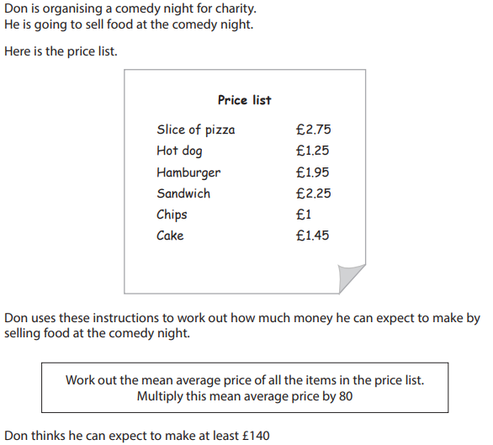
3.

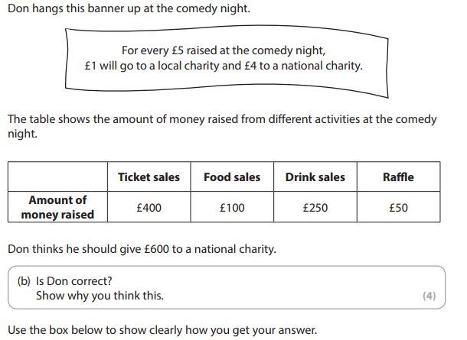

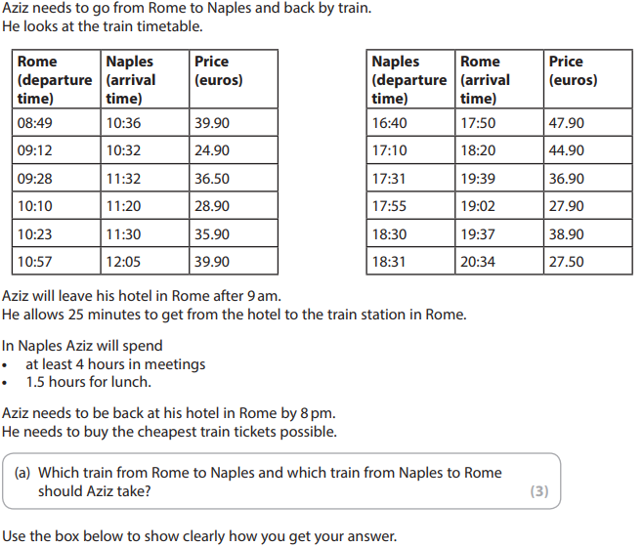
4.

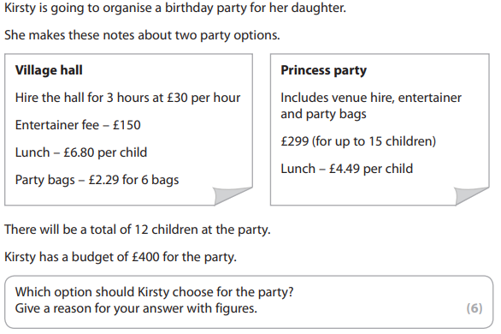
5.

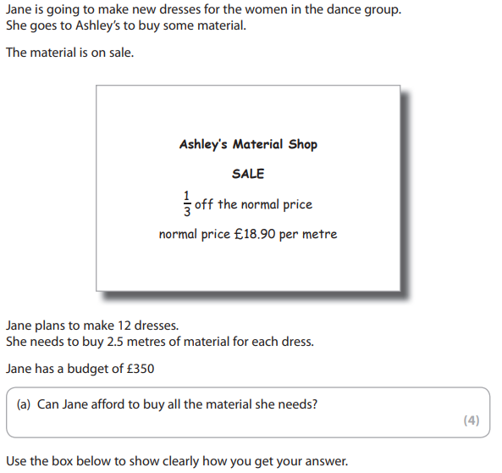
6.

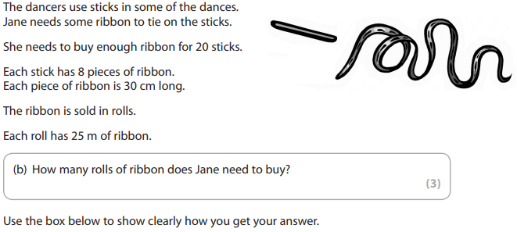
7.

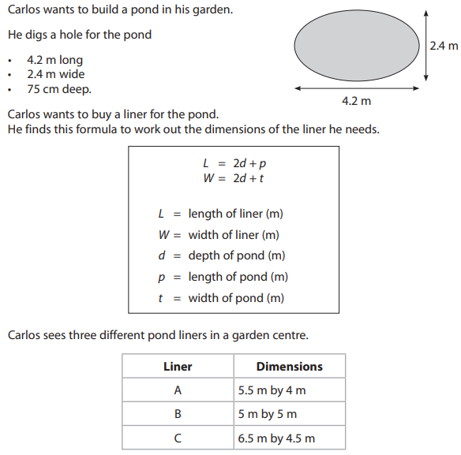
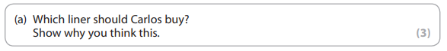
8.
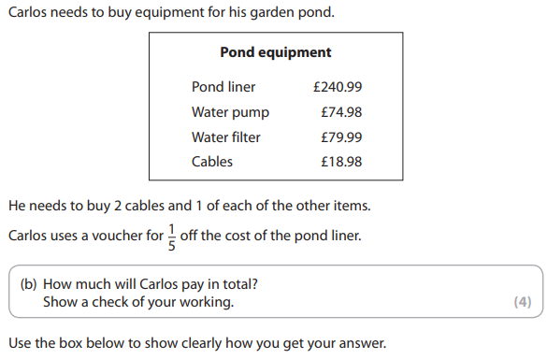

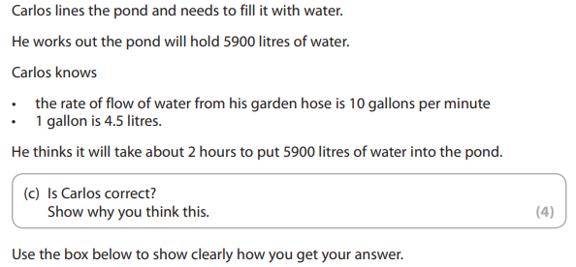

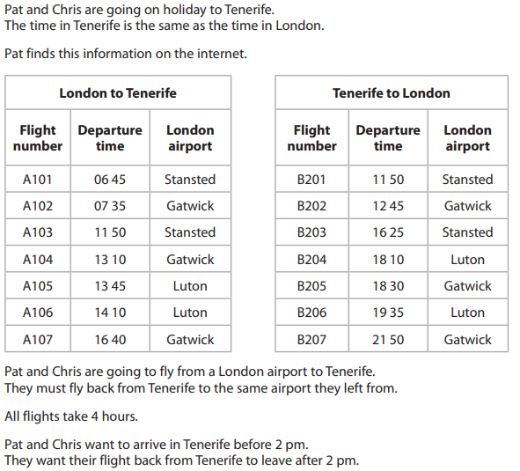
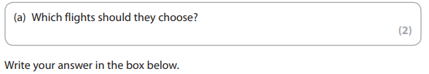
9.

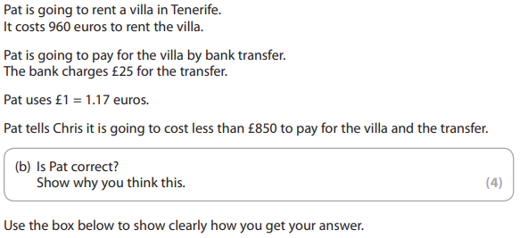

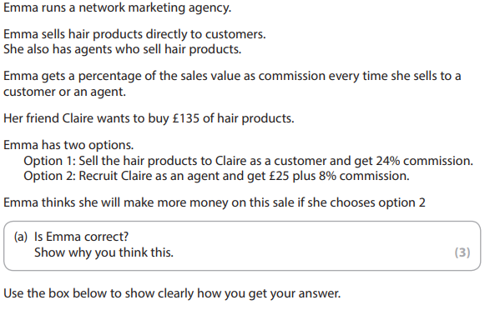
10.

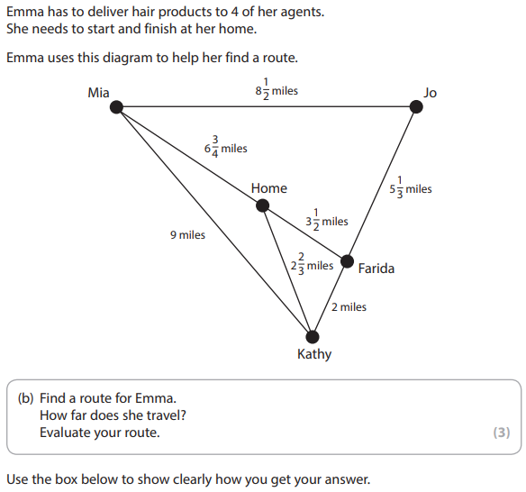

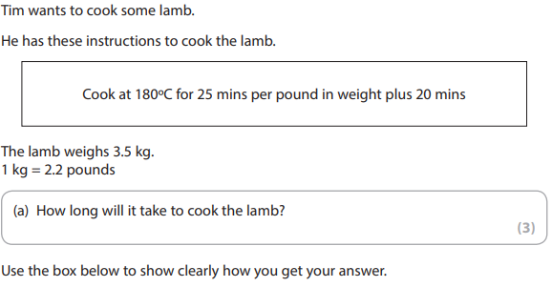
11.

Notes
________________________________________________________________________________________________________________________________________________________________________________________________________________________________________________________________________________________________________________________________________________________________________________________________________________________________________________________________________________________________________________________________________________________________________________________________________________________________________________________________________________________________________________________________________________________________________________________________________________________________________________________________________________________________________________________________________________________________________________________________________________________________________________________________________________________________________________________________________________________________________________________________________________________________________________________________________________________________________________________________________________________________________________________________________________________________________________________________________________________________________________________________________________________________________________________________________________________________________________________________________________________________________________________________________________________________________________________________________________________________________________________________________________________________________________________________________________________________________________________________________________________________________________________________________________________________________________________________________________________________________________________________________________________________________________________________________________________________________________________________________________________________________________________________________________________________________________________________________________________________________________________________________________________________________________________________________________________________________________________________________________________________________________________________________________________________________________________________________________________________________________________________________________________________________________________________________________________________________________________________________________________________________________________________________________________________________________________________________________________________________________________________________________________________________________________________________________________________________________________________________________________________________________________________________________________________________________________________________________________________________________________________________________________________________________________________________________________________________________________________________________________________________________________________________________________________________________________________________________________________________________________________________________________________________________________________________________________________________________________________

QR Codes




Addition & Subtraction
Multiply & Division
Negative Numbers
Rounding





Estimating
Powers & Roots
BIDMAS
Fraction of an amount





FDP Conversion
Ratio Basics
Proportion
Proportion

