Transformations of Graphs - Translations
Name : | Class : | Date :

Mark : | /12 | %

1) The graph of $y=f(x)$ where $f(x)=2x^{2}$ is shown below. Identify which of the following graphs represents a sketch of $f(x+3)$. | [1]
  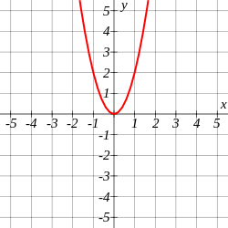
     | A: | 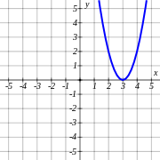 | B: | 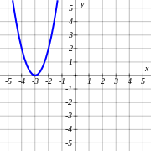
     | C: | 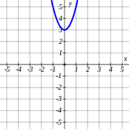 | D: | 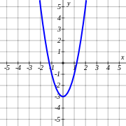
2) The graph of $y=f(x)$ where $f(x)=x^{2}+3$ is shown below. Identify which of the following graphs represents a sketch of $f(x+1)$. | [1]
  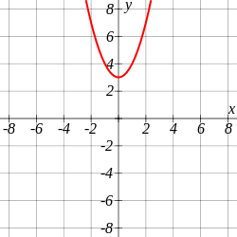
     | A: | 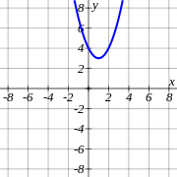 | B: | 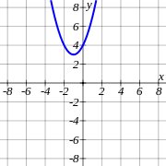
     | C: | 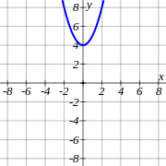 | D: | 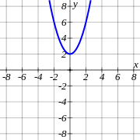
3) The graph of $y=f(x)$ where $f(x)=x^{2}-2$ is shown below. On the other grid, draw the graph of $f(x-1)$. | [1]
   | 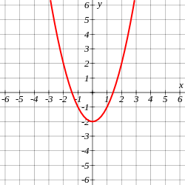 |  | 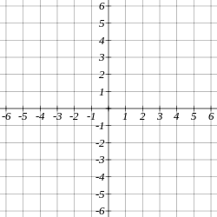
4) The graph of $y=f(x)$ where $f(x)=-x^{2}$ is shown below. Identify which of the following graphs represents a sketch of $f(x)+2$. | [1]
  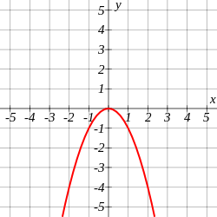
     | A: | 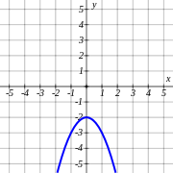 | B: | 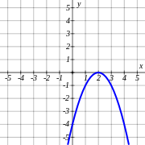
     | C: | 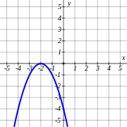 | D: | 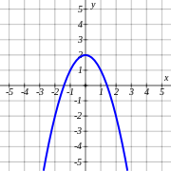
5) The graph of $y=f(x)$ where $f(x)=-2x^{2}+2$ is shown below. Identify which of the following graphs represents a sketch of $f(x)+1$. | [1]
  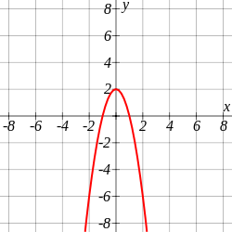
     | A: | 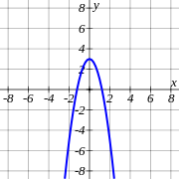 | B: | 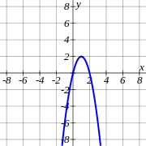
     | C: | 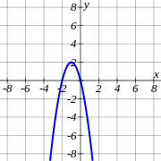 | D: | 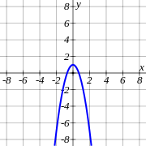
6) The graph of $y=f(x)$ where $f(x)=2x^{2}-3$ is shown below. On the other grid, draw the graph of $f(x)-1$. | [1]
  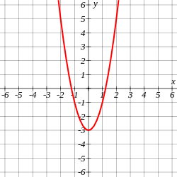
7) The graph of $y=f(x)$ where $f(x)=2x^{2}$ is shown below. Identify which of the following graphs represents a sketch of $f(2x)$. | [1]
   | A: | 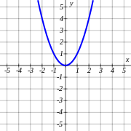 | B: | 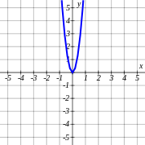
   | C: | 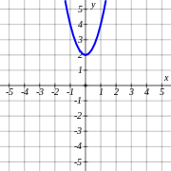 | D: | 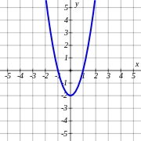
8) The graph of $y=f(x)$ where $f(x)=-2x^{2}+1$ is shown below. Identify which of the following graphs represents a sketch of $f(2x)$. | [1]
  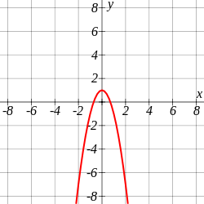
     | A: | 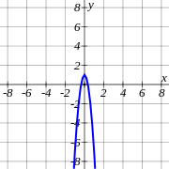 | B: | 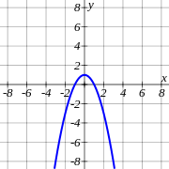
     | C: |  | D: | 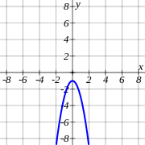
9) The graph of $y=f(x)$ where $f(x)=x^{2}-2$ is shown below. On the other grid, draw the graph of $f(3x)$. | [1]
10) The graph of $y=f(x)$ where $f(x)=2x^{2}$ is shown below. Identify which of the following graphs represents a sketch of $-3f(x)$. | [1]
   | A: | 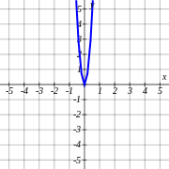 | B: | 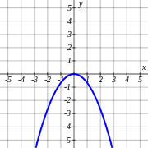
   | C: |  | D: | 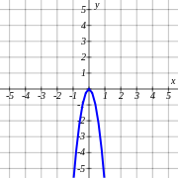
11) The graph of $y=f(x)$ where $f(x)=x^{2}-3$ is shown below. Identify which of the following graphs represents a sketch of $3f(x)$. | [1]
  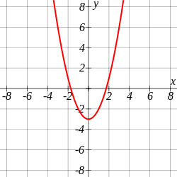
     | A: | 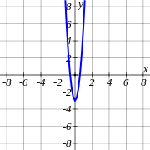 | B: | 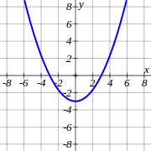
     | C: | 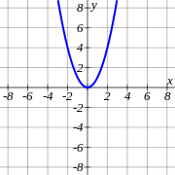 | D: | 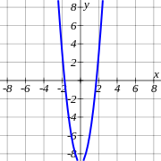
12) The graph of $y=f(x)$ where $f(x)=-x^{2}+3$ is shown below. On the other grid, draw the graph of $-2f(x)$. | [1]
  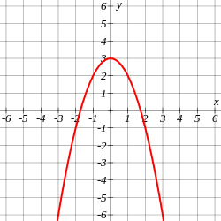
Solutions for the assessment Transformations of Graphs - Translations
1) $B$ | 2) $B$
3)
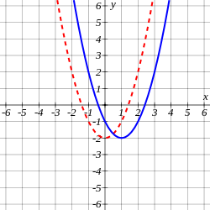

4) $D$ | 5) $A$
6)
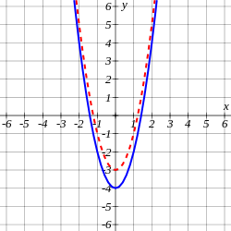

7) $B$ | 8) $A$
9)
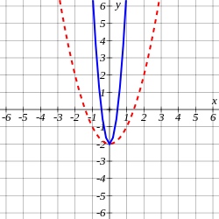

10) $D$ | 11) $D$
12)
