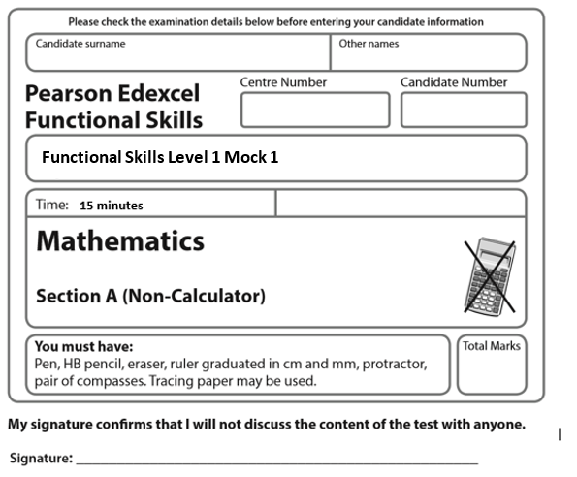
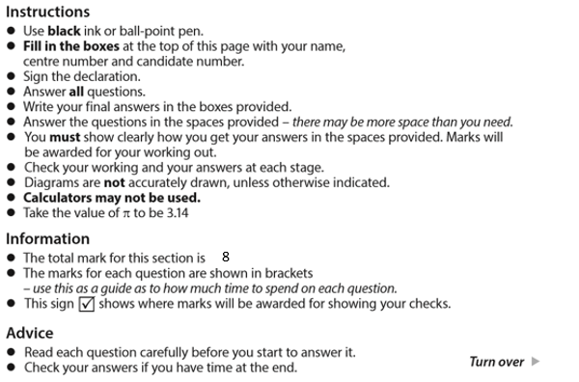

April Mock

1
- Calculate 12² (1)

b) Work out 80 – 6 x 2 (1)

C ) Work out -18 – 14 (1)

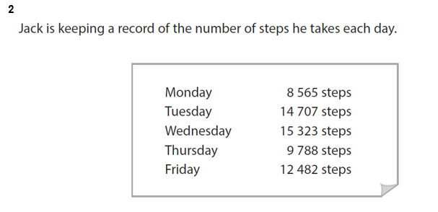
Work out the range of the number of steps. (2)
Steps

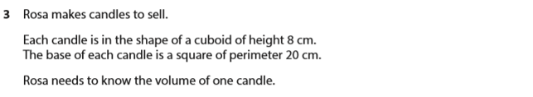
Work out the volume of one candle. (3)
Remember to give units with your answer.

