



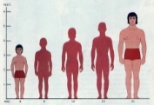
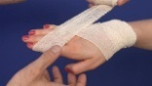
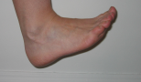
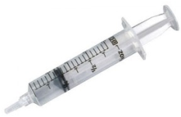
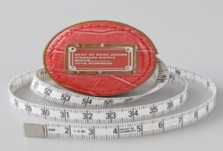

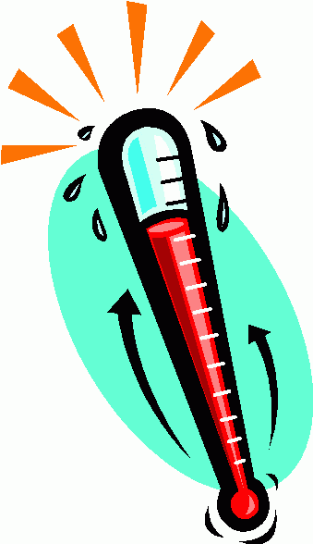
Check your phone?
Measure out. Write out in order of size
Order, smallest to largest
Measure your hand
Measure your foot
Measure your height
m cm
bpm=???
Room
Temp
Body
temp
Outside
temp
0.048kg
1600 g
750 g
0.075 g
2 kg
0.006kg
5 g
5000mg
2000 g
0.2 kg
6 g
0.75 kg
48g
75 mg
1.6 kg
200g
Medical Record Card – Entry 3
Measure weights
A) 15ml …..
B) 750ml ….
C) 1.5 l ….
D) 200ml ….
E) 0.5 l ….
F) 0.1 l ….
G) 975 ml ….

cm mm
Measure liquids
: person
count
Measure lengths
Take a temperature
Take a pulse rate

