
L1
L1
Manufacture:
sheets of plastic, 27cm by 20cm
How many can you make from 3mx2m sheet of plastic?
Manufacture:
a metal tin 15cm long, width 6cm
How many can you make from 1m² sheet of metal?

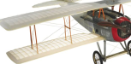
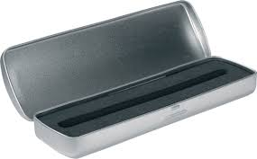
L1
L1
Manufacture:
cereal boxes from card, 30x5x10 cm
How many can you make from 3m² sheet of card?
Manufacture:
plastic rulers, 30cm long, 5cm wide
How many can you make from an A3 sheet of plastic?

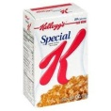
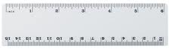
L1
L1
Manufacture:
a 1m² of paper

How 1m² will fit along one of the walls in this room?
Design:
a wall paper pattern of squares and rectangles
How many patterns fit on an A4 sheet of paper?

