M E A N
Don’t be mean! Be fair… divide the sweets up properly
Add the sweets back up
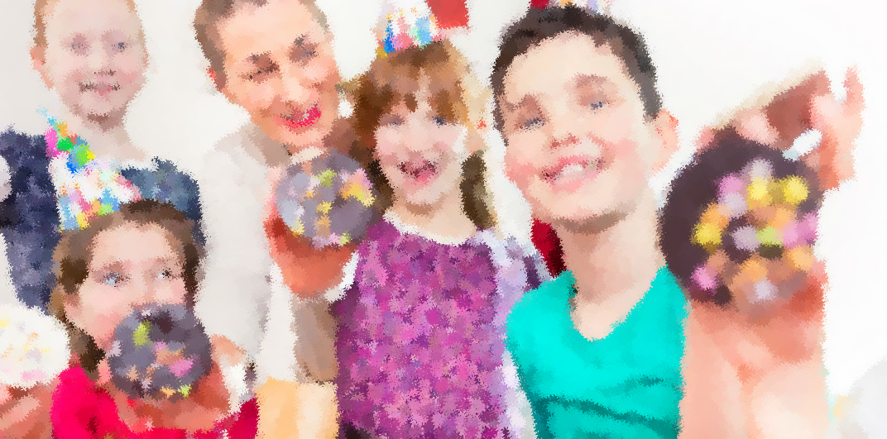
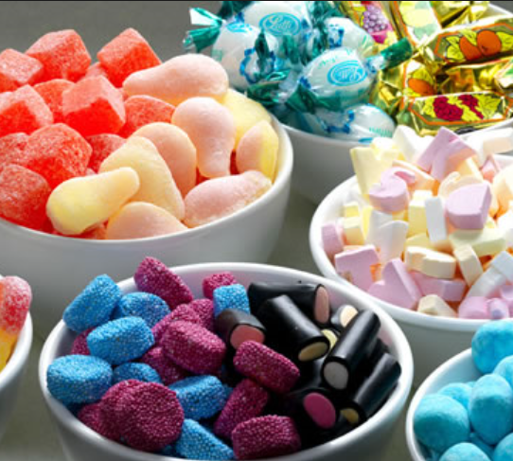
Divide them evenly between the children, this is the mean number of sweets

