Mark Scheme
- Corbettmaths – Ordering Fractions
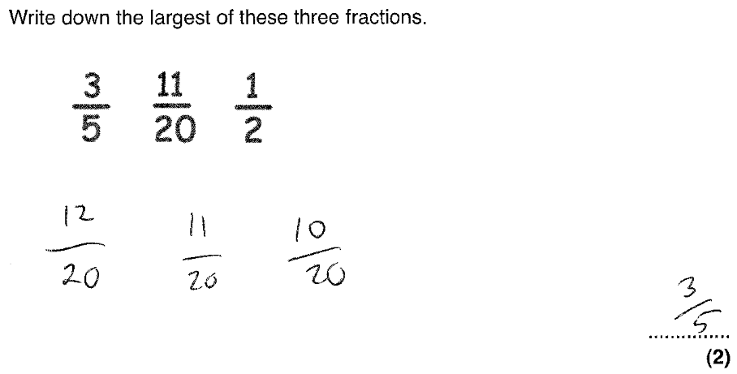
- Corbettmaths – Ordering Fractions
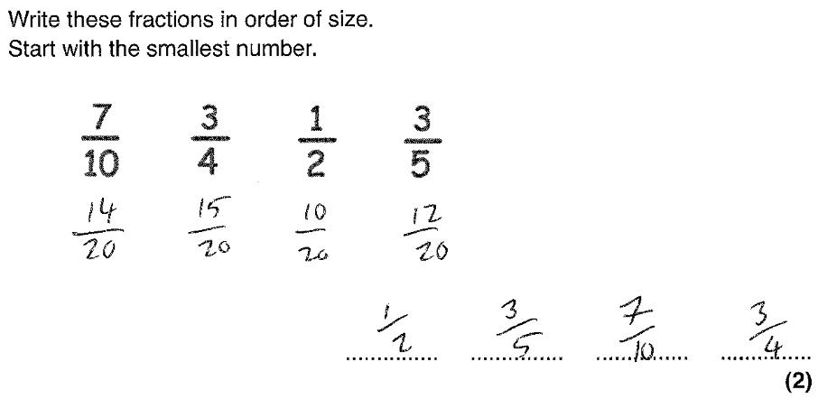

- Corbettmaths – Ordering Fractions
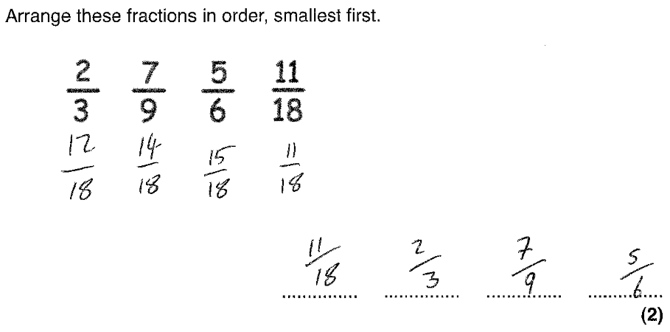
- Corbettmaths – Ordering Fractions
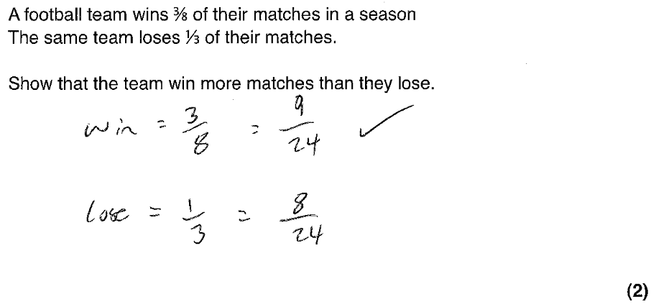
- Corbettmaths – Adding (and Subtracting) Fractions
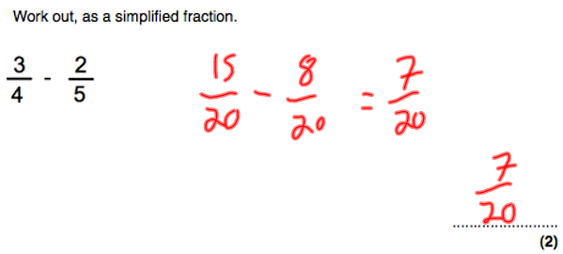

- Corbettmaths – Adding (and Subtracting) Fractions
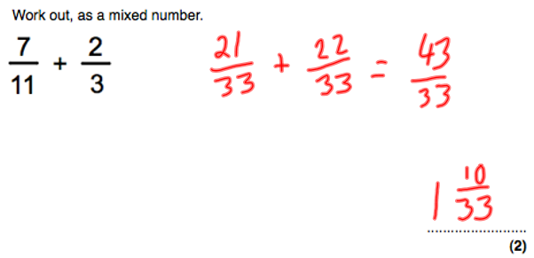
- Corbettmaths – Adding (and Subtracting) Fractions
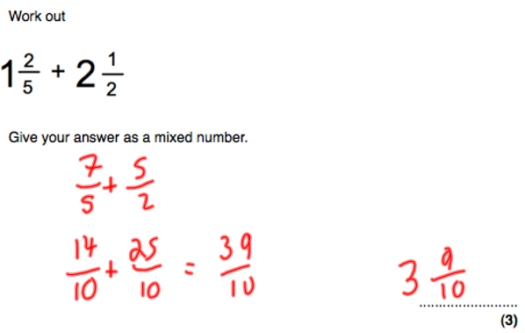
- Corbettmaths – Adding (and Subtracting) Fractions
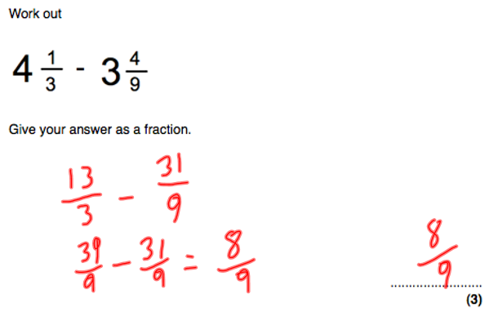
- Corbettmaths – Adding (and Subtracting) Fractions
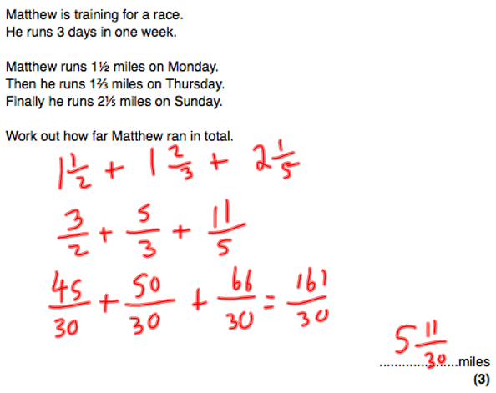
- Corbettmaths – Expressing as a Fraction
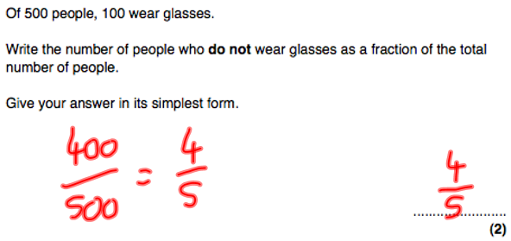
- Corbettmaths – Expressing as a Fraction
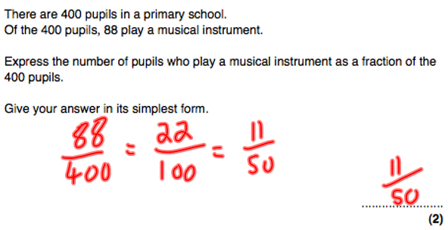
- Corbettmaths – Expressing as a Fraction
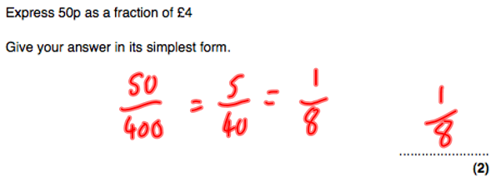
- Corbettmaths – Expressing as a Fraction
