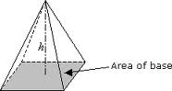
V=
V=
V=
V=
V=
V=
PYRAMIDS V= 1/3 Base H
L2

