Entry Level Course Budgeting –
Income Expenses and Numbers

MK Council
MK College

2023/24

Entry Level (Entry 3)

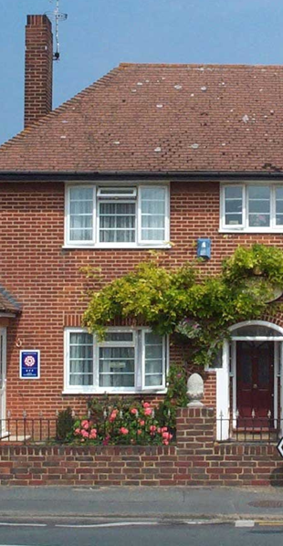
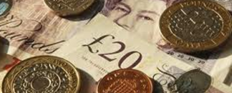
Name

Student Name

I confirm that the evidence listed above is my own work and was carried out under the conditions and context specified in the standards.

Candidate name.................................................... Signature ...................................................... Date .....................

Assessor’s name.................................................. Signature ...................................................... Date .....................

Internal Verifier’s name......................................... Signature ...................................................... Date ..................
(only if sampled)

Course Evaluation

Have you enjoyed the course? Yes No

What was your favourite part of the course?

____________________________________________________

What was your least favourite part of the course?

____________________________________________________

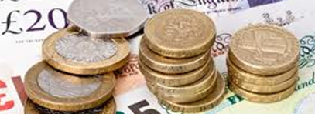

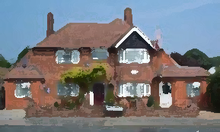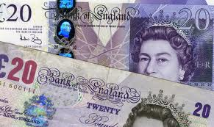

ACTIVITY 1 – Monthly bills

Make a list below of ten common MONTHLY household bills

ACTIVITY 2 – When to pay 1

For each expense, write a capital ‘M’ for monthly bill or ‘Y’ for yearly bill. If you think they could be paid either way put ‘E’ !
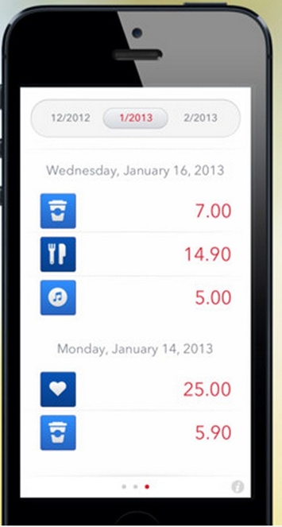
Vision Express

Car insurance

House insurance

Boiler Service

Annual football
membership

Xmas presents

Car tax disc

Electricity

Gym membership

ACTIVITY 3 – When to pay 2

State a reason why you might want to pay a bill only once per year.

State a reason why it might be good to pay a bill in monthly instalments

ACTIVITY 4 – Monthly bills

Identify each bill below as either a common MONTHLY bill or an expense that could be paid at any time. Circle the MONTHLY bills.

Shopping Petrol

Train ticket

Gas

Pizza

Car Insurance

Loan repayment

Clothing

Meal out

Prescription

Computer game

Council tax

Water
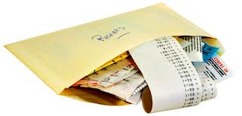



ACTIVITY 5 – being regular!

Identify the REGULAR EXPENSES by ticking those statements. Cross the statements that do not show regular expenses.

- I pay a vet bill of £65 to treat my sick dog

- I save each month towards a trip to a theme park in the summer

- I set up a direct debit to pay my electric bill

- I use a voucher to pay for a subway meal

- My brother gives me £10 each week to pay back some money he borrowed
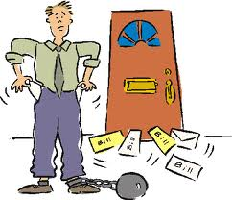

- I put my loose change in a tin at home at the end of each day

- I pay into a savings scheme every month through my job

- I give the electrician the money I owe for the repair

- I pay tax and national insurance from my pay slip
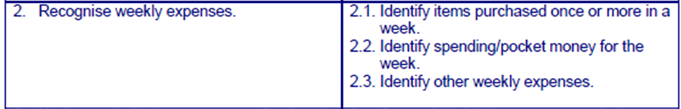

ACTIVITY 6 – Weekly purchases

Use a line to join up items to the shopping bag if you think you would buy the item EVERY week.


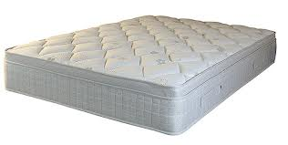



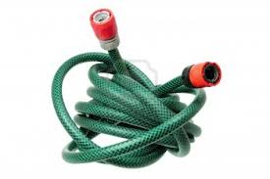


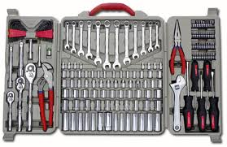






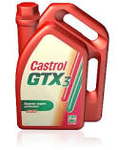
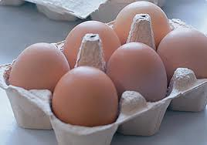


ACTIVITY 7 – small purchases

On each day of the calendar write an item that you might buy costing less than £3 per item. Do not use the same item twice!!
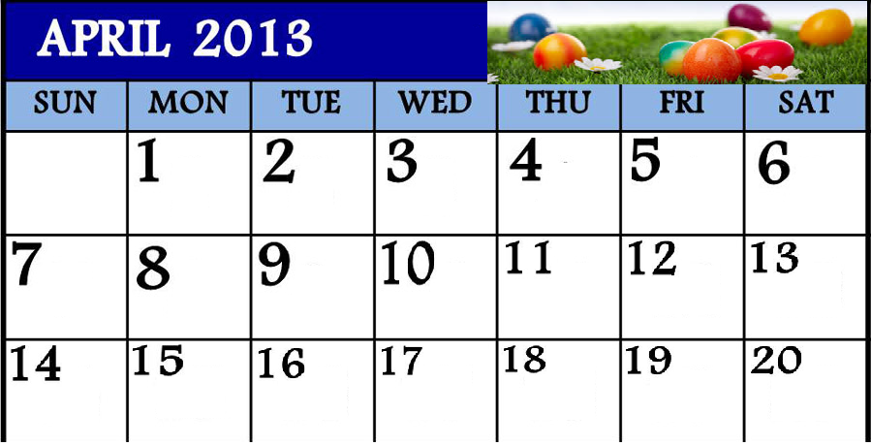

bag of
chips

Swimming

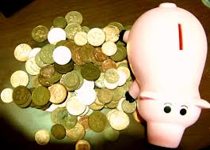

ACTIVITY 8 – do I have enough?

Cross out any purchases that CANNOT be made using ‘pocket money’.

Buying a new laptop Getting new stationery for a course
A sister’s birthday present Toping up mobile phone
Parking ticket Buying a suit for an interview
A wedding dress Giving money to charity
Repair to garage roof Packet of mints
Buying new shoes in town Lunch out with friends

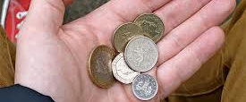

ACTIVITY 9 – pocket change or card?

List items below that, each WEEK, you would pay for using cash in your pocket and those you might use a card for.
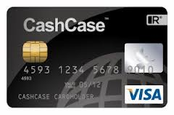
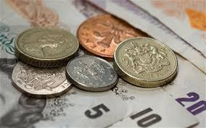

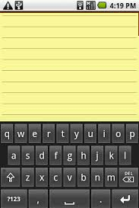

ACTIVITY 10 – Regular bills?

For each below write a purchase required. Include a sensible amount for that item. Identify if this is a regular, weekly purchase or not.



Looking after a baby Pet care

£
Weekly Y / N
£
Weekly Y / N


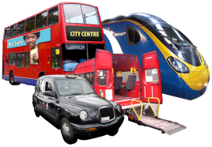

Getting to work Saturday night
entertainment
£
Weekly Y / N
£
Weekly Y / N




Shopping Holiday
£
Weekly Y / N
£
Weekly Y / N

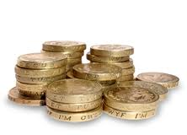


Celebrations
£
Weekly Y / N

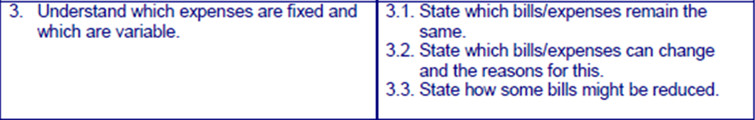

ACTIVITY 11 – Fixing bills

Some bills stay the same each month. These can be paid straight from a bank using ‘Direct Debits’. These authorise your bank to pay the company you want every month the SAME amount on the SAME day. Write below a list of monthly bills that are commonly paid using direct debits.

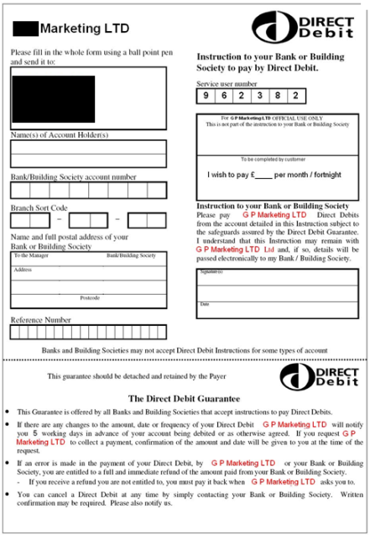
1

2

3

4

5

6

7

8

9

10

ACTIVITY 12 - Fixed or Variable?

Many bills stay the same each month but some will change. The bills that stay the same are called ‘FIXED’ expenses. Those that change are called ‘VARIABLE’. Write six expenses in the correct boxes below. eg: shopping costs vary each month but your rent stays the same
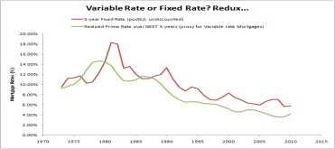


FIXED VARIABLE


ACTIVITY 13 – changing costs
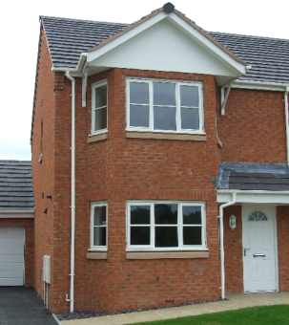


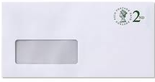
Complete the following

My electricity bill is the same each month because……

My transport costs change each month because……

My mortgage is the same each month because…..

My savings can change each month because…..

TV licence bills are always the same each month because…..

ACTIVITY 14 – recording expenses

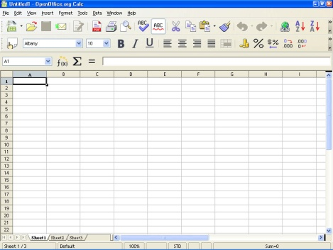
Include here a copy of your spreadsheet showing your expenses spread over a year (this will include FIXED and VARIABLE amounts)

ACTIVITY 15 – cutting the costs

For each of the following bills write possible ways of reducing the amount paid for each
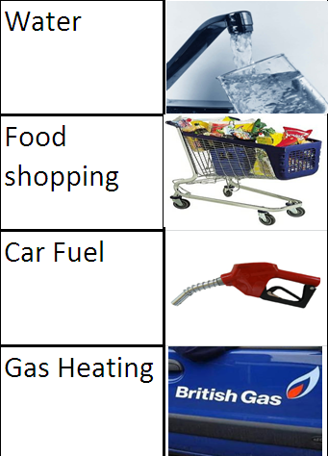

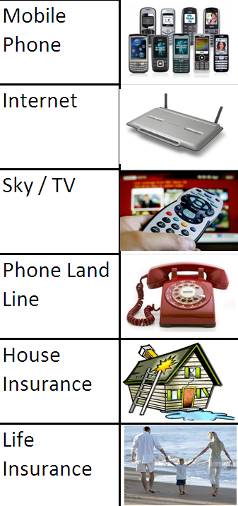

ACTIVITY 16 – what house repairs?

In each of the rooms write possible repairs that may be required


Got to fix
that door!

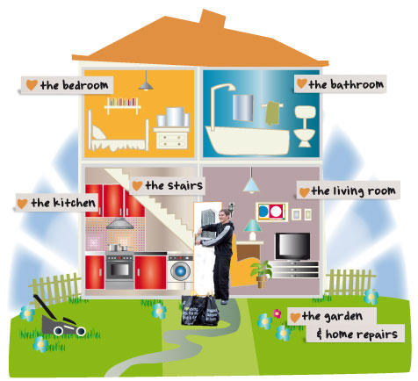

ACTIVITY 17 – How to plan for repairs

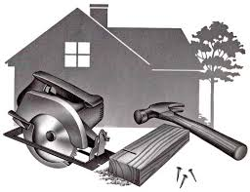
Each person below has a suggestion for how to save towards a possible household repair. Cross out any ideas you thinks are not practical/sensible !


When I know the cost I will just pay for it

I will put an extra expense into my monthly budget called ‘Repair Savings’

All the money I have left over each month that I do not spend can go in a jar for repairs

I will buy two of everything in case it breaks

I can take out the insurance when I buy a product

I will not pay one of my other bills if a repair is urgently required

I can get a loan when needed if something goes wrong

Pay into a company SAYE (save as you earn) scheme and draw on that if I need to

I will pay more into my pension then claim it early if I really have to


Get someone to take money off me each week and I can get them to give it back if I need it

ACTIVITY 18 – Repairs: What to do

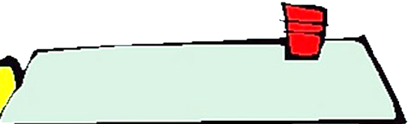
A repair is required. Make a suggestion for each as to how to plan for the cost.

1) In six months my car MOT is due and I know I will have to get new tyres otherwise it will fail

Estimate the cost and spread over six months. Save around that amount each month to ensure you have the money when needed

2) I need to plan for boiler repairs as it always seems to break during the winter

3) My bike is probably going to have some punctures this year

4) My washing machine will need replacing in the next couple of years

5) I have broken slabs outside and will need a new patio

6) I must get that fence mended in the back garden

7) My computer is full of errors and running slow, I need an update and repair

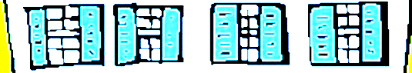

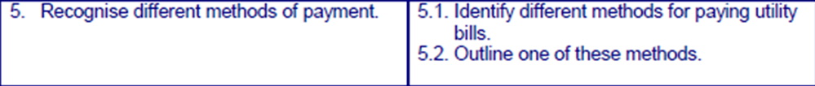

ACTIVITY 19 – How to pay

Utility bills are ‘gas, water and electric’ bills. When you receive one of these bills in the post, many methods are given to help you to pay. Look up on a bill and list the methods suggested.

pay methods

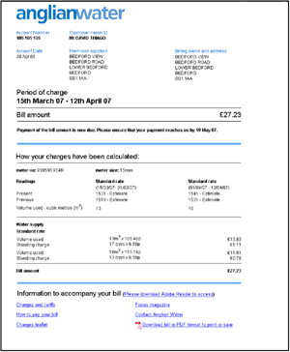

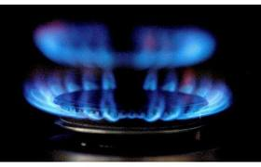

ACTIVITY 20 – how to pay

Choose two of the methods to pay for utility bills and describe what they mean and how you can pay the bills using this method.

METHOD 1 : ……………………………………………
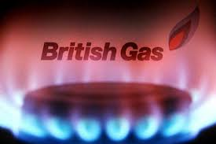



METHOD 2 : ……………………………………………

