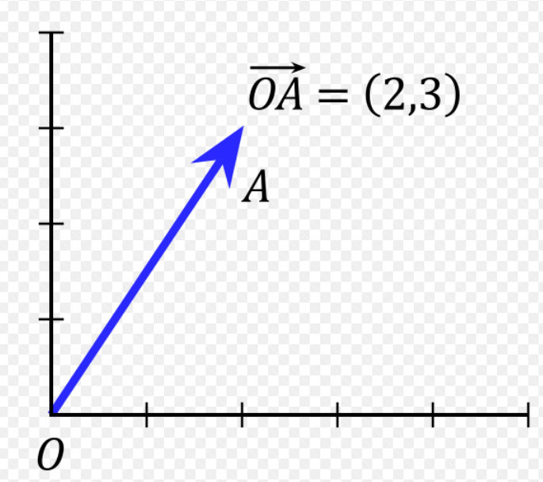

Can you draw the vector arrow for (4, -2) .. ?

…what about the vector that is perpendicual to (2,3)..? or in the opposite direction?

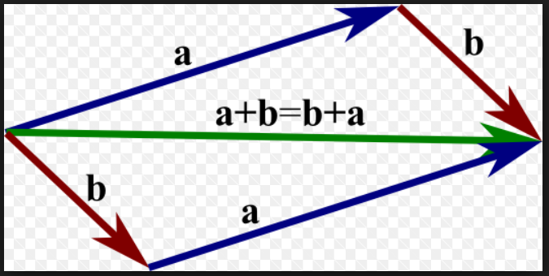
Discuss what you see…!

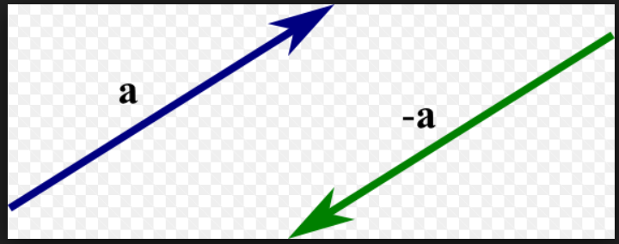

How are the 2 vectors different?

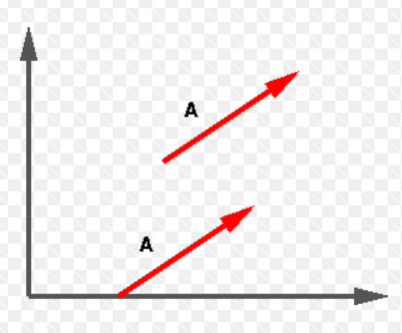
How are the 2 vectors different?
What is the same about them?

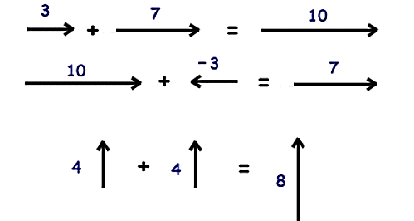

Discuss what you see…!

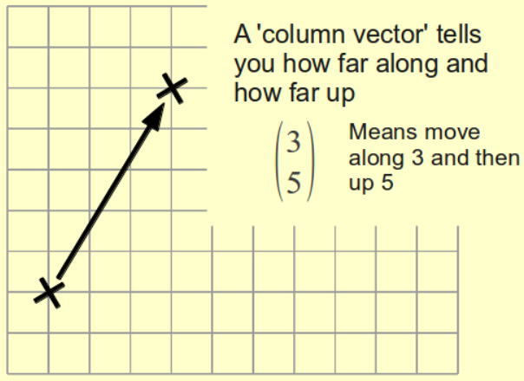

Try some of your own now…!

Discuss what you see…!
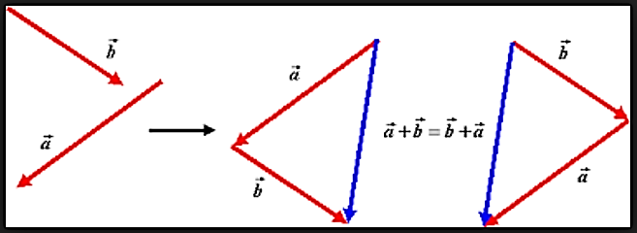

Can you make your own up..!
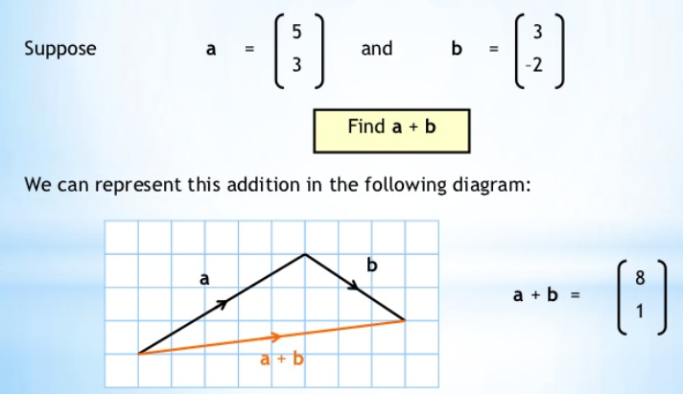

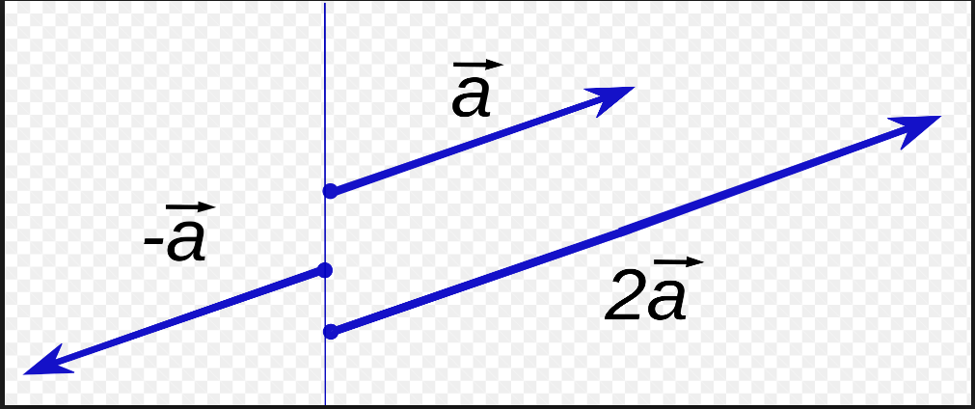
Discuss what you see…!

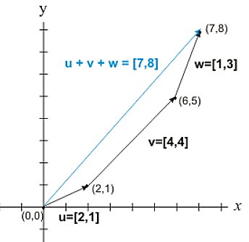
Discuss what you see…!

