
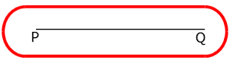
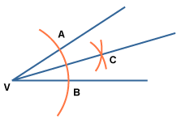
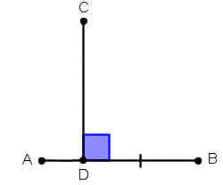
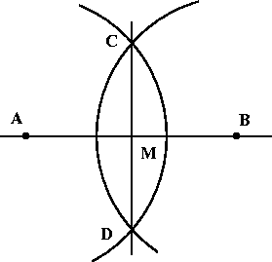
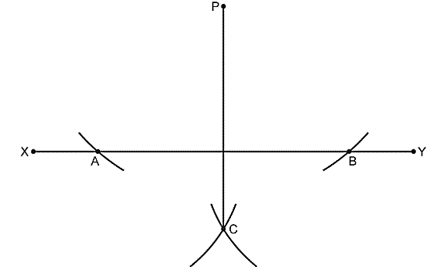
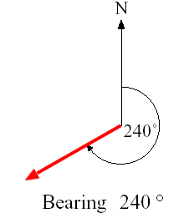
A Bearing
Angle bisector: all points
the same distance from two lines
Loci of all points from a point
on a line perpendicular to
the line
Loci of all points the
same distance from two
points.
‘Perpendicular bisector’
Loci of all points from
a point perpendicular
to a line
Loci of all points the
same distance from a line
Loci of all points the
same distance from a point
1
7
6
5
3
4
2
1

