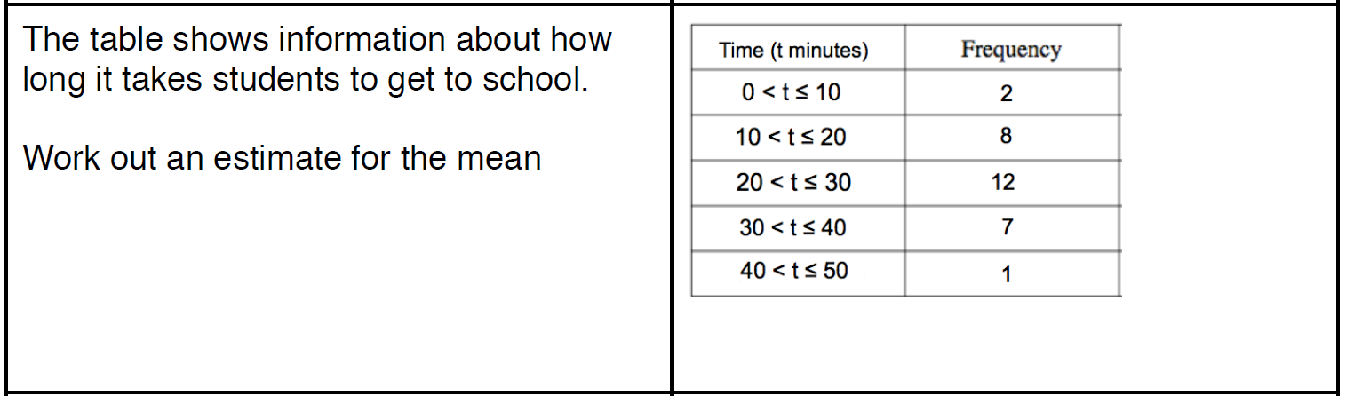
ASSIGNMENT 21

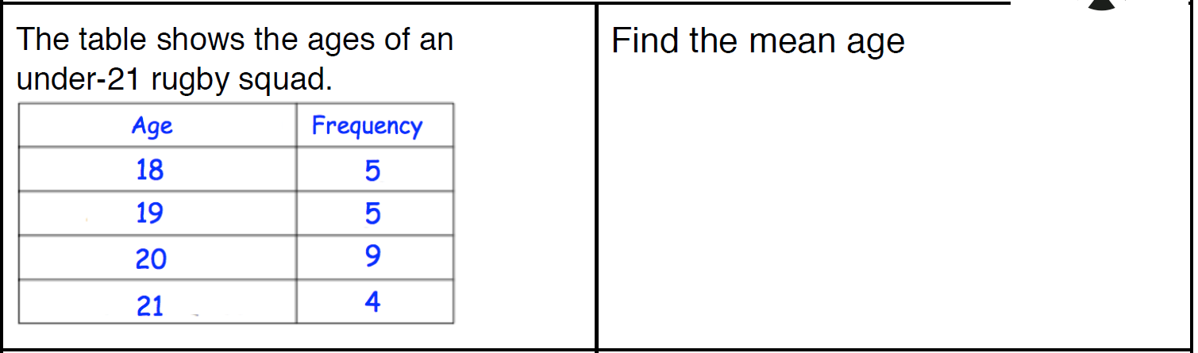

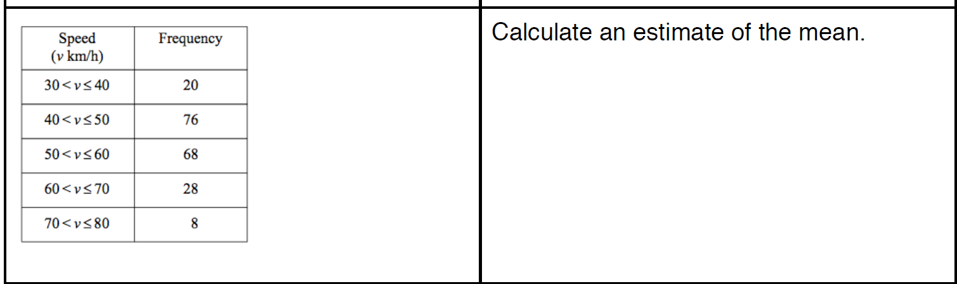

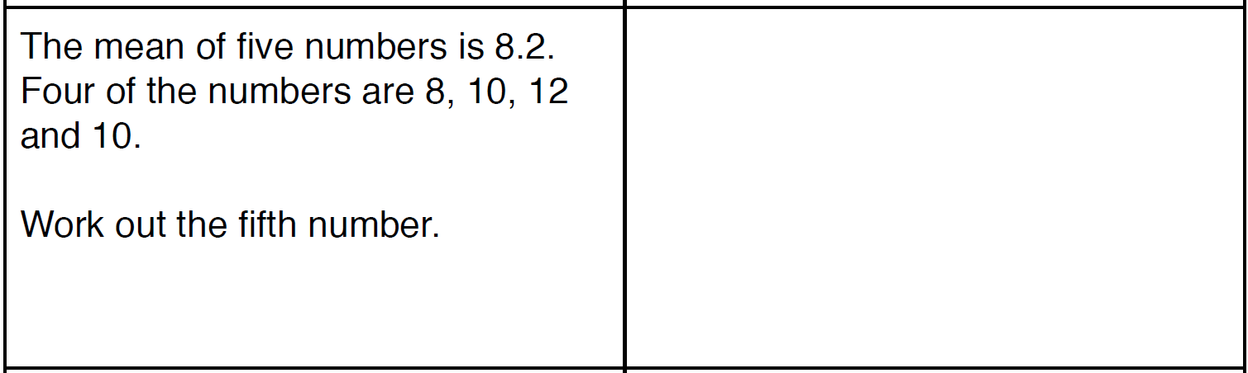

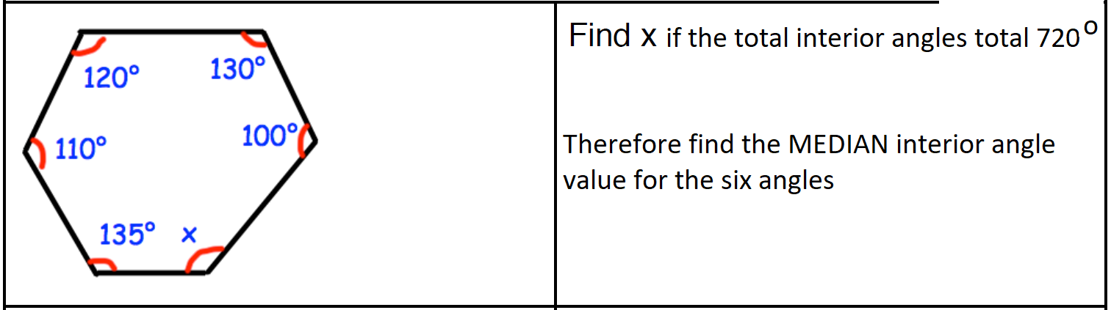

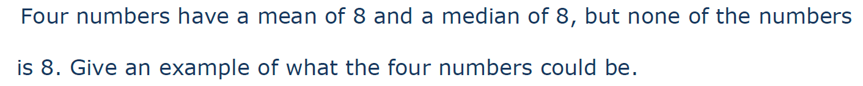
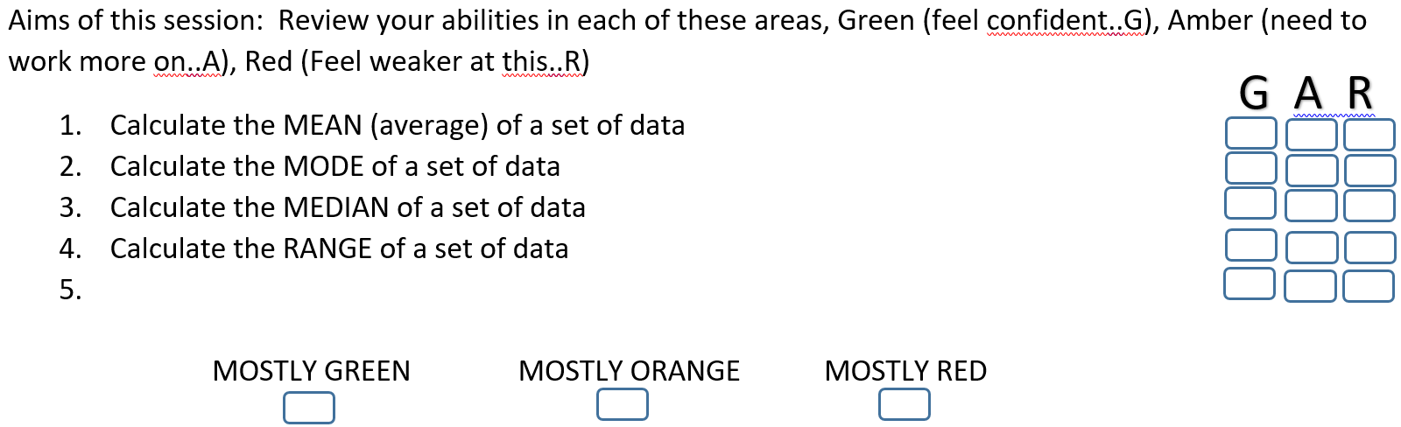
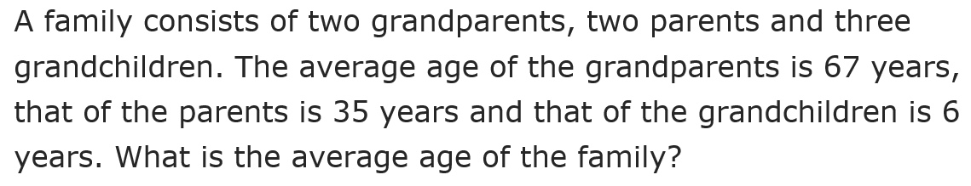
Find the greatest, the Mean,
Median, Mode or Range?
-1, 0, 1, 0, -2

