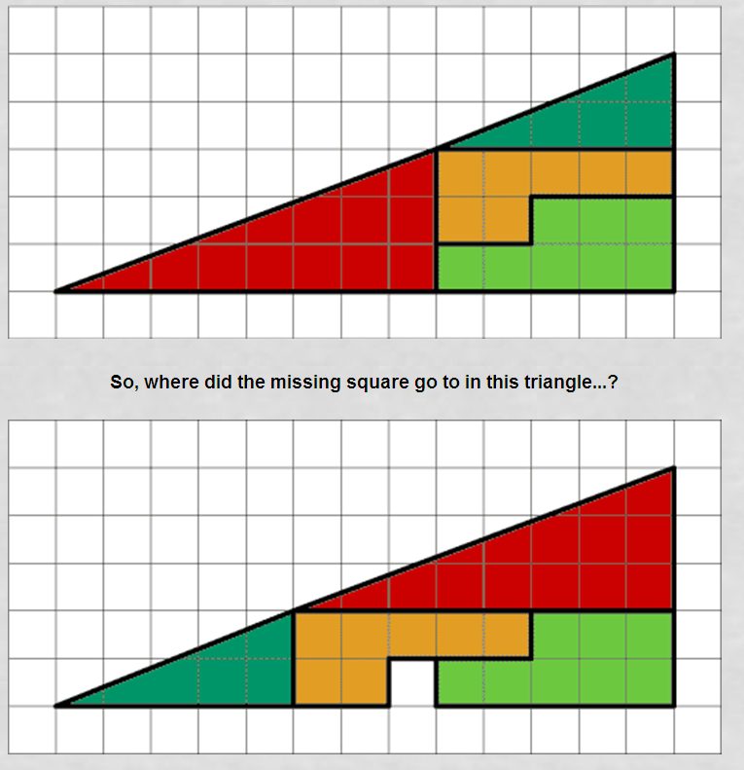
The ‘Impossible Triangle Illusion’
4
4
3
3
2
2
1
1

