
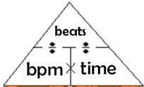
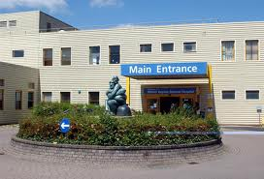
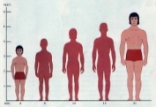
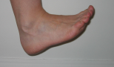
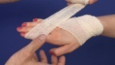
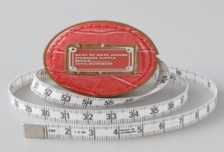




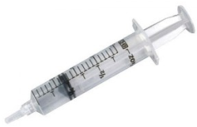

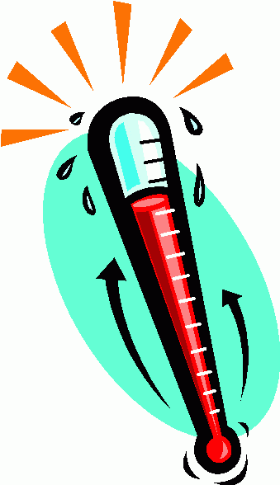
bpm= beats per minute
0.33min
0.16min
0.25min
0.5min
bpm
time
beats
F=
C=
F=
C=
F=
C=
F=
C=
Order, and convert to a different unit eg.. 20flozs = 1pint
convert imperial to metric
Order, and convert to a different unit eg.. 1kg = 2.2 lbs
inches, feet or miles
Distance to MK Hospital
Measure your height
Measure your foot
Measure your hand
Measure lengths
C = 5/9 (F-32)
1 ozs
¼ lbs
0.3 kg
500 g
45 ozs
6 kg
0.5 st
1276 g
1.4 kg
28 g
7 lbs
0.1 kg
0.7 lbs
18 ozs
13 lbs
3 lbs
Medical Record Card – L2
Measure weights
15ml ….. ltrs
750cc …. flozs
1.5 l …. pts
200ml …. flozs
0.5 pt …. ltrs
0.1 flozs …. cc
975 ml …. flozs
ml = cm³ = cc
Measure liquids
F = 9/5 C + 32
Take a temperature
Take a pulse rate

