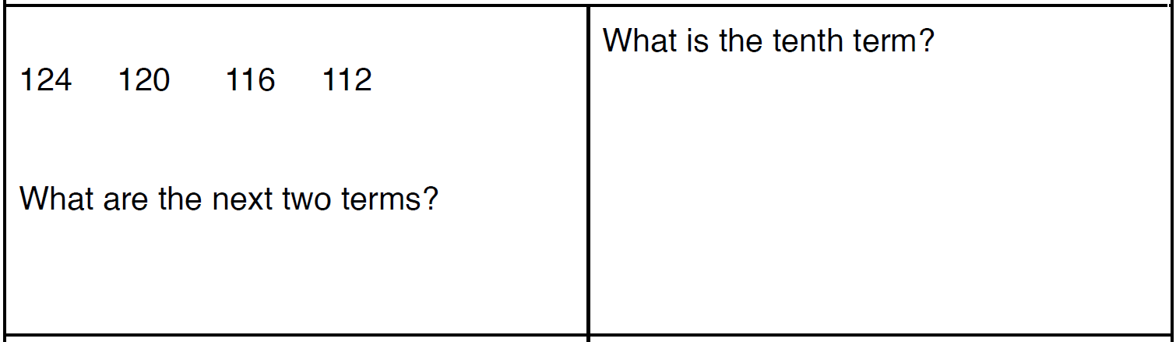
ASSIGNMENT week 17
Sequences

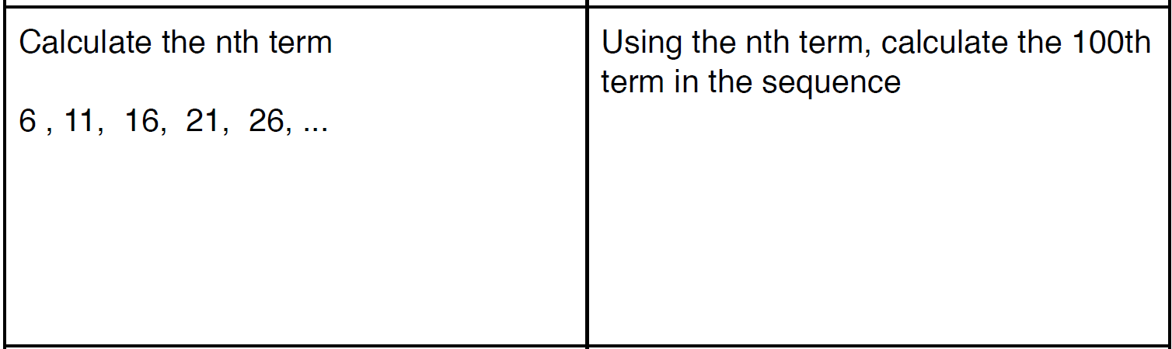

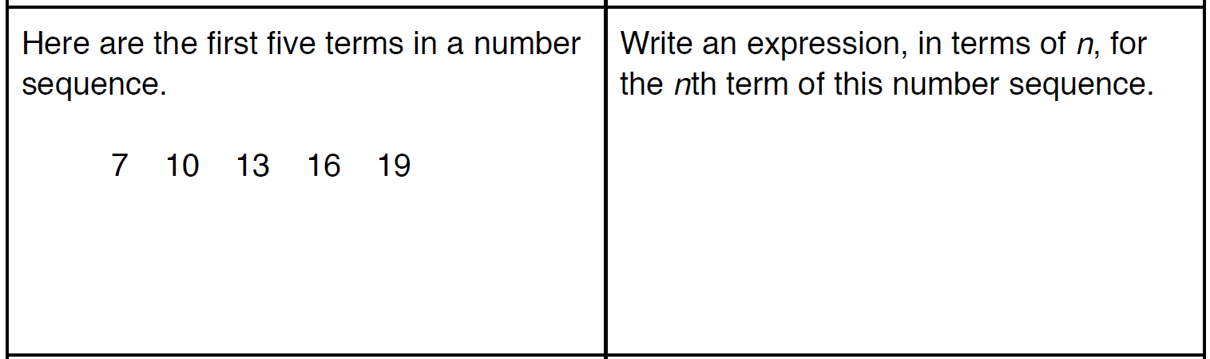

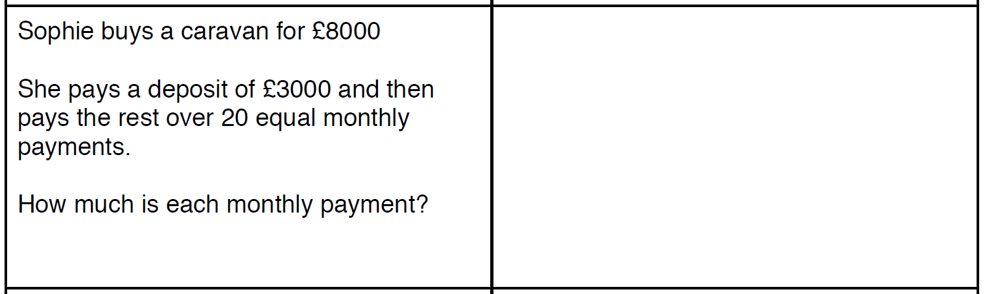

x_{n+1} = x_{n} - 3
Write out the next four terms of this
sequence, starting with the first term
as 10

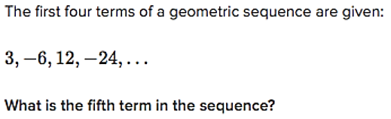

Using ‘a’ as the first term of the sequence and ‘r’ as the multiplier each time…. find the fourth term of the
sequence when ‘a=2’ and ‘r=3’
x _{n} = a r ^{n-1}

