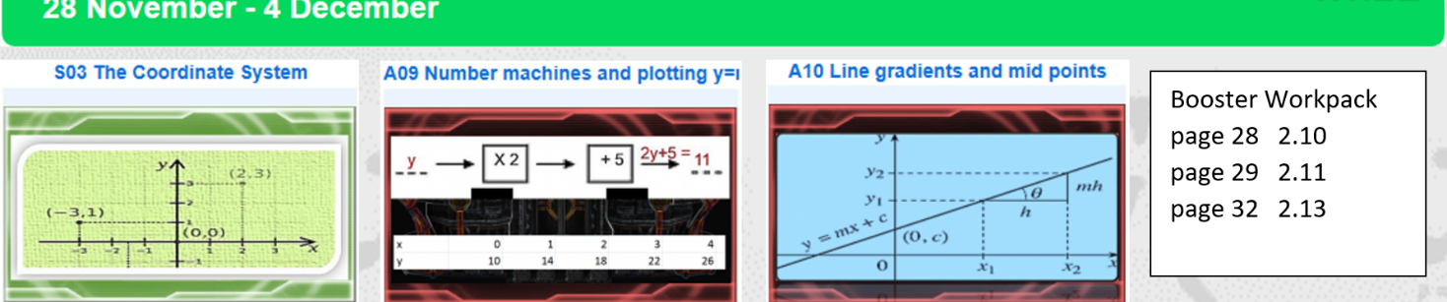
Assignment 11 b

Understanding y = mx + c

Task 1

A B C D E
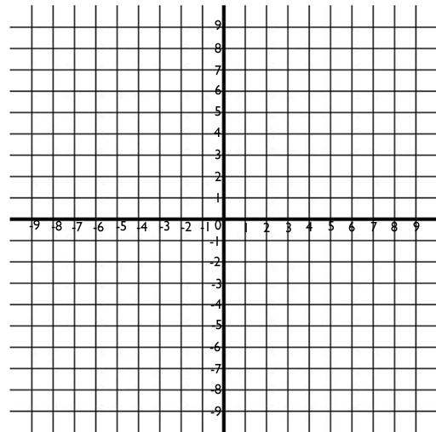

G
F

1. Which lines have a y-intercept at: 2. Which lines have a gradient (slope) 3. Which lines are
- 1? a.  - 6? b.  - -4? c. | positive? negative? zero?  parallel?
d. | infinite?
Task 2
Complete the following sentences, using these words: using y = m x + c

steeper
(0
,-3)
y
-
intercep
t

shallower

paralle
l

negative

(0
,2)
steep
g
radien
t

crosses

equa
l

- ‘m’ tells us the ________________ . This is how _________ the line is.
- ‘c’ tells us the ___________ . This is where the line __________________ the y-axis.

- The y-intercept of line y = x + 2 is _______________.
- The y-intercept of line y = x – 3 is _______________.
- y = 4x is _______________ than y = 2x.
- y = ½x is _______________ than y = 3x.
- y = -2x has a _______________ gradient, so the line goes downhill (from left to right).
- y = 2x + 1 and y = 2x – 3 have _______________ gradients so they are _______________ lines.

Task 3
Match each line on the axis above to an equation.  y = 2x – 4 y = ½x – 4 y = 4x + 6 y = 2x + 6 | y = -2x + 1 | x = -7 | y = 9

Task 4

A number machine is shown below. What is the line equation that is the same as the machine?

ꭓ x6 +4 = y

a) x=64y b) y=4x /6 c) y=6x +4 d) 6x -4 = y

Task 5
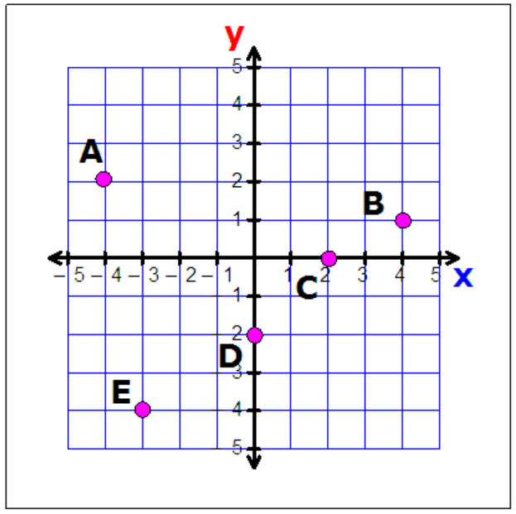
Write the coordinates of each point

A ( , )
B
C
D
E

What are the equations of the lines that join
any two points together (eg A and B..)?

