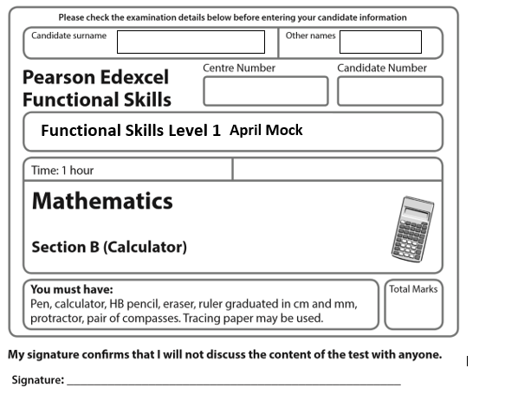
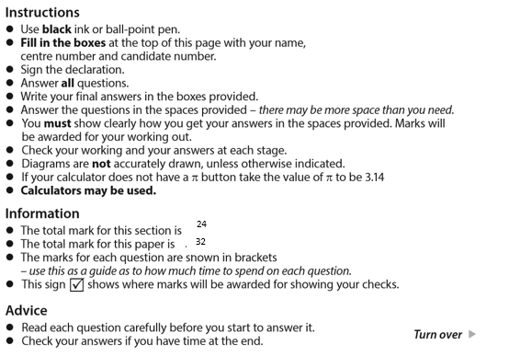

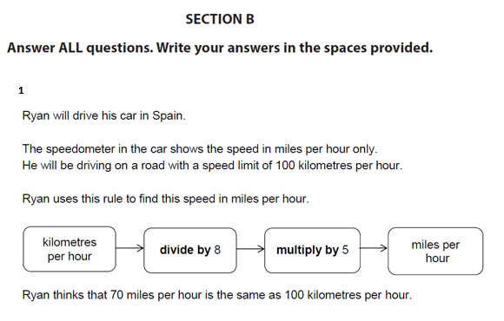
Is he correct?
Show why you think this. (3)

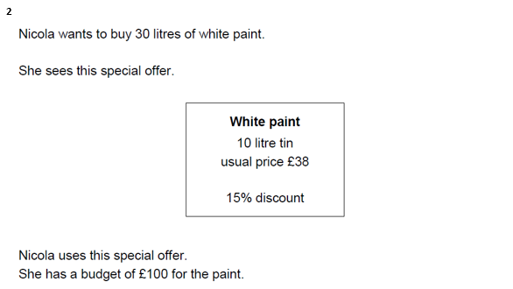
Does Nicola have enough money to buy 30 litres of white paint? (4)

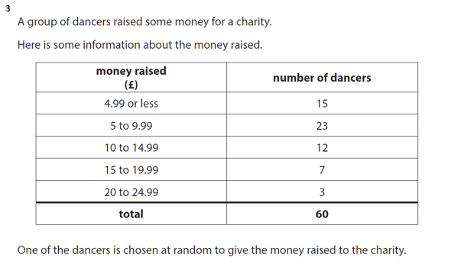
What is the probability that this dancer raised less than £10? (2)

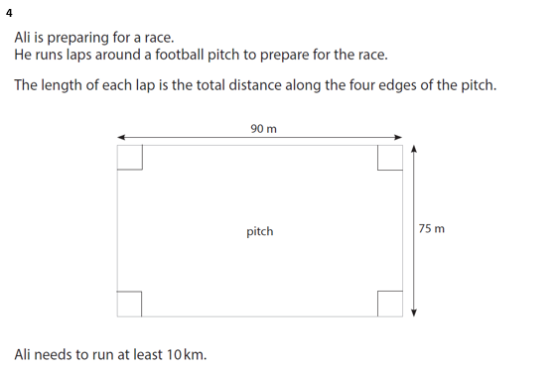
What is the minimum number of complete laps Ali should run? (4)

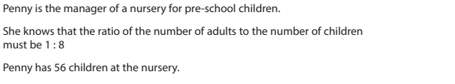
5

- Work out the number of adults Penny needs for 56 children. (2)

b) Use a reverse calculation to show a check of your answer. (1)

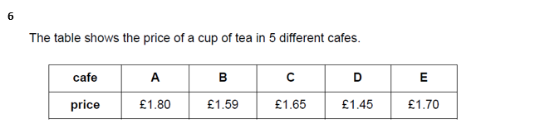
Calculate the mean price of a cup of tea. (3)

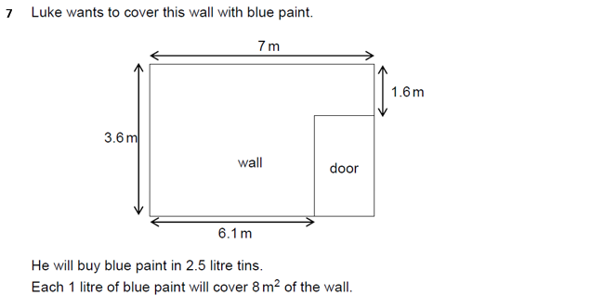
How many tins of blue paint does Luke need to buy? (5)

