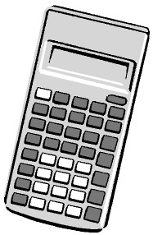
Candidate surname
Other names
Total Marks
Centre Number
Candidate Number
Please check the examination details below before entering your candidate information
You must have:
Pen, HB pencil, eraser, ruler graduated in cm and mm, protractor,
pair of compasses. Tracing paper may be used.
Paper Reference
PMAT2/N08
Time: 25 minutes
Mathematics
Level 2
Section A (Non–Calculator)
Pearson Edexcel
Functional Skills
Set 8
My signature confirms that I will not discuss the content of the test with anyone.
Signature:

Instructions
- • Use black ink or ball-point pen.
Fill in the boxes at the top of this page with your name, centre number and candidate number.
- • • • • Sign the declaration.
Answer all questions.
Write your final answers in the boxes provided.
Answer the questions in the spaces provided – there may be more space than you need. You must show clearly how you get your answers in the spaces provided. Marks will be awarded for your working out.
- • • • Check your working and answers at each stage.π
Diagrams are not accurately drawn, unless otherwise indicated.
Calculators may not be used.
Take the value of to be 3.14

Information
- • The total mark for this section is 16.
The marks for each question are shown in brackets
– use this as a guide as to how much time to spend on each question.
- This signshows where marks will be awarded for showing your checks.

Advice
• • Read each question carefully before you start to answer it.
Check your answers if you have time at the end. ^{P68470A} *P68470A0108*
Turn over
©2021 Pearson Education Ltd. 1/1/1/1/1/1
BLANK PAGE

*P68470A0208*
SECTION A
Answer ALL questions. Write your answers in the spaces provided.
1 Eve buys lunch on her way to work. She sees this meal deal.
Meal deal
Buy any sandwich
snack and drink
for £3.99
Eve chooses these items.
Chicken sandwich £2.85
Fruit snack pot 79p
Coffee
£1.59
Work out how much money Eve will save using the meal deal.
You
must
show your working.

(3)
(
Total for Question 1 is 3 marks
)
£

3

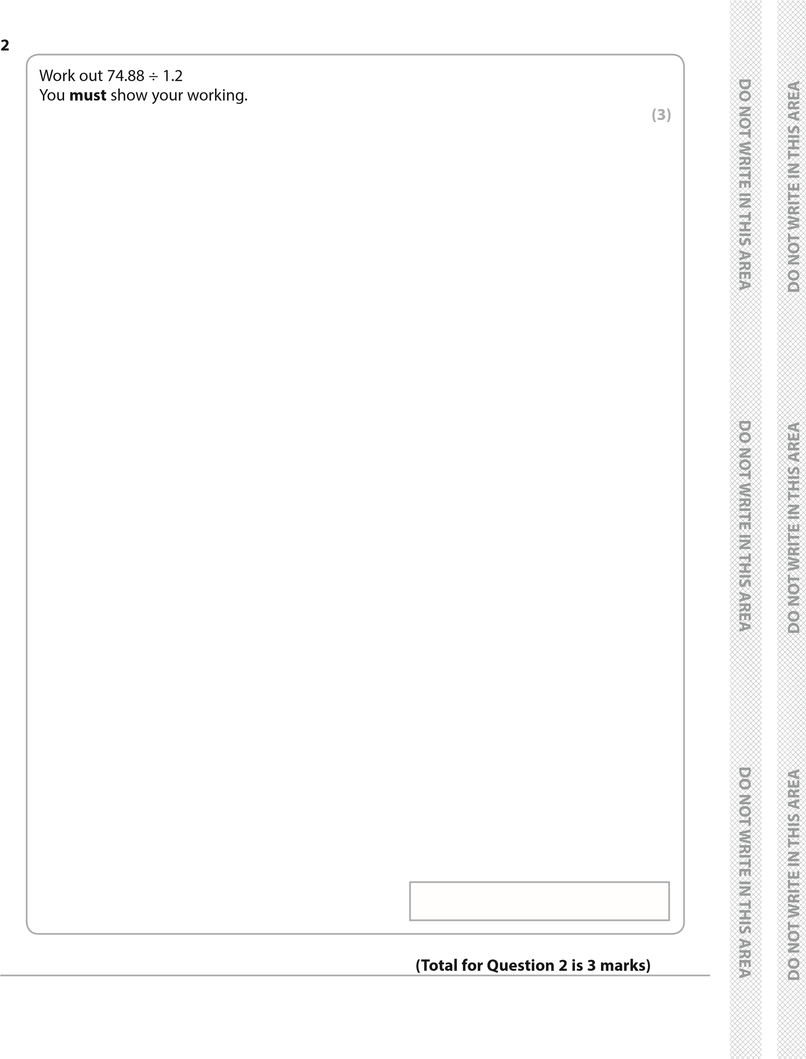
*P68470A0308* Turn over *P68470A0408*
3 ABCD is a 4-sided shape.
BD is a line of symmetry of the shape.
49
˚
108
˚
B
A
C
D
x
˚
(
a)
Work out the value of
x
.

(3)
(
b) Use estimation to check your answer.

(1)

(
Total for Question 3 is 4 marks
)

5

*P68470A0508* Turn over
4 Max is building a new shed. He has drawn this sketch.
2

m
3

m
1.8

m
2.6

m
2 m
Each shaded wall of the shed is in the shape of a trapezium. The other two walls are rectangular.
Max wants to cover the four walls with wood cladding. He will not use any cladding for the floor or the roof.
Max will buy the cladding in packs.
Each pack of cladding covers 1.1 m²
The cladding can be cut and joined.
Max knows that the two rectangular walls need 8.8 m² of cladding in total.

Work out how many packs of cladding Max needs to cover the four walls.

(6)

*P68470A0608*
(
Total for Question 4 is 6 marks
)

TOTAL FOR SECTION A IS 16 MARKS *P68470A0708* ⁷

BLANK PAGE

*P68470A0808*

