
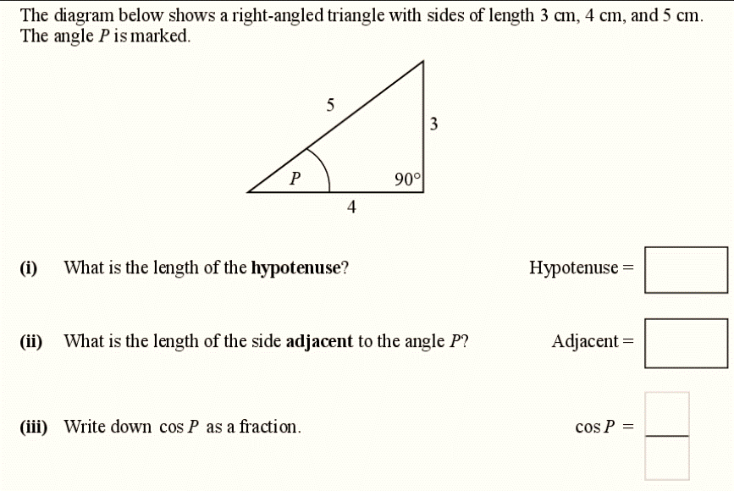


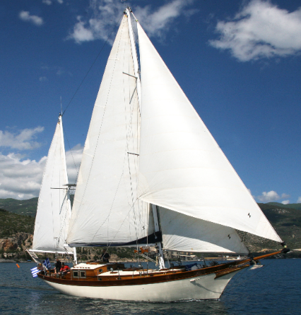
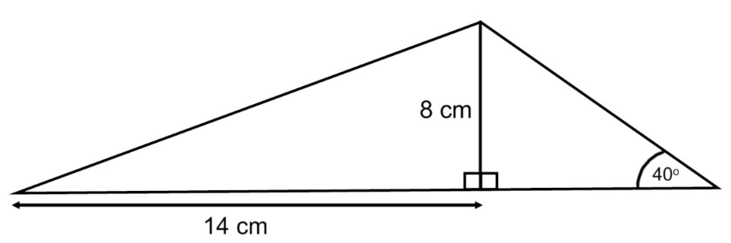

..so is it best to use Pythagoras or Trigonometry to find the missing lengths and angles? Can you try using both methods? Do you get the same answers?

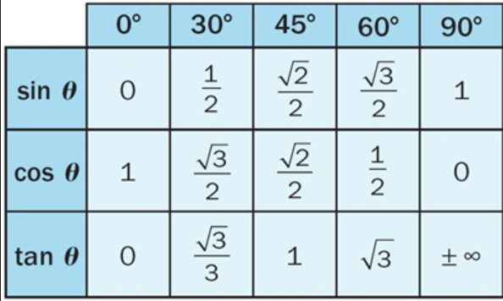



These are the trig ratios for common angles. How are you going to learn and remember them? Can you draw triangles and lable them correctly for each angle and ratio (sin,cos,or tan)

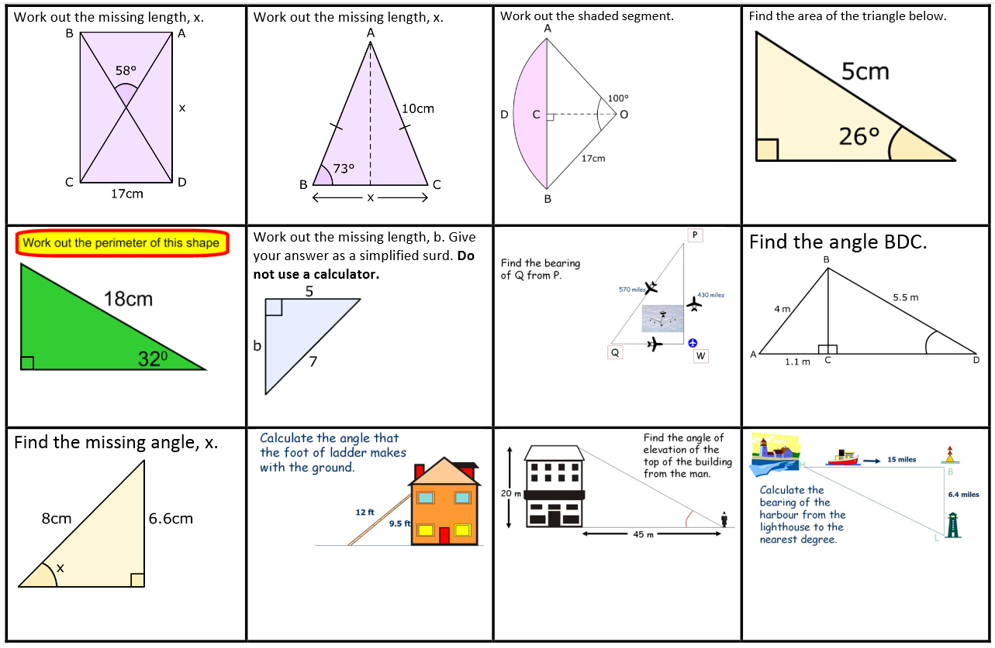

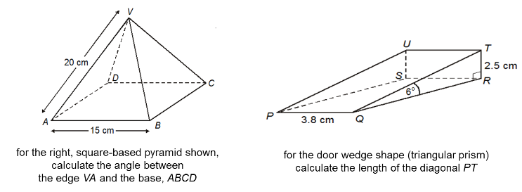

Can you use trig and pythagoras in 3D ?

What is the straight line distance a diver has to swim to the coral reef from point A?

A
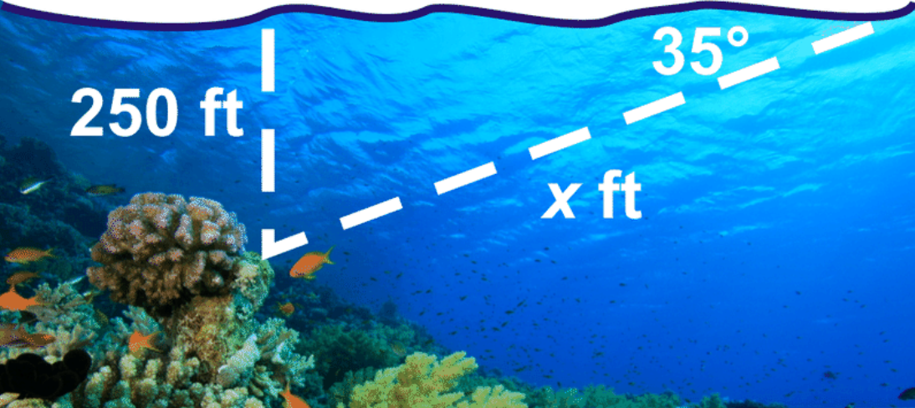

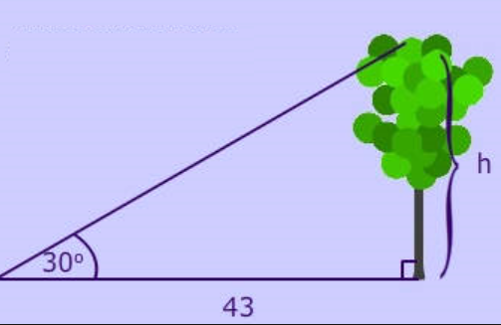
What happens to the angle when you move nearer the tree ?

For different tree heights what happens to the angle if you stay 43m away?

Can you label the 3 sides correctly with opp, adj and hyp ?

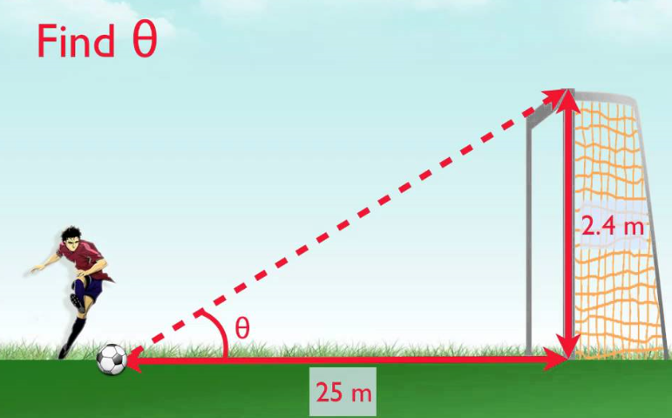

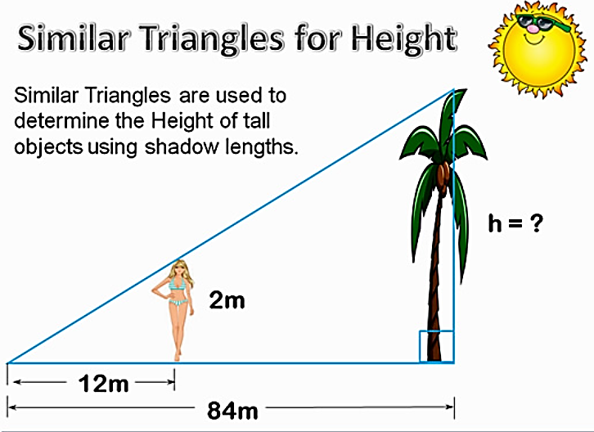
How do we find the tree height?
What type of ratio are we using (sin, cos or tan?)

Can you find the angles in the triangle?

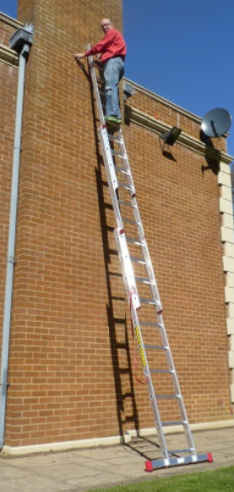
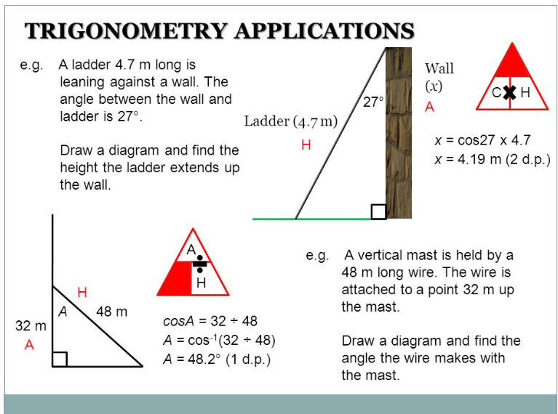

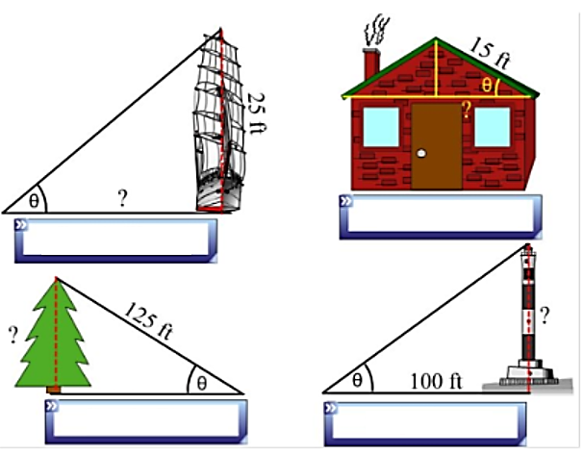
Measure the angles with a protractor.

Find the missing actual side lengths.

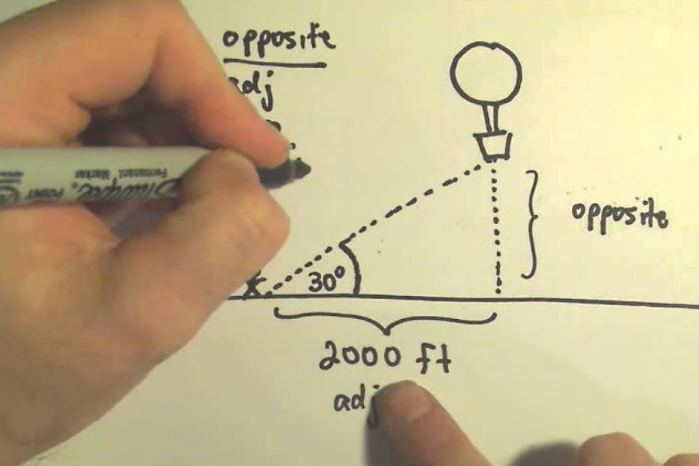


Can you solve this exam question before he does and find the height of the ballon?


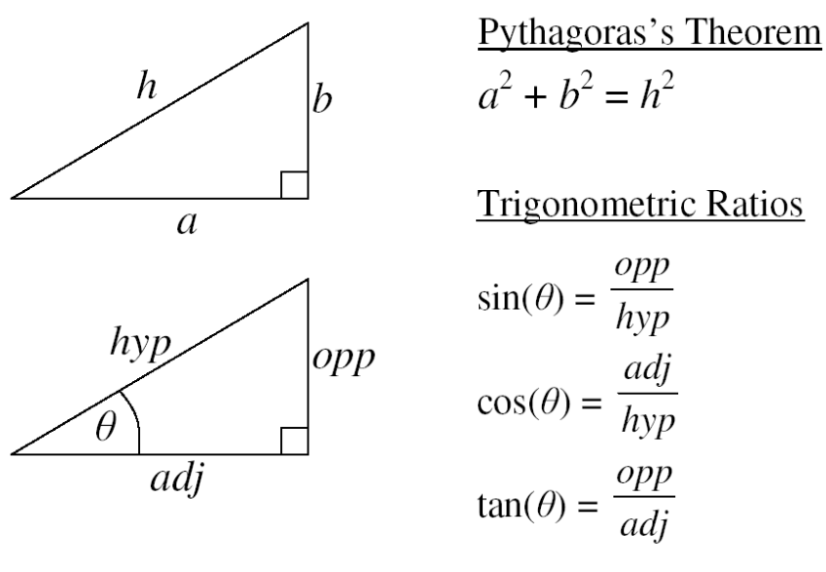
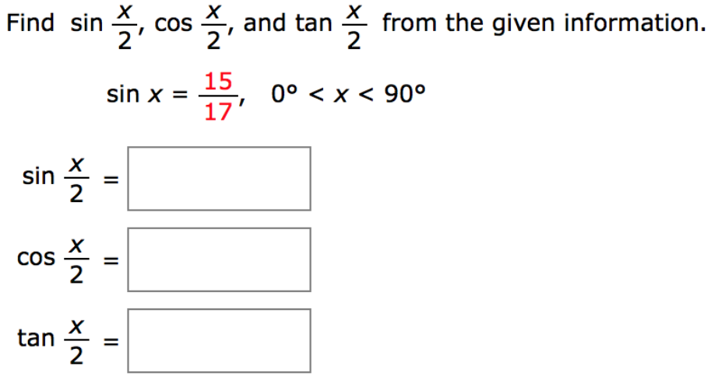
What is the difference between pythagoras theorem and trigonometry?
What do you use them for?
Think about how you can use the ‘15’ and ‘17’. What are these numbers?

HIGHER ONLY!

