Perimeter/Area Scale factor Enlargement Formulae

Where k = scale factor value between the old and new values.

Perimeter formula P_{new} = k P_{old}
The new perimeter is k times larger than the old perimeter
_{Example:…}
_{P(old) =16+10+16+10 = 52} _{P(new)= 15+24+15+24 =78}
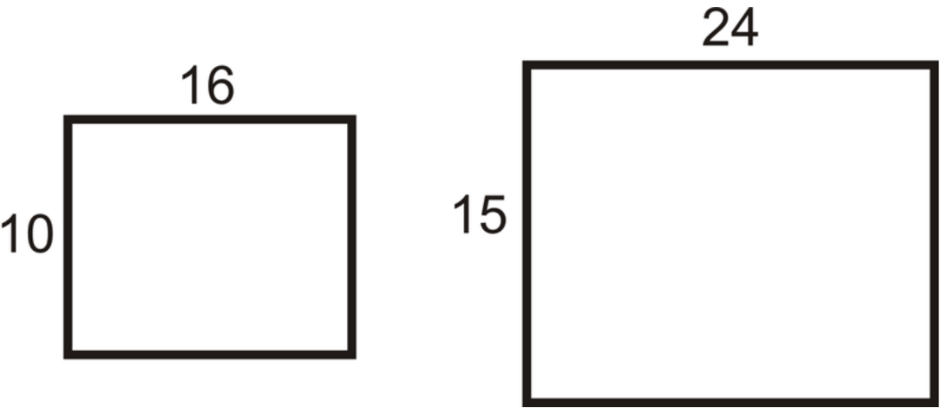
_{78/52 = 1.5 times longer}


_{Area Formula} A_{n}=K A_{o} = L W √k √k
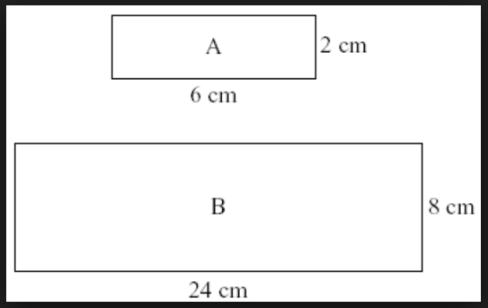
The new area is k times larger than the old area, which is also the same as the old length x width x square root of the scale factor squared.
Example:…..

New area is 24 x 8 = 192cm²
Old area is 2 x 6 = 12cm²
so.. 192 = 12K = L x W x √k x √k
the scale factor can be found by dividing 192 by 12 = x16

so.. 192 = 12x16 = L x W x √16 x√16
192 = 12x16 = Lx4 x Wx4

