
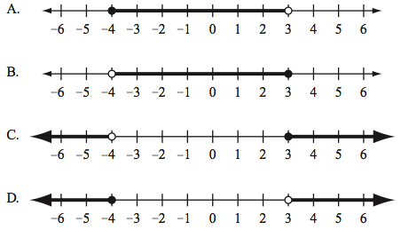

What do the arrows mean?
What are the dots and circles for?

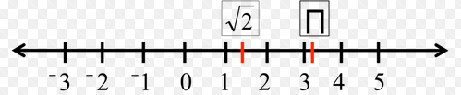

What are the symbols on the number line?
What value do they have?
Can you place another value on the line?

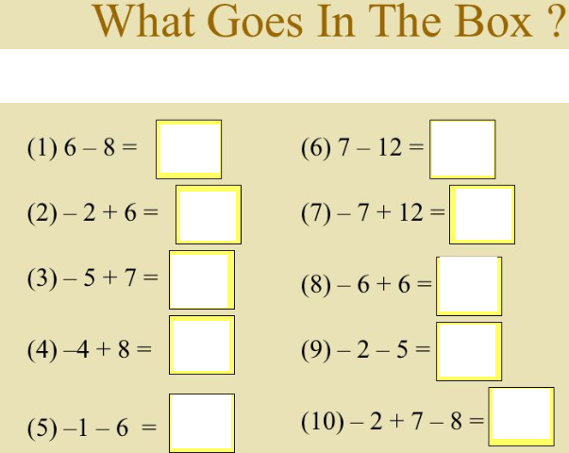
Use a number line that includes negatives to help. Can you create your own sums and test each other?
What about if the values had decimals

or fractions in the sums? Can you write an inequality for two of the answers?

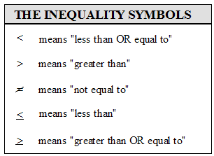

Do you agree with the above?
If you don’t what is wrong?
Does it matter which way round the symbols go (L to R)?

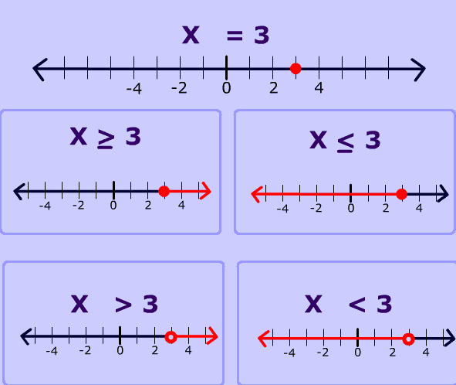

Discuss the above.. what is shown?

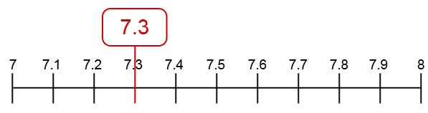

If you had to round 7.3 to the nearest unit where would it go? What are the upper and lower bounds of 7.3?

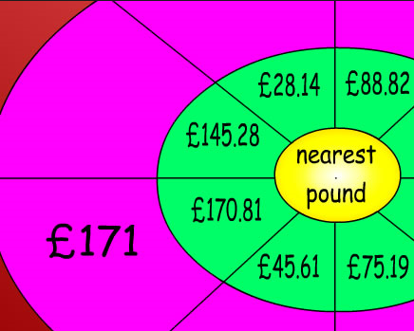

If £170.81 rounds to £171, can you discuss what the other values would round to and why. What methods do you and others in your group use?

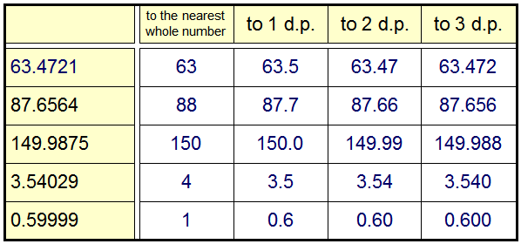

What can you learn from this table? What are the upper / lower bounds of each pre rounded value?
Try showing them on a number line. What is difficult?



200 sheets = 10cm
100 sheets = 5cm

Can you work out how thick each sheet of paper is?
As it is difficult to measure thin items accurately, what is the upper and lower bounds of each sheet to a thousandth of a centimetre?

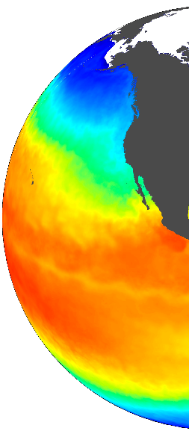

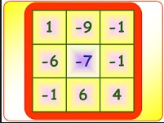

Take any two values, find the distance between them.
Is the answer negative or positive?
Can you write an inequality for this distance that includes both values, includes only one value or does not include either value?

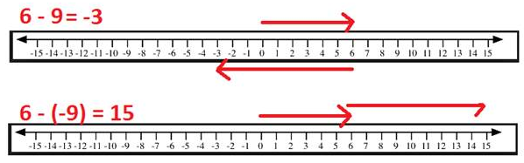

Can you explain adding and subtracting negative numbers to someone else?
What rules do you know?

The food in the fridge can be temperatures that include 4C, temperatures lower that 4C but must be higher than 0C

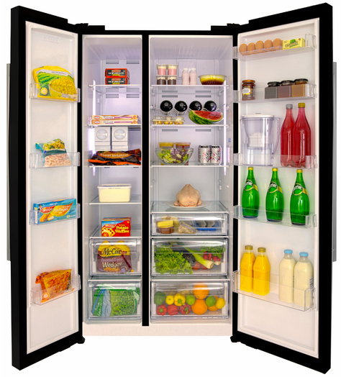
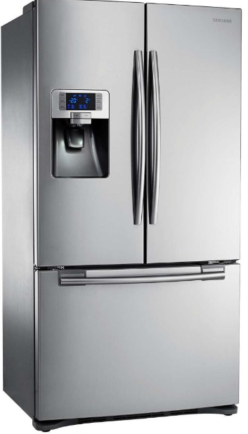

Can you discuss how to write an inequality for this temperature range?
Can you plot these values on a number line?

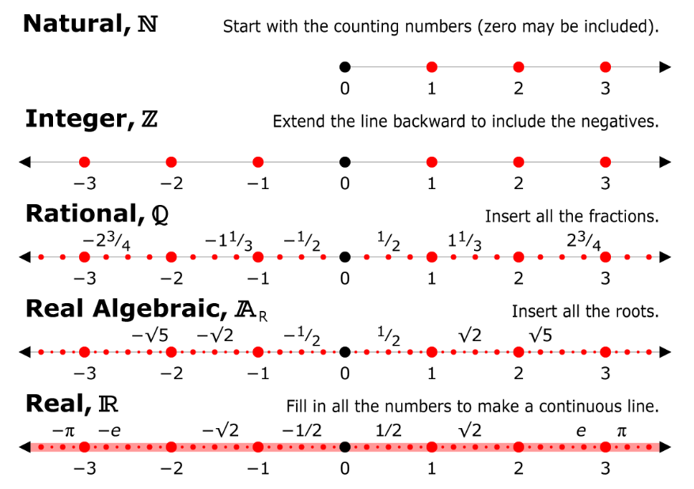

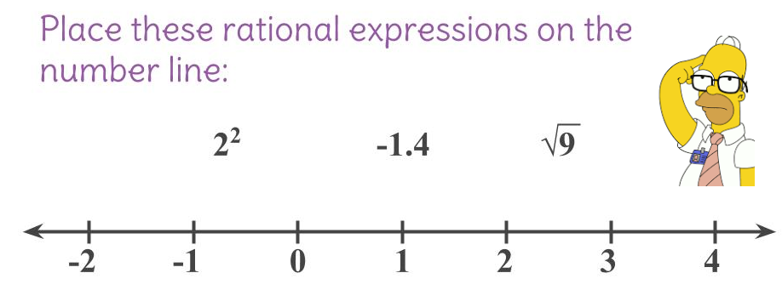

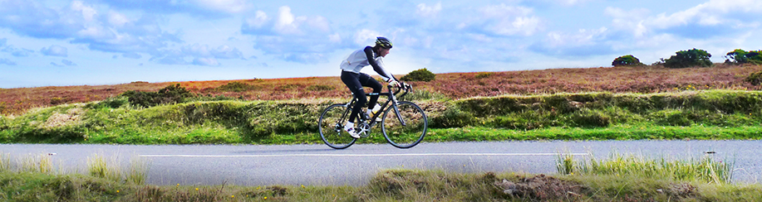

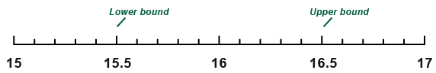

What numbers fit between the upper and lower number bounds shown above?


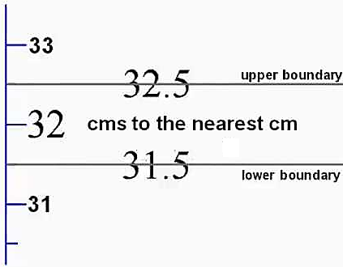



Discuss the show boundary condition.
Why is 32.5 included?


A car has driven 64.283596.. miles.
Discuss why this value is not ‘sensible’ and why

rounding it is best. What would you round this distance to? What are the rounding boundaries?

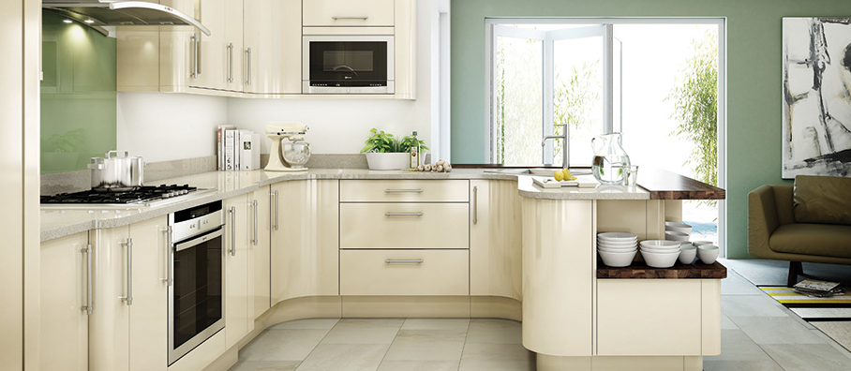

A kitchen unit must be within a range of lengths that allow it to fit but not leave gaps. Discuss how an inequality can be written for a kitchen unit.

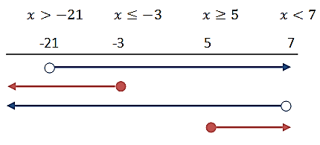

Which lines match with which inequalities?




A height restriction at a theme park states that you may ride if you are 1.2m or above. Draw a number line. Show the inequality. What would happen if you were exactly 1.2m tall?

