GCSE MATHS AQA – REVISION GUIDE

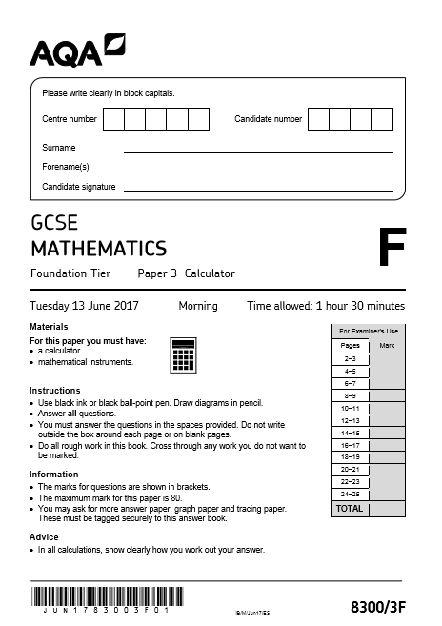
AQA GCSE MATHS - EXAM DATES
19th May 2020 - Non Calculator
4th June 2020 – Calculator 1
8th June 2020 – Calculator 2

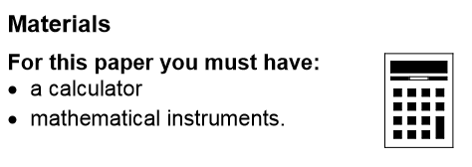

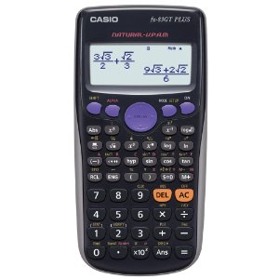
REMEMBER YOUR CALCULATOR!!!!
EQUIPMENT CHECK-LIST:
BLACK PEN
PENCIL
CALCULATOR
GEOMETRY SET

Casio FX-83GTPLUS Scientific Calculator
USEFUL WEBSITES AND RESOURCES

*** www.mathsgenie.co.uk – GCSE Grades 1-5 (foundation) ***
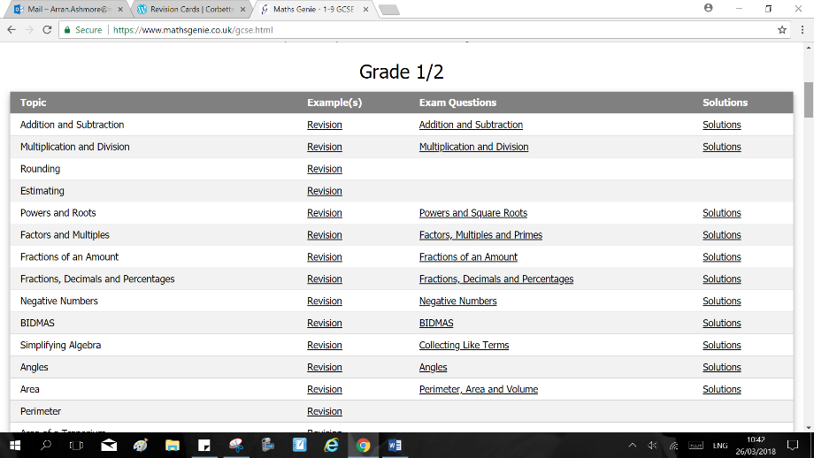

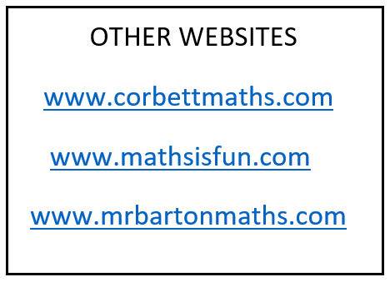

CHECK HERE ALSO (GCSE maths):
http://moodle.mkcollege.ac.uk/course/index.php?categoryid=324
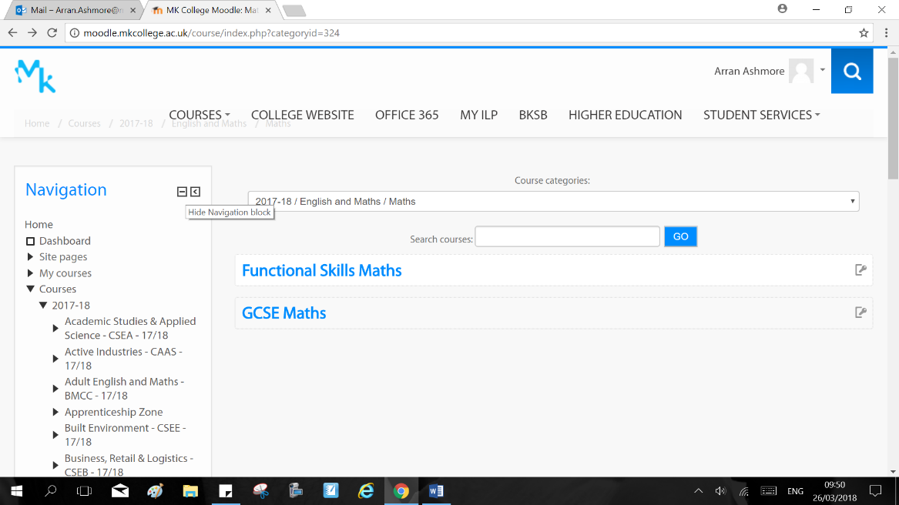

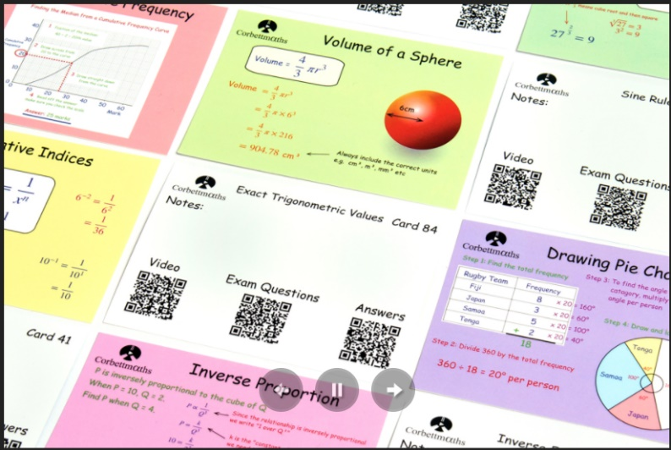
www.corbettmaths.com/revision-cards/

www.missbsresources.com/maths-resources
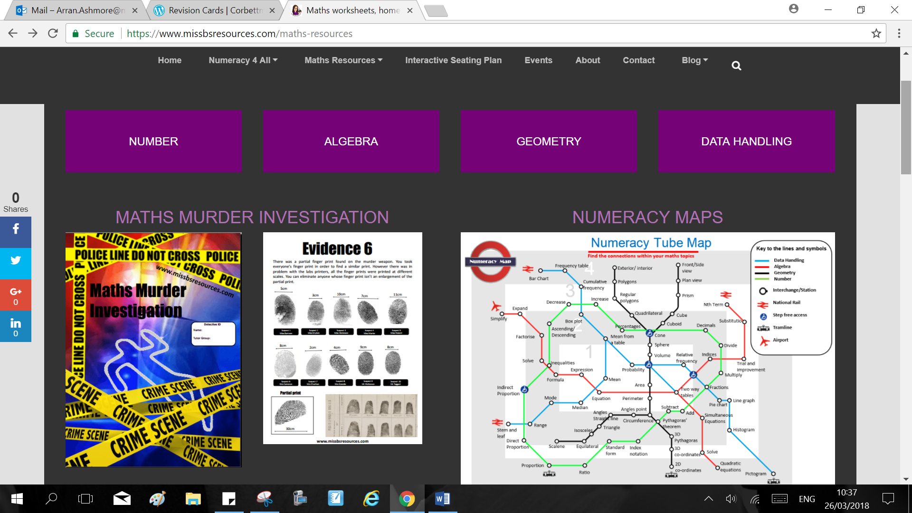
BBC Bitesize app (Android and Iphone): 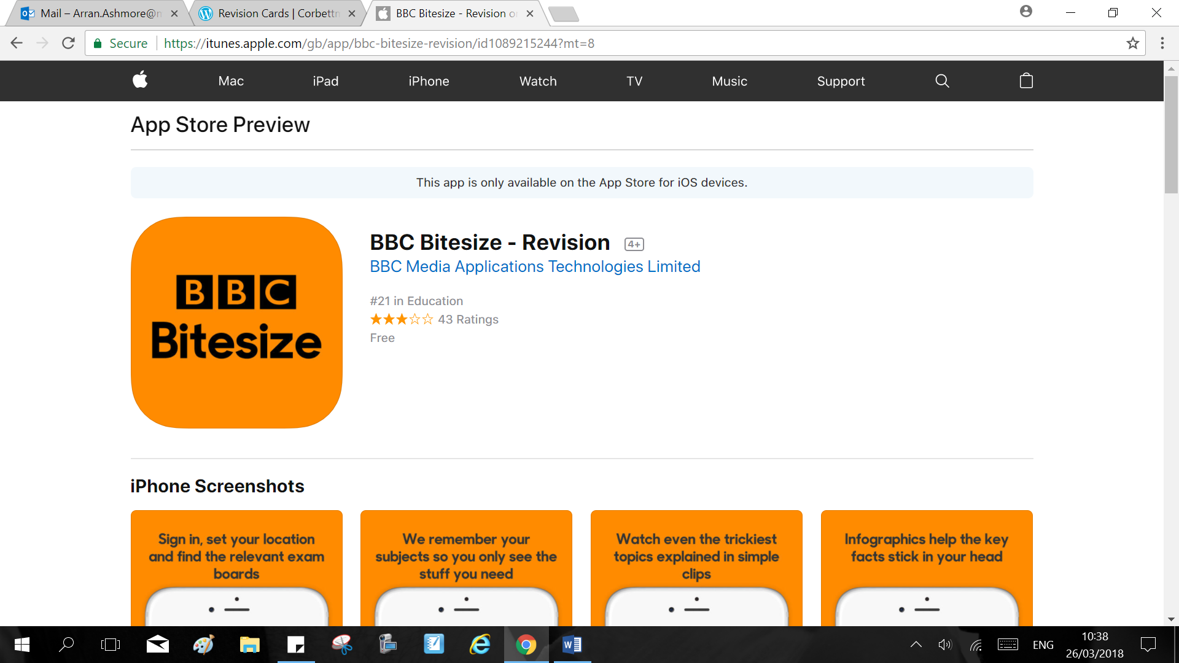

‘No longer given’ info you will now need to know….

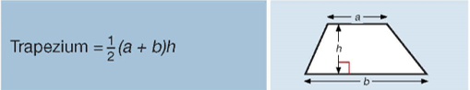
Area

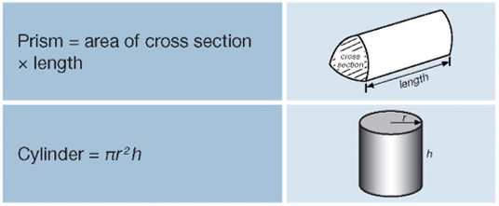

Volume

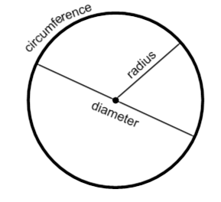
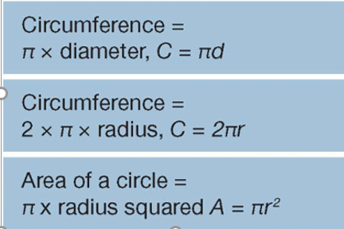

Circles

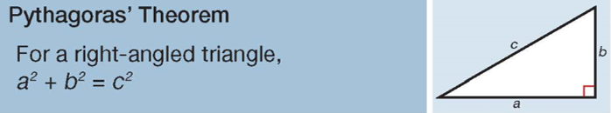
Pythagoras

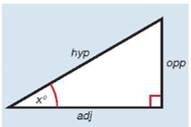
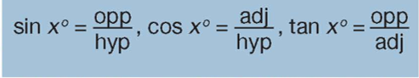
Trigonometry

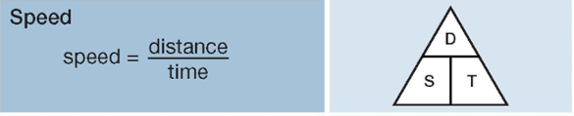
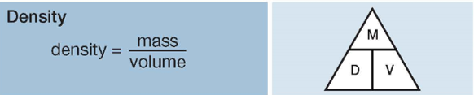
Compound measures
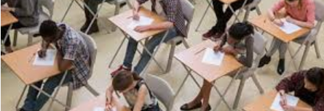
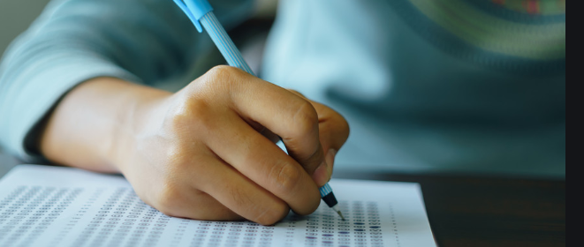
EXAM TIPS

- Make sure you understand the key word in the question:
- Write down/state – No explanation needed
- Calculate/find/solve/show – Show your working (step by step!)
- Draw – Plot accurately on graph provided and draw (using a ruler and pencil)
- [3 marks] – This is an indication of how many steps you will be required to show to answer the question

- Show your working and check your answers:
- Units – Ensure you include the units in your final answers
- Round at the end! – DO NOT round numbers during a calculation as this will mean the final answer is incorrect.
- Logical order – Put your workings in a logical step by step sequence.
- CHECK/CHECK/CHECK – Check you have put enough maths per marks and that you have answered the question (YES or NO etc).

- What are the examiners looking for?
- Work that is clearly set out, easy to follow and with a clear underlined answer.
- Neat drawings and graphs that have been well presented and the correct equipment used.
- Logical working out that clearly leads to the right answer.
- THE RIGHT ANSWER – obviously (make it obvious even if you are unsure)

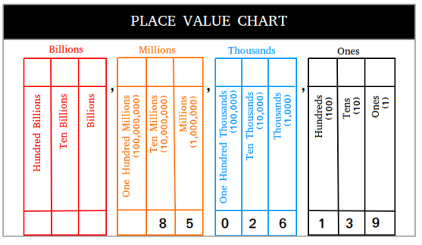
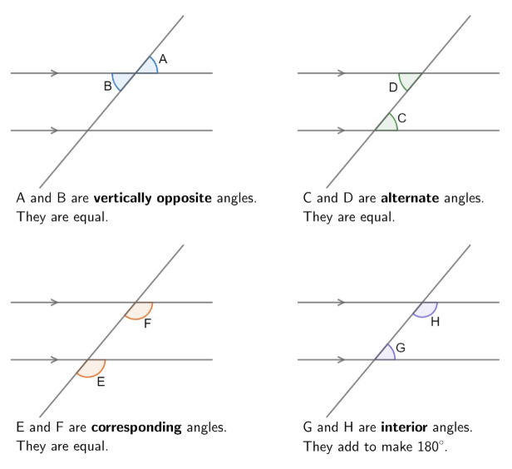
smaller < bigger 7=7 8 ≤ 8,9,10,11…..
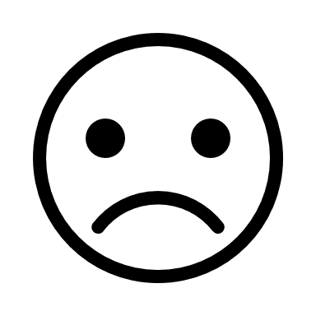
-neg 0 +pos Signs the same Pos+ Signs different – Neg

Bounds +0.5 and -0.5 eg. upper bound of 13 is 13.5, lower bound is 12.5
0.
%

fraction to decimal to percent eg. 0.42 42% 42/100
----
100
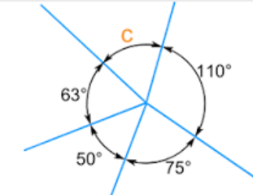
Angles at a point add to 360
Triangles add to 180
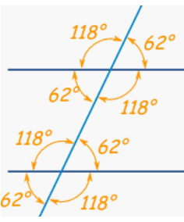
z z angles are the same inside
Quadrilaterals add to 360

BODMAS BIDMAS 3x2+4/6-1
+4x²

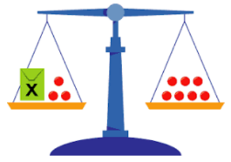
Algebra balance X + 3 = 7 becomes X = 7 - 3
term
Do the S A M E to both sides !

-2 times table starting at 5
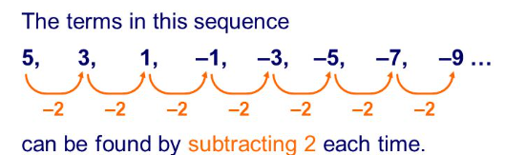
5 is different from -2 by 7
So…. 7 – 2n is the sequence
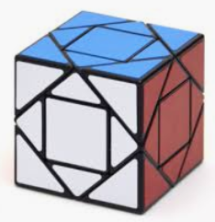

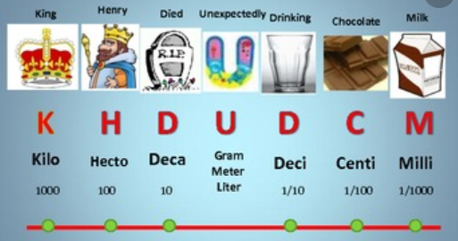
Y=kx Enlargement Side x k (..perimeter )
x k² (..area )
x k³ (..volume )

Kilo Hecto Deka Unit Deci Centi Milli eg 310 cm = 3.1 m
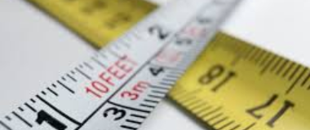
king henry drinks ukky dark chocolate milk ! METRIC CONVERSIONS !

RATIO 1kg = 2.2lbs ozs pounds stone tons
5 x 1kg = 5 x 2.2 lbs fl ozs pints
IMPERIAL CONVERSIONS in feet yards miles
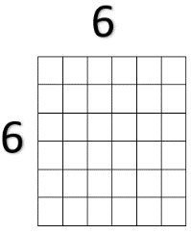

6x6 = 36 so square root of 36 is 6 √36 = 6
length of the line area of the shape
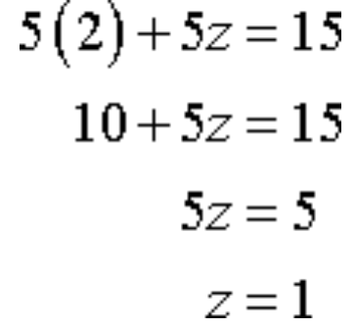
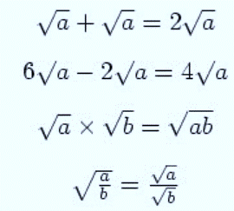

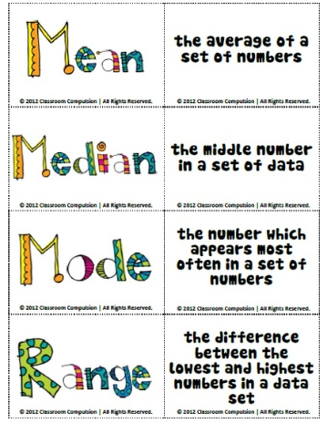

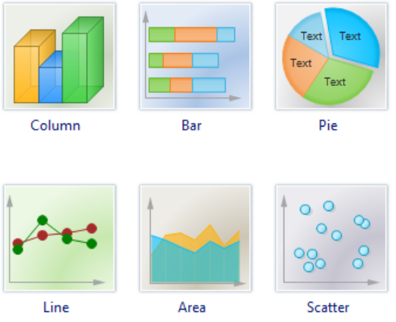

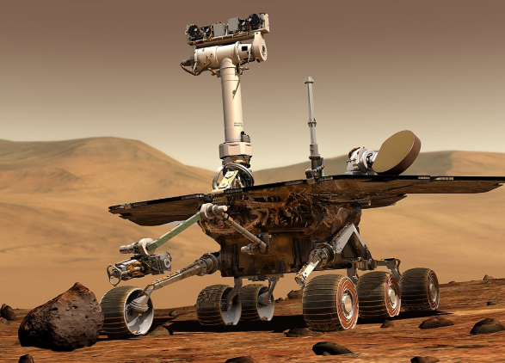
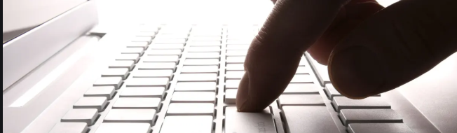
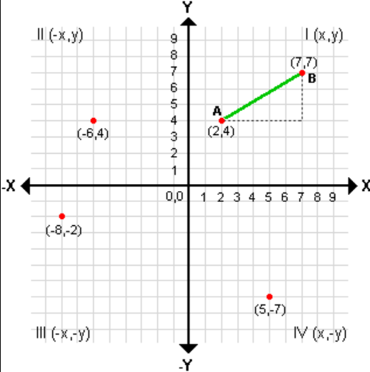

Coordinates ( x , y ) x first, then y

y = m x + c

Gradient is change in height (y) /change in run (x)

+c is where the line crosses the y axis
Nets
Plans

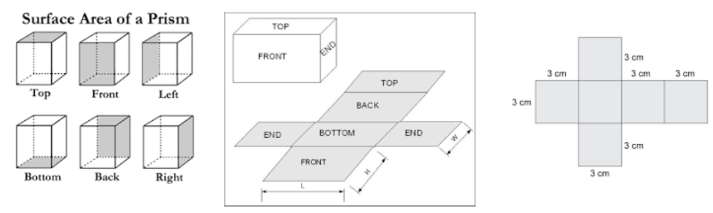

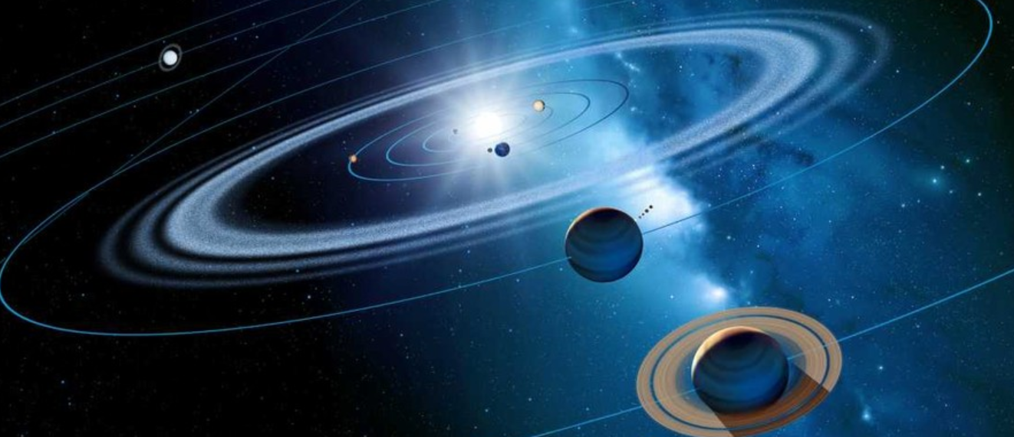
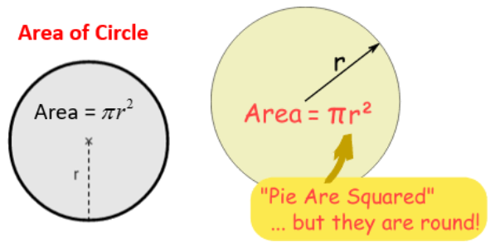
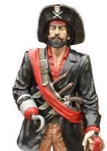
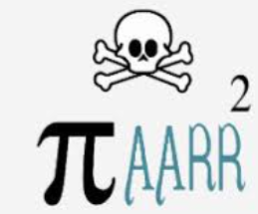

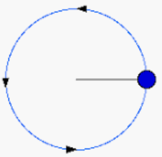
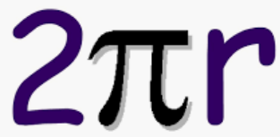

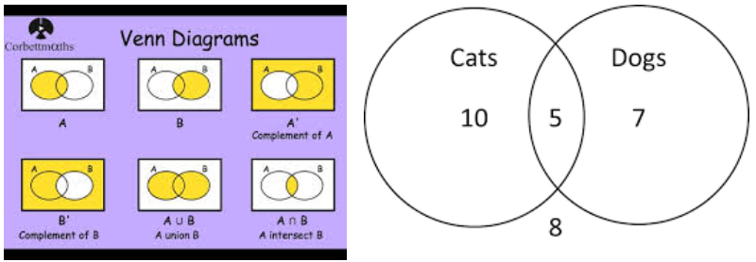

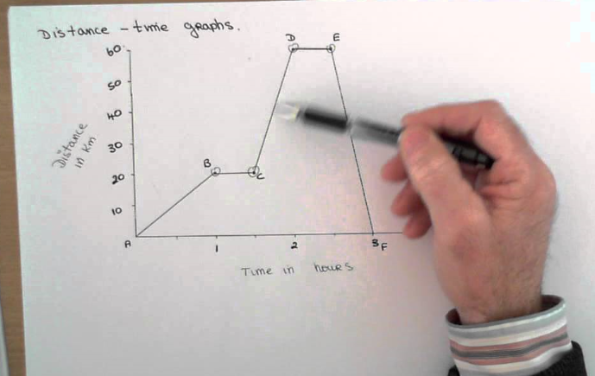
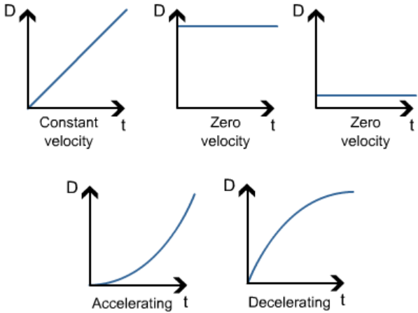

Split the graph into sections, describe each…
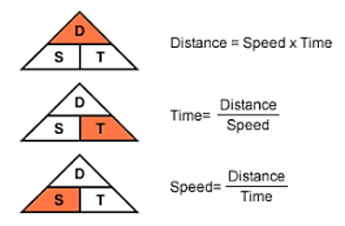
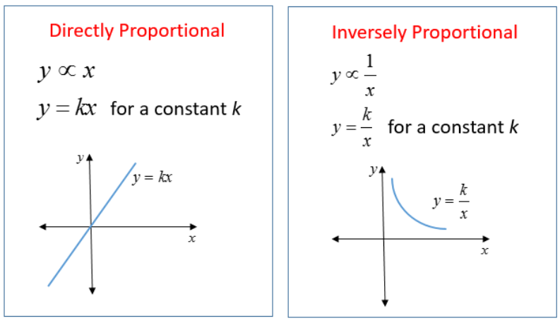

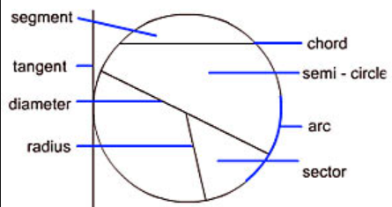
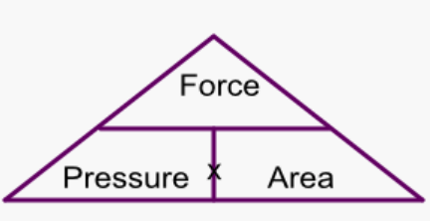

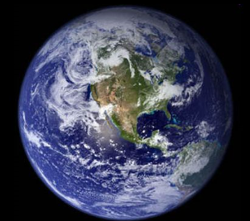
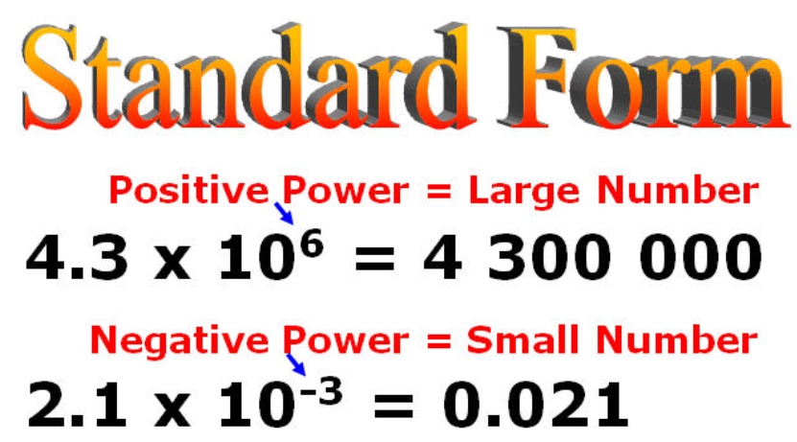

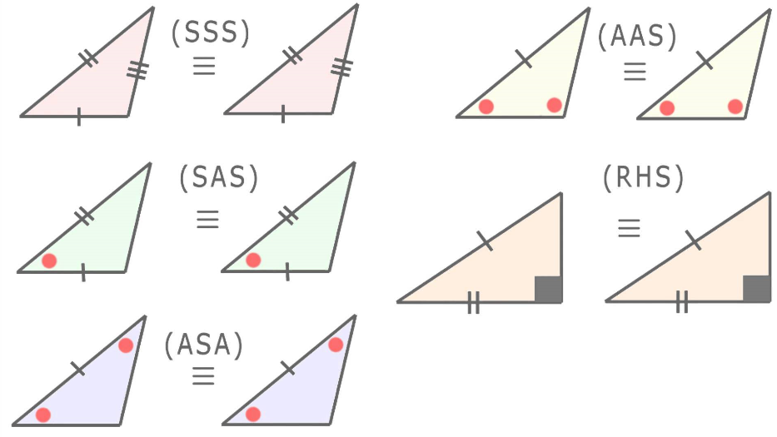
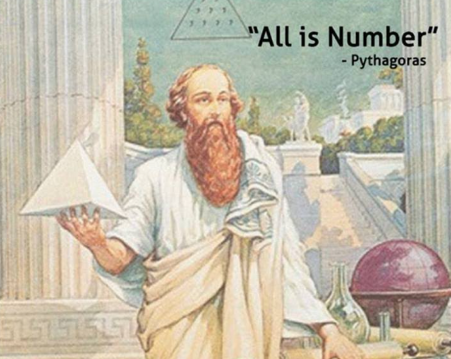
Same (congruent) triangles

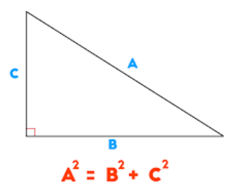
Isosceles SAME !

Similar – smaller or bigger

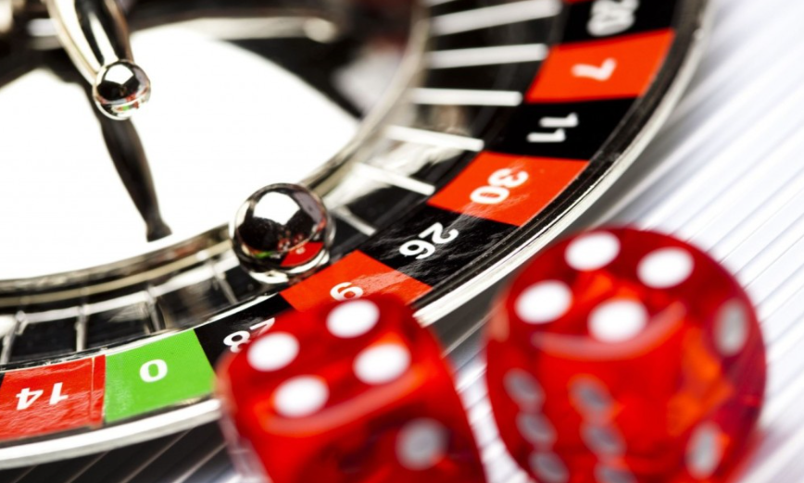
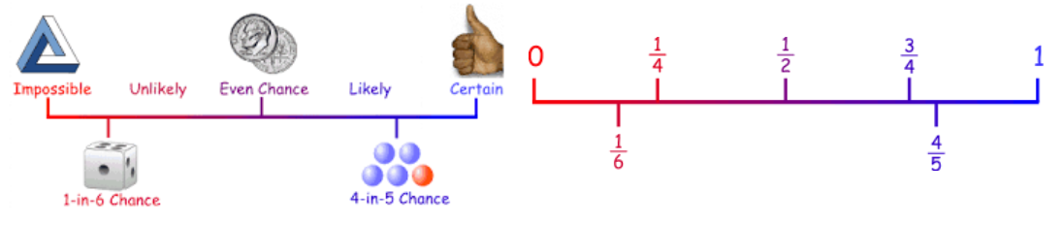

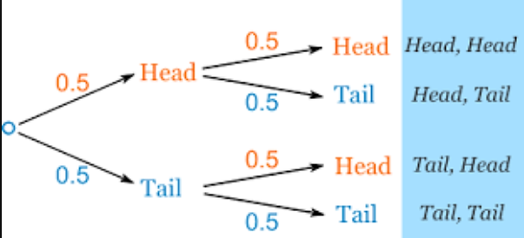

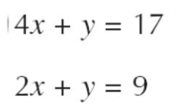
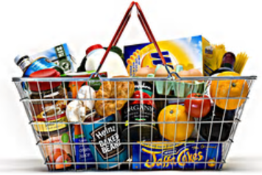

Simultaneous, .. make something the same…subtract…solve !
4x ////// = 17
2x ////// = 9

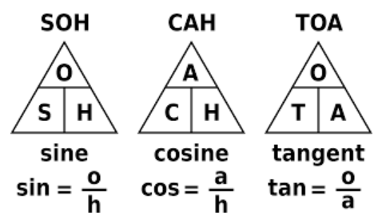
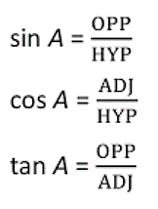

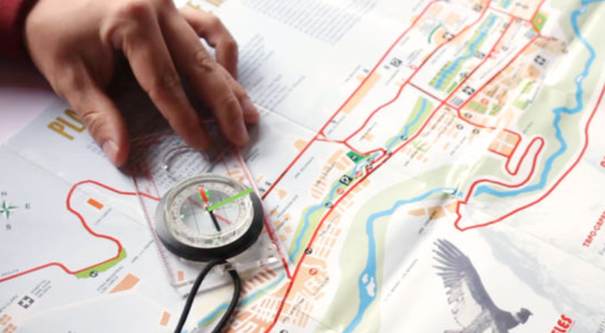

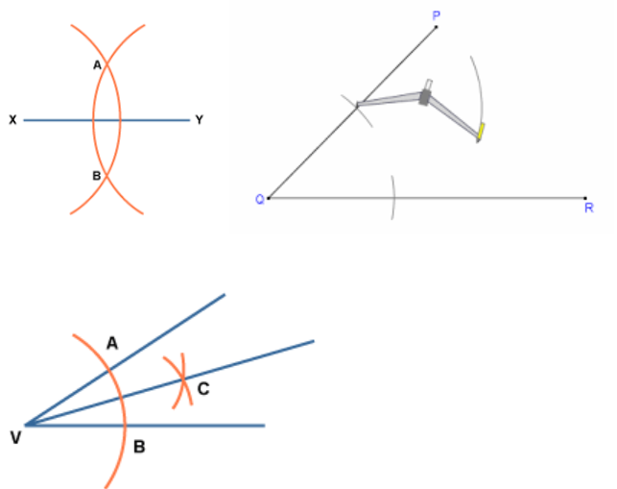

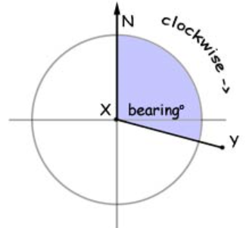

095⁰

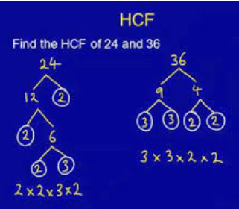
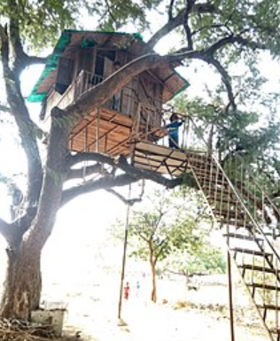
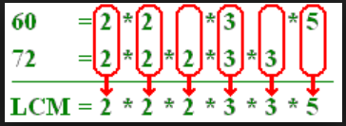

Lowest common multiple, Highest common Factor
‘QUAD’ (4) ratics…
