Matching Cards – LCM and HCF
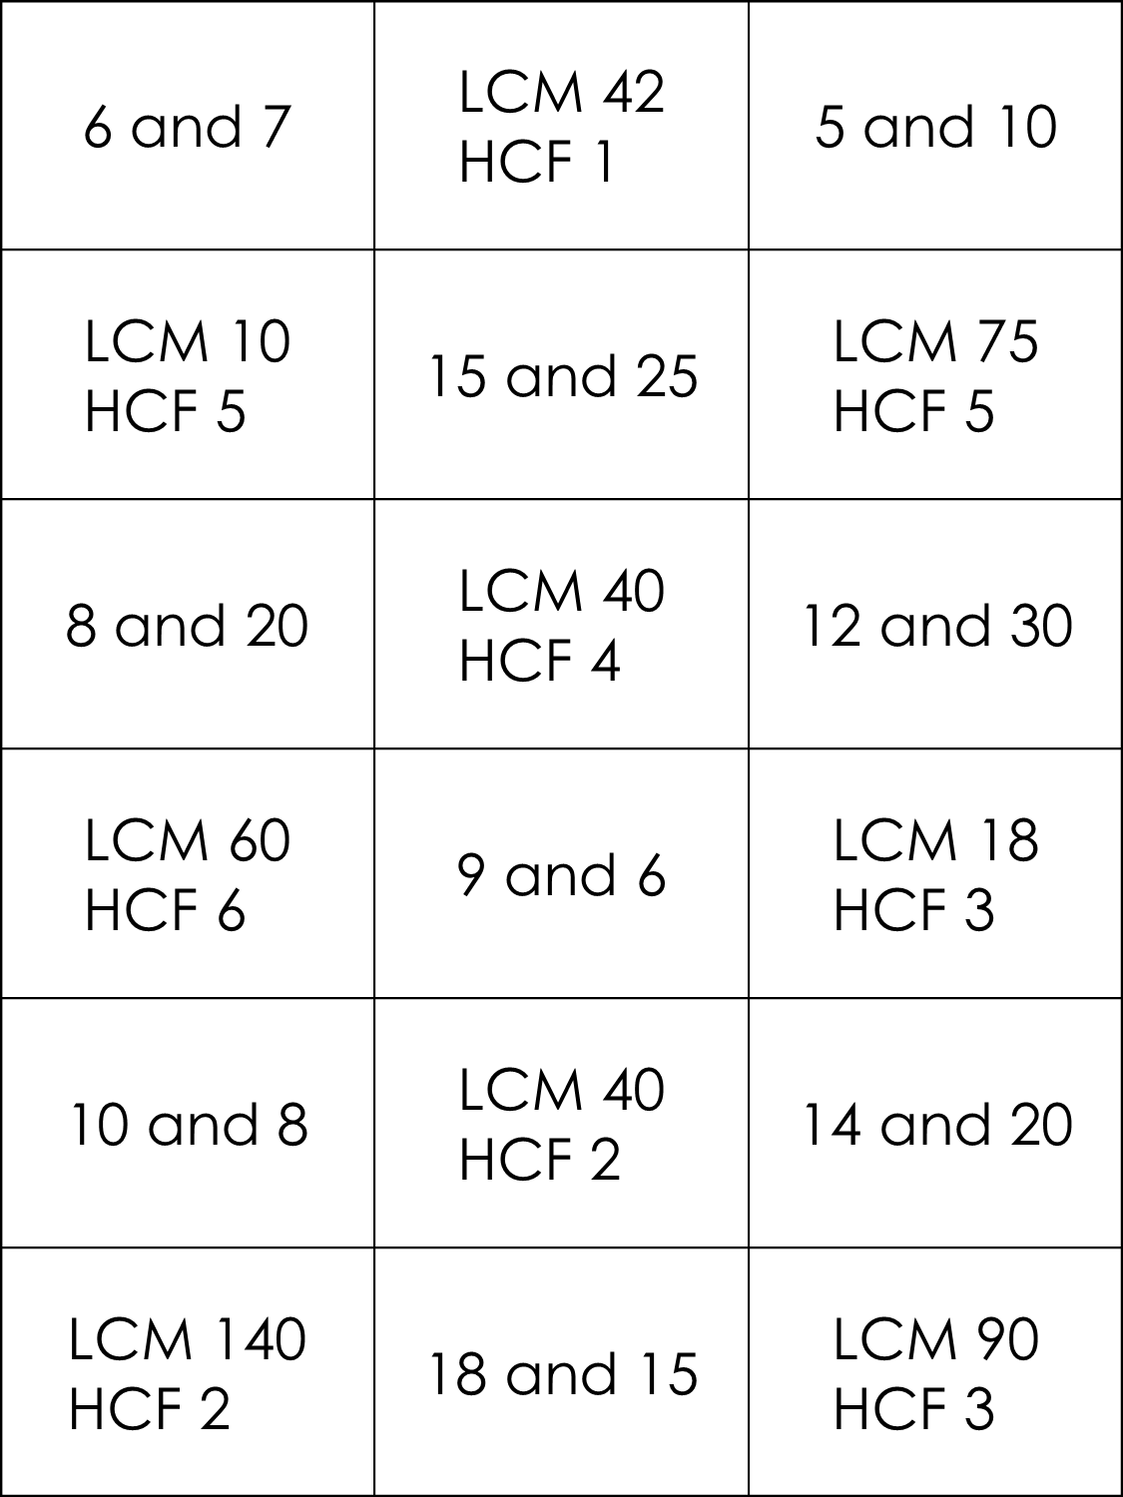

Matching Cards – LCM and HCF
