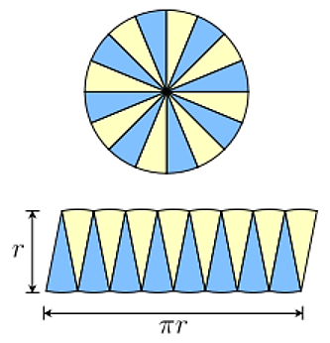
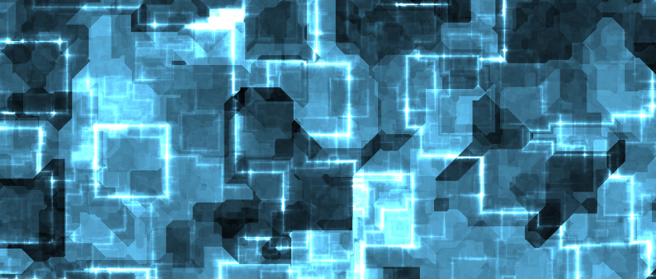
Is this image useful in showing you how a circle can be cut to produce a rectangle? How is this helpful in finding a circles’ area?

What measurements on the circle do you need to take to find its area?

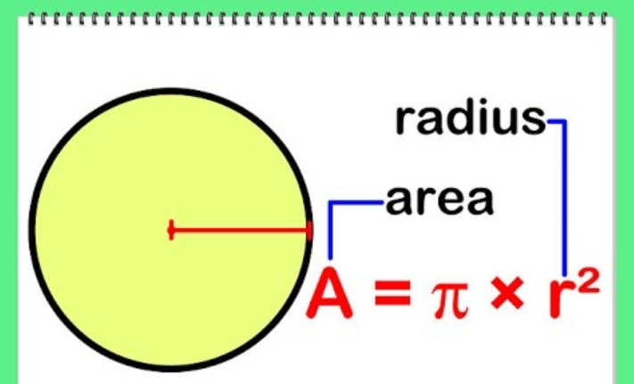
This is the formula for the area of a circle.
What is ‘A’?
What is ?

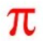
Why do you multiply ?
What is r² ?
If a circle has area 55cm², what’s its radius?

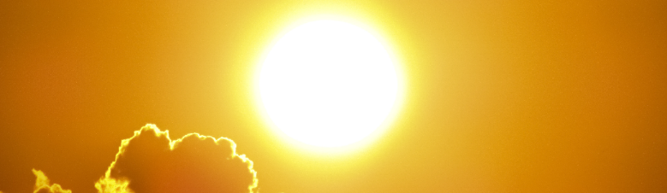

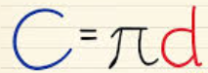
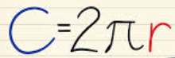
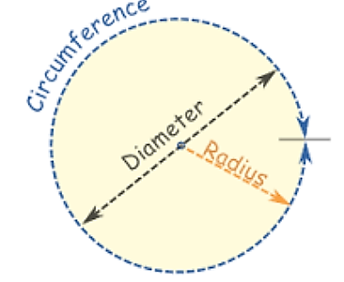

What is the connection between these three lengths?
If you know just one of these lengths, could you find the other two?


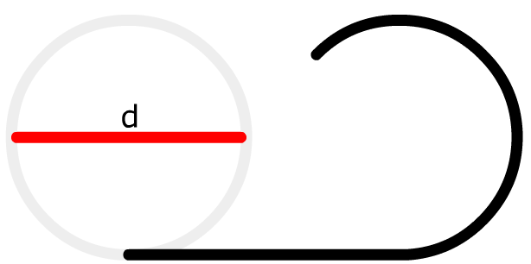
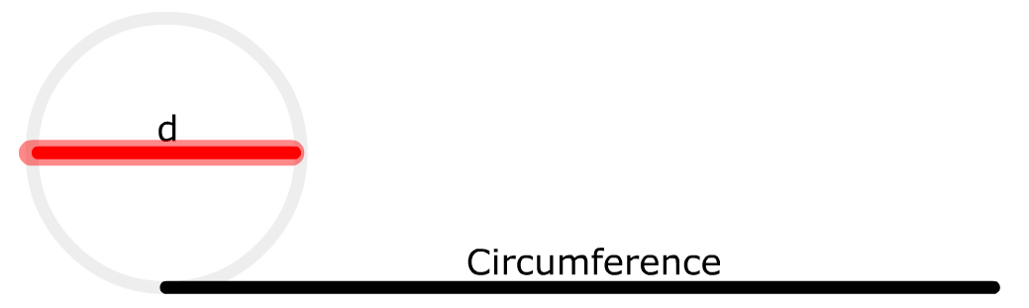

- The circumference of a circle is opened up and laid flat.
- How many times longer is this (black) circumference than the (red) diameter measurement?
- What is this special number called? How is it written?
- Knowing the length of the (red) diameter line can you work out the length of the black?...and the other way round?

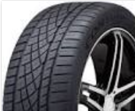

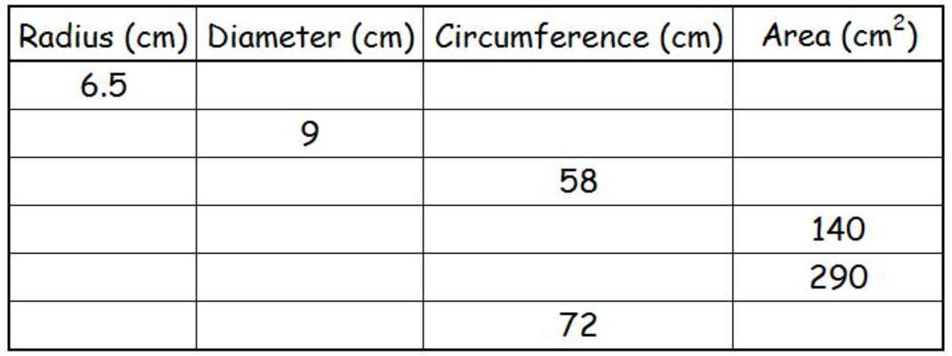

- Can you complete the table above with all the missing values?
- What formulas do you need to use?

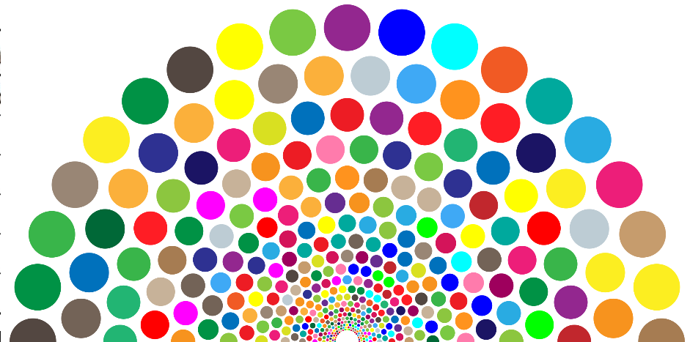

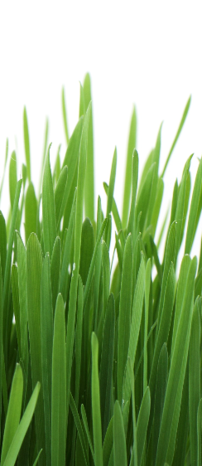

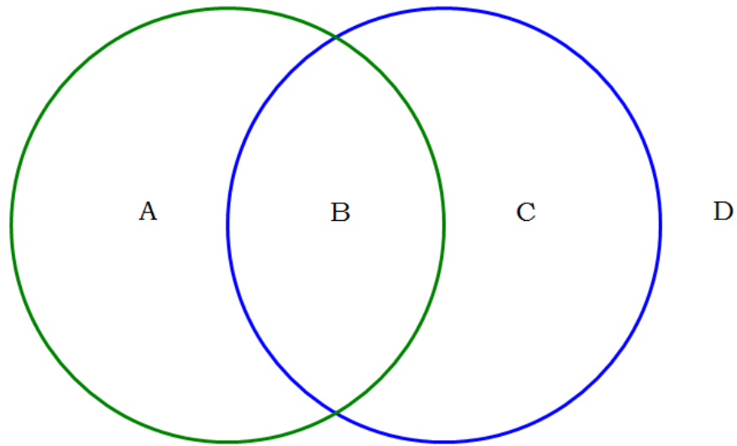

Each area A B C and D on this ‘Venn Diagram’ can be shaded in and given a symbol.
Can you draw and shade..
A n D C u A D’ (A n D)’

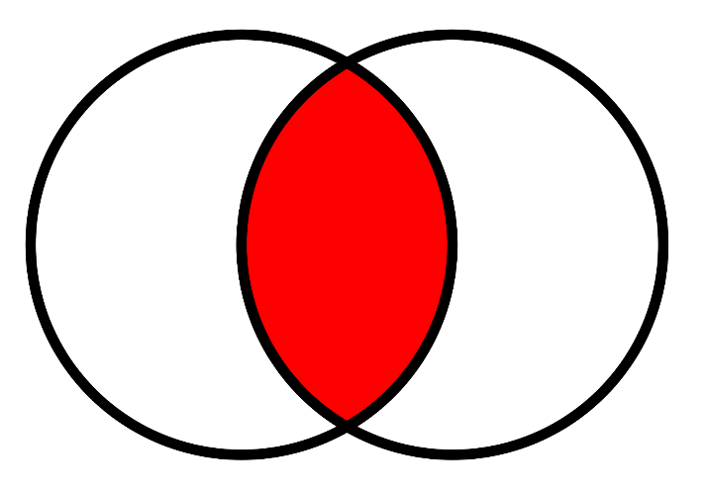
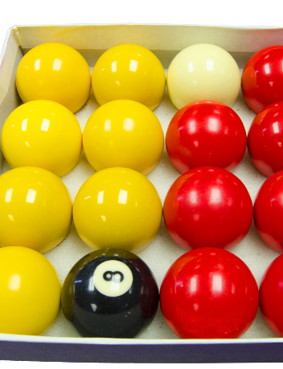

Discuss this shape and how it is used to show the intersection of two sets.
Can you suggest some sets of information that can be sorted like this?
Can you think of information that would be the same in both sets?

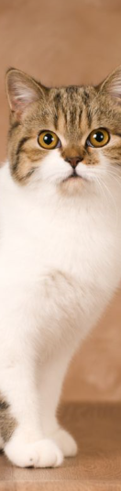
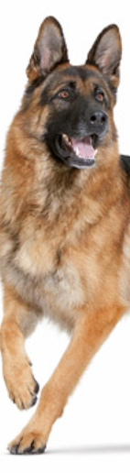
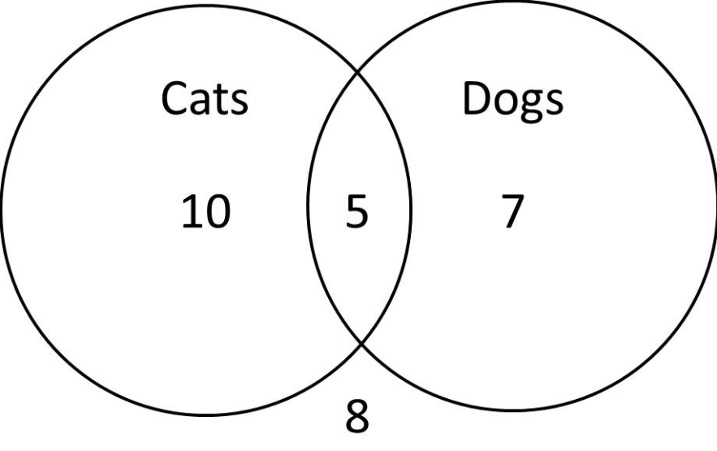

Discuss what the numbers 10, 5, 7 and 8 mean in this Venn Diagram.

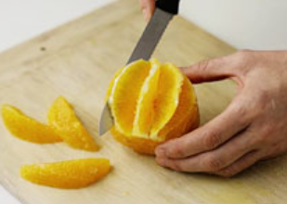
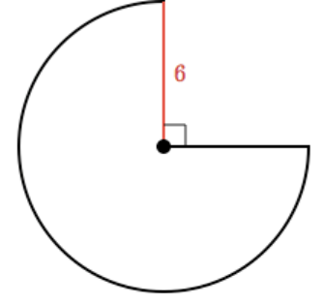

- What is the area of this shape?
- Can you write a formula for any fractional size piece taken from a circle?
- If this was 3D (a sphere) could you calculate fractional volumes?

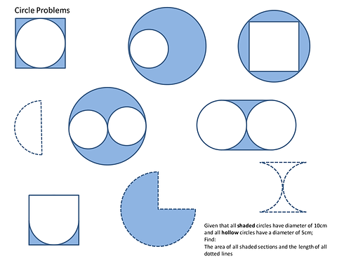

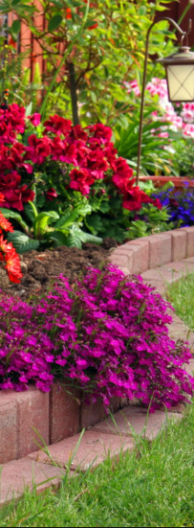
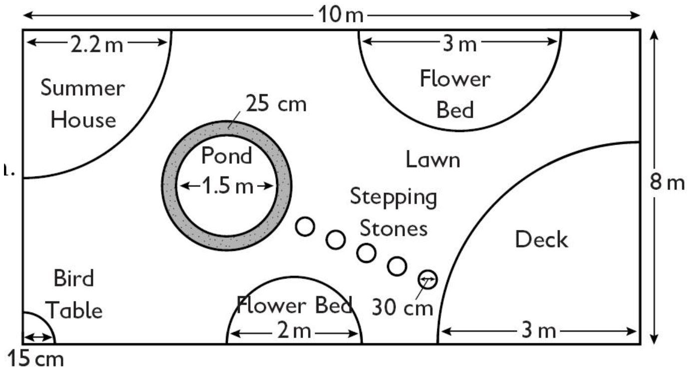

- Discuss this real life situation in regards to measurements of perimeter fence, land area etc and how you could calculate each of these.
- Show your calculations and formulas used

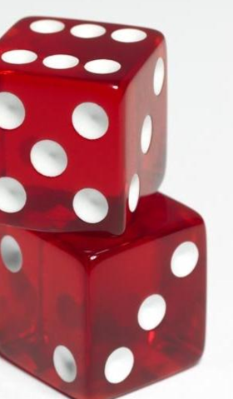
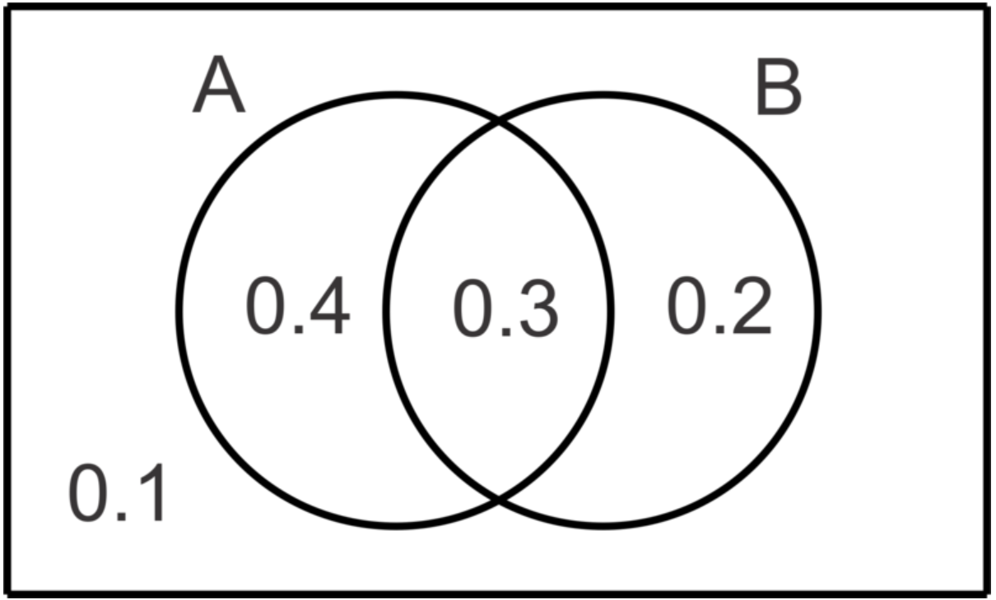

- Discuss how you can find the probability score…

P(AuB) or P(AnB)’

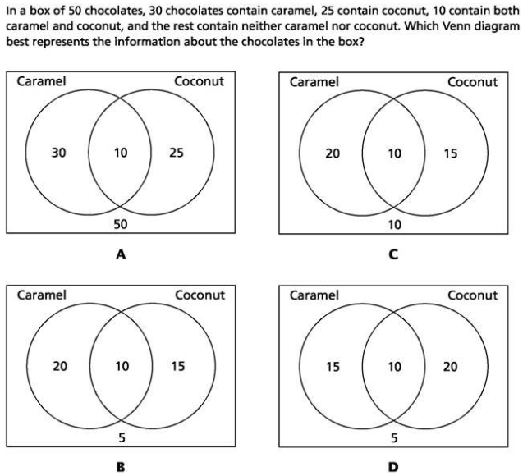
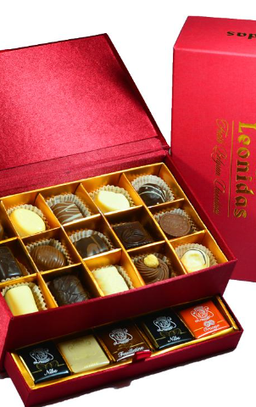

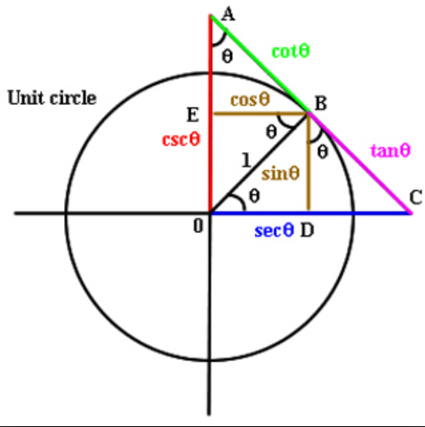
Find the lengths of all the coloured lines and the missing angle sizes
