Histograms
Name : | Class : | Date :

Mark : | /7 | %

1) The table below shows the heights of 20 people.  Complete the table to show the frequency densities, rounding your answer to 1 decimal place. | [1]
  Height | Frequency | Frequency Density
  140 $≤$ h $<$ 145 | 4
  145 $≤$ h $<$ 160 | 9
  160 $≤$ h $<$ 170 | 13
  170 $≤$ h $<$ 180 | 1
2) The histogram below shows the distribution of heights (cm) of 900 people.  Complete the table to show the frequency density and frequency for each class. | [1]
  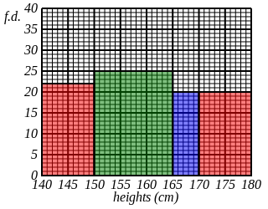
  Height | Frequency Density | Frequency
  140 $≤$ h $<$ 150
  150 $≤$ h $<$ 165
  165 $≤$ h $<$ 170
  170 $≤$ h $<$ 180
3) The histogram below shows the distribution of heights (m) of 900 trees in metres.  Complete the table to show the frequency for each class. | [1]
  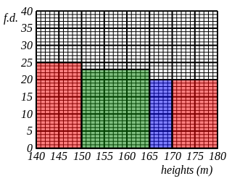
  Height | Frequency
  140 $≤$ h $<$ 150
  150 $≤$ h $<$ 165
  165 $≤$ h $<$ 170
  170 $≤$ h $<$ 180
4) The table below shows the height, in metres, of 1000 trees.  Use the table to fill in the missing bar in the histogram. | [1]
  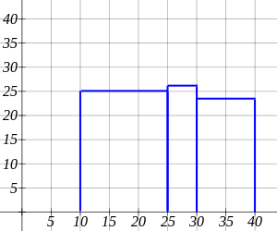
  Height | Frequency
  0 $≤$ h $<$ 10 | 257
  10 $≤$ h $<$ 25 | 377
  25 $≤$ h $<$ 30 | 131
  30 $≤$ h $<$ 40 | 235
5) The table below shows the heights of 900 people. Calculate the frequency densities for each class and construct a histogram. | [1]
  Height | Frequency | Frequency Density
  140 $≤$ h $<$ 145 | 114
  145 $≤$ h $<$ 155 | 246
  155 $≤$ h $<$ 165 | 208
  165 $≤$ h $<$ 180 | 332
6) The histogram below shows the distribution of heights (cm) of 1000 people.  Complete the table to show the frequency for each class. | [1]
  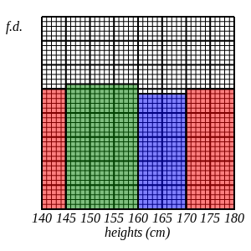
  Height | Frequency
  140 $≤$ h $<$ 145
  145 $≤$ h $<$ 160
  160 $≤$ h $<$ 170
  170 $≤$ h $<$ 180
7) The incomplete table and histogram give some information about heights (cm) of 900 people.  Use the information in the histogram to complete the table and hence find the value of the frequency density for the missing bar in the histogram. | [1]
  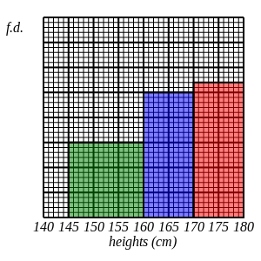
  Height | Frequency
  140 $≤$ h $<$ 145 | 155
  145 $≤$ h $<$ 160 | 225
  160 $≤$ h $<$ 170
  170 $≤$ h $<$ 180
Solutions for the assessment Histograms
1) 0.8,0.6,1.3,0.1 | 2) fd: 22,25,20,20  frequency: 224,375,98,203
3) 252,346,102,200

4) 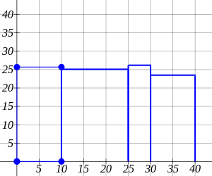

5) 22.8,24.6,20.8,22.1
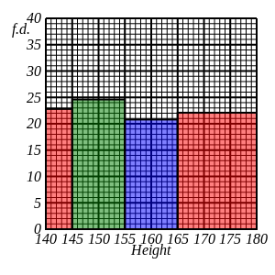

6) 124,392,235,249

7) Tables values are: 250, 270
Frequency density of missing bar is 31
