TASK 1


Q1 Daily Plan Practice

Derek wants to plan for his holiday. Use the information below to make a daily planner showing what Derek could do on each day and the times.

Derek is on holiday for 6 days and will arrive on a Sunday (day 1 of his holiday), he will not do anything the first day. He will travel back on the last day so no activities then. He wants to take a trip to a castle for 4 hours, plus a day at the beach. He also wants to explore a town centre but does not want to spend any more than 3 hours. He would like to take a walk in the area to sight see for about 4 hours. He wants a rest day by the pool after the longest days activities. No activity should be over 7 hours long or less than 2 hours.

Make a daily planer for Derek below showing the days, activities and times.


Q2 Working out the number of laps

A Formula 1 race track is 3200 metres long. A driver wants to have some practice laps and wants to complete at least 39km. Another driver says that this would be 12 laps of the race.
Show if the driver is correct that 12 laps will be at least 39km


Q3 Using Target Formulas

Jo swims laps at her local swimming pool to improve her performance while in training for a swimming competition. She uses the target formula below to work out her target training pace.

Target Training pace per km = Target for 5km + 10 seconds
5

Her target time for a 5km swim is 40minutes.
Use her formula to work out the target training pace per km.


Q4 Comparing actual swim time to target

Jo records her actual swim time for a 3km race while in training.
35 m : 14 sec
Jo thinks that she is not swimming fast enough. Show with workings below if she is correct.


Q5 Evaluating probabilities given prior outcomes

Jo looks at the times she has taken to swim the 5km race over the past six attempts while in training.
42min, 48mins, 43mins, 40mins, 47mins, 41mins

Jo thinks she will be faster in the actual 5km race and be better than these training times by 4 minutes.
Based on the prior 6 training times will she likely complete the actual race in 40mins? Show workings.

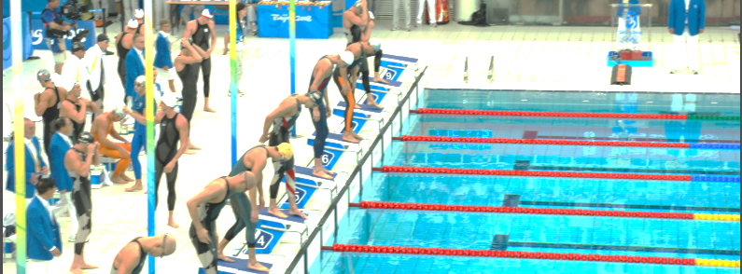
Q6 Top percentage calculation

Last year there were:
Number of swimmers = 250
Number of swimmers completing the 5km race in under 40mins = 75
Jo wants to finish in the top 20%. Would a race time of 40mins achieve this?


Q7 Sponsorship money

Jo asks her family for money to sponsor her for the 5km swimming race.
Below are the people and amounts offered
Name | Amount per km
Sister | 25p
Best friend | 10p
Work friend | 60p
Steve | 40p
Jenny | 50p

Jo has 2 more friends to ask for charity money. Jo thinks she can work out how much the other 2 friends can give so that the overall money with the two extra friends will be between 40% and 50% extra that has so far been offered.
Work out some values that the other two friends could be asked for to achieve this increase.

Q7b Show a check

Show a check of any of the calculation in Task 1. Make sure you use a DIFFERENT METHOD.

TASK 2

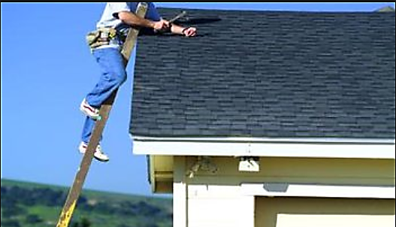
Q1 Measurement constraints

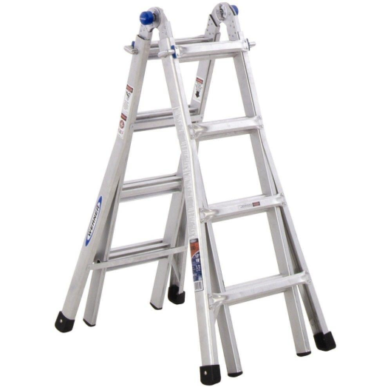
A ladder is to be bought to help with a DIY project. John wants the ladder to be small enough to carry but big enough to reach above a 3m high roof.

The ladder is folded in half when stored. John is 1m80cm tall. He wants the FOLDED ladder to not be taller than him. Work out a suggested ladder’s height that can be bought.

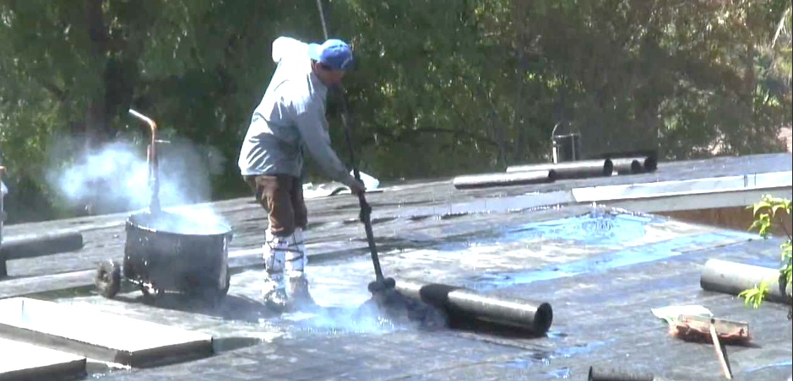
Q2 Checking materials area suitability



John’s flat roof is to be covered in a weather proof black tar bought in tins. Each tin of tar covers the area shown below.
1.5m

1.5m

John’s flat roof is 7 square metres large. He thinks he needs to buy 5 tins of black tar to cover the roof. Show if this is enough.

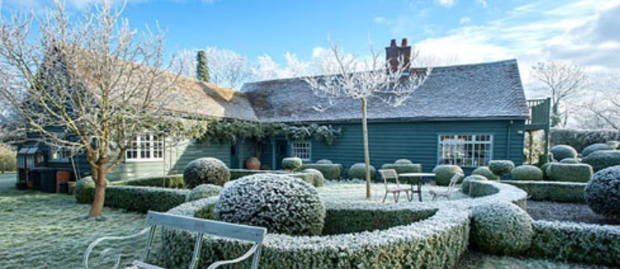
Q3 Working temperatures

John is outside completing his new roof but will not work when the temperature is below freezing.
Below are the temperatures over the past week.
Day | Mon | Tue | Wed | Thur | Fri | Sat | Sun
Temp C | 2 | 3 | 0 | -1 | 4 | 1
Work? YN

Between Saturday and Sunday the temperature drops by 4 degrees C. Record this Sunday temperature in the chart above and if he is working on that day or not.

Q3b Likely events based on prior knowledge

John thinks the temperatures next week will be colder than this week by 1 degree C. Based on this information, state if it is likely he will be able to work for at least 3 days next week.


Q4 Enough material?

John uses data on his phone each day. He estimates he uses 2.3 Gb of data each week. He has a contract with 10Gb of data per month. Show if he will go over his data allowance for a 31 day month.

Q5 Pricing up over time

The data John uses for his mobile is £5 for 2.5Gb top up or £18 for 10Gb per month. Show which is the best option to choose and how much this will cost over a year.

Q5b Show a check

Show a check of any of the calculation you have made in TASK B. Remember to use a DIFFERENT METHOD.

