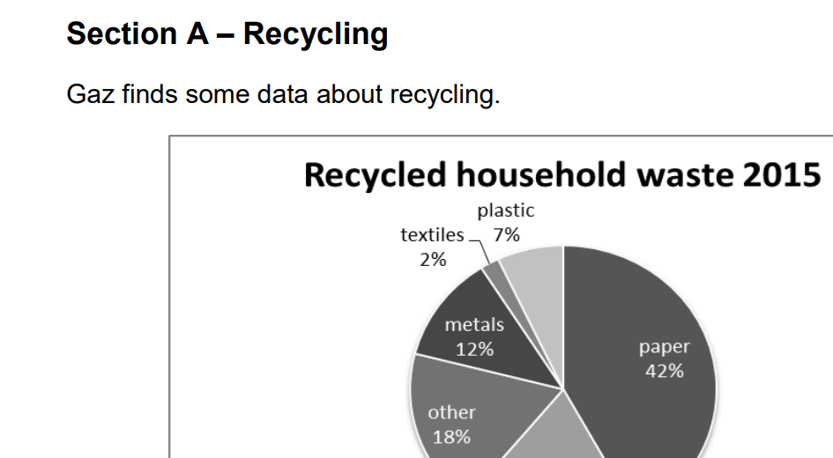
Practice Exam Questions
Target Sheet – Recycling L2

Please use this sheet to set at least 3 targets for your own home study based on the paper you practiced.
A Tick correct / incorrect Set as target??
1 Pie Charts/Reading
2 Percentages/Pie charts
3 Probability from Pie charts
4 Interpret info/%add to 100%
5 Ratios/Metric Weight
6 Checking work
B
1 Data comparison
2 Select info/Ratios/Fractions
C
1 Percentages
2 Percentages
3 Imperial-Metric convert/Area
4 Volume (Cylinder)
5 Area 2D shape diagrams
6 Checking Work

