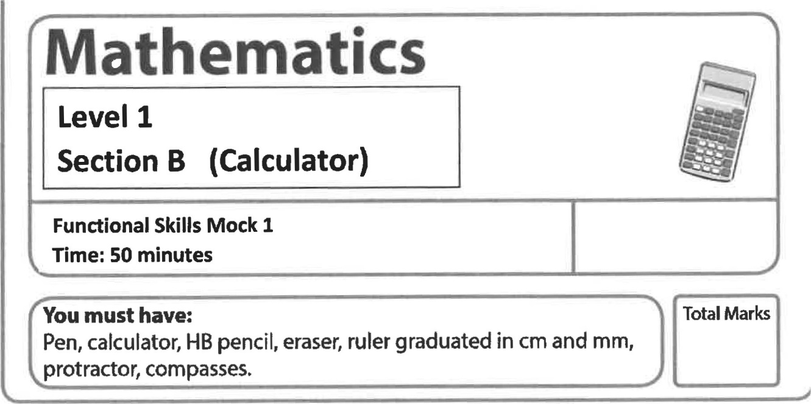
My signature confirms that I will not discuss the content of the test with anyone.
Signature:

Instructions
Use a black ball-point pen
- Fill in the boxes at top of this with your name
- Sign the declaration.
- Answer all questions.
- Answer the questions in the spaces provided — there may be more than you need
- You must show clearly how get your answers in the spaces provided Marts will be awarded for working out-
- Check your work and answers at each stage
- Diagrams are not accurately drawn, unless otherwise indicated.
- Calculators may not be used
Information
- The total mart for this 32
- The marks each question are shown in brackets use this as guide to how much time to spend on each question.
Read each question carefully

