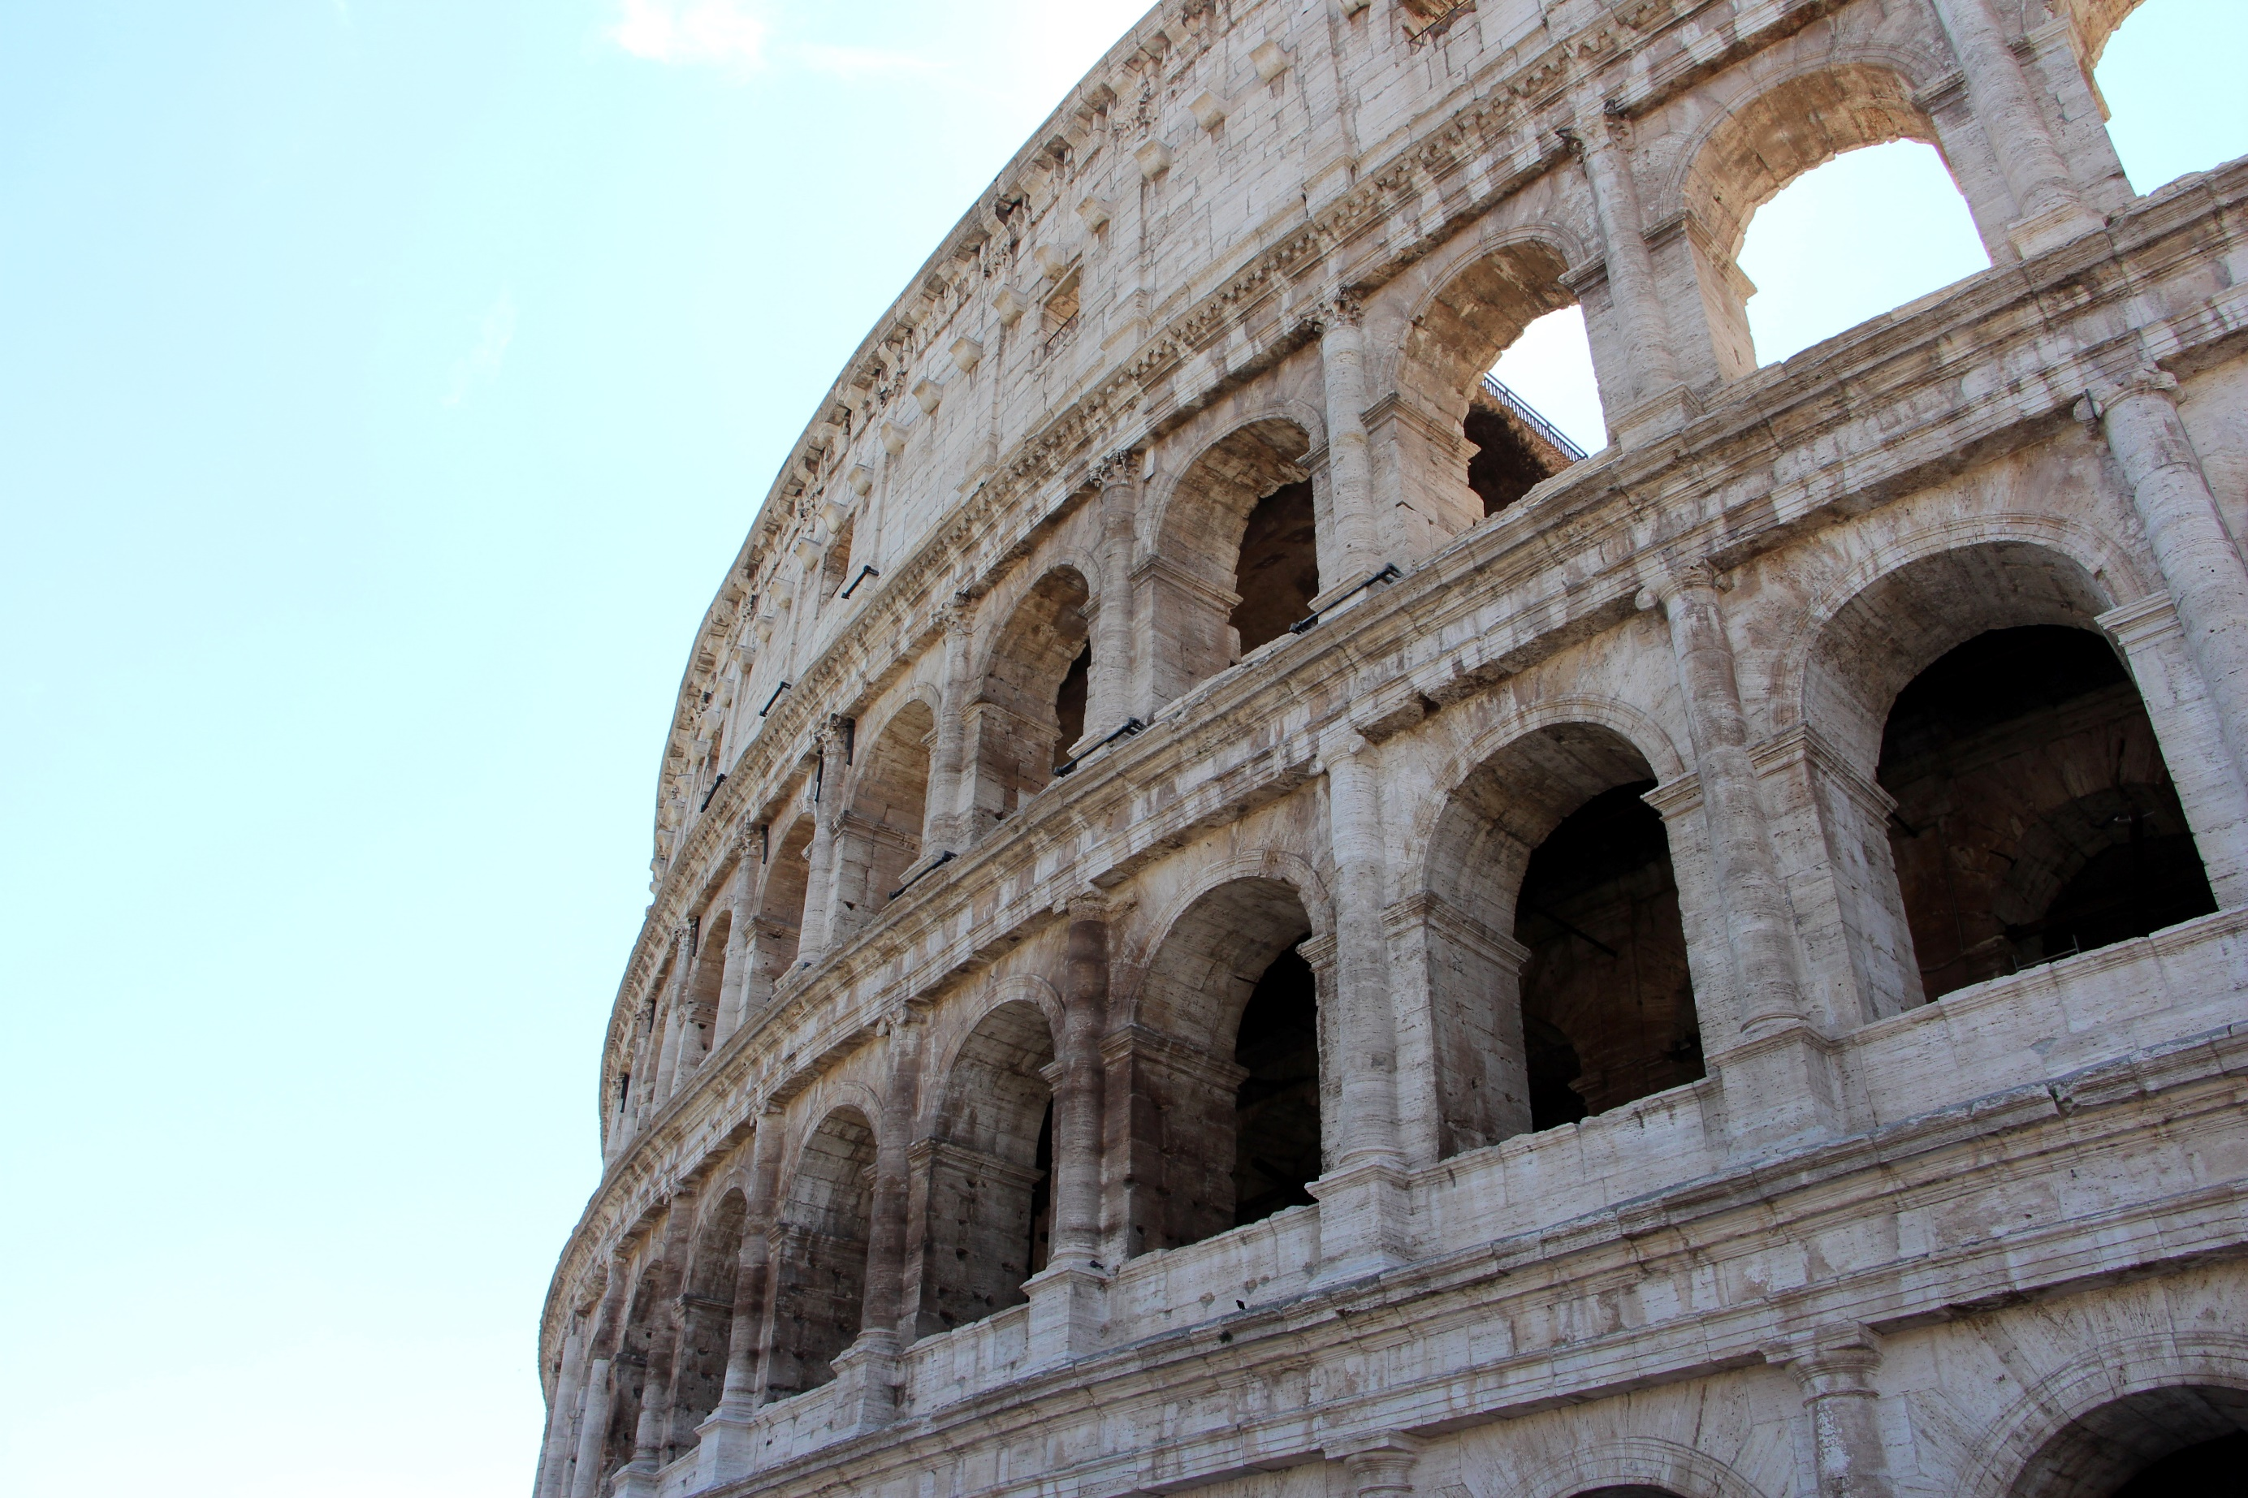
X~B(9,0.17)
Who will win at least 5 out of their 9 contests ??

