

How many discussion cards can you get through today? What was the most useful question…?

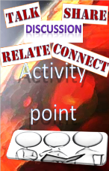

Draw a Venn diagram with 2 circles intersecting shading in (A’n B)

Q
On the ‘Learner Wall’ today, work with others and test each other by making up your own problems or solving the ones in the baskets!
Take a pic of your work to show later..

On the ‘Build’ table, use the Standards Units development sheets and/or the number/letter cards to explore today topic.
Don’t forget!... keep a copy of work produced!
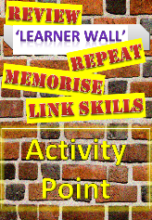
√
Q

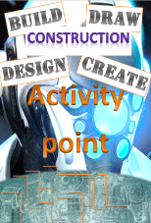
If the radius of a wheel is 70cm and you turn it 30 degrees, what is the arc length turned at the circumference?
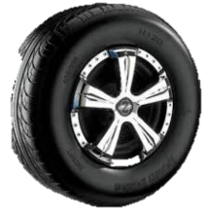

Use the ‘Ipad Station’ to access Moodle and BKSB. What did you get done today?

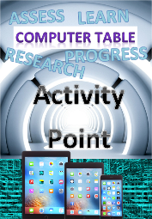


What English skills do you think you have developed today? (read, write, speak, listen)

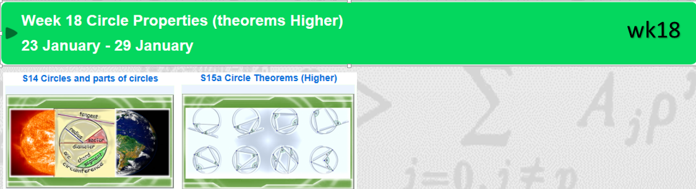

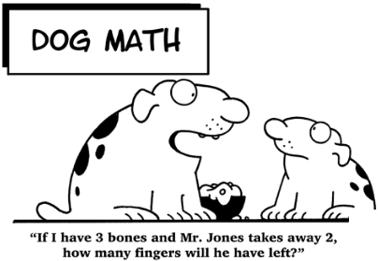
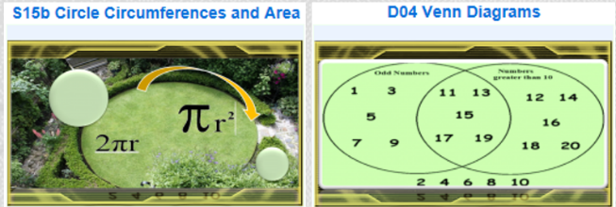

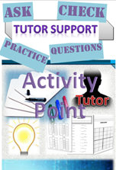
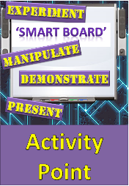
Can you name 6 parts of a circle? What is the relationship between the radius and circumference of a circle?
Booster Workpack
page 37-39 4.1
page 40 4.2
page 51 4.9
page 70 5.3

Make sure you test yourself with worksheets, online quizzes and bksb today. Are you happy with your score? What could you do to improve?
Use the smart board. What did you explore? Keep a copy of a screen to show back to the whole group at the end!
Nice simple question I hope… What did you learn today!

It would have been even better if…?
Q

Write down a really difficult problem below. Work with your tutor and other learners today and attempt to solve it by the end of the session!

