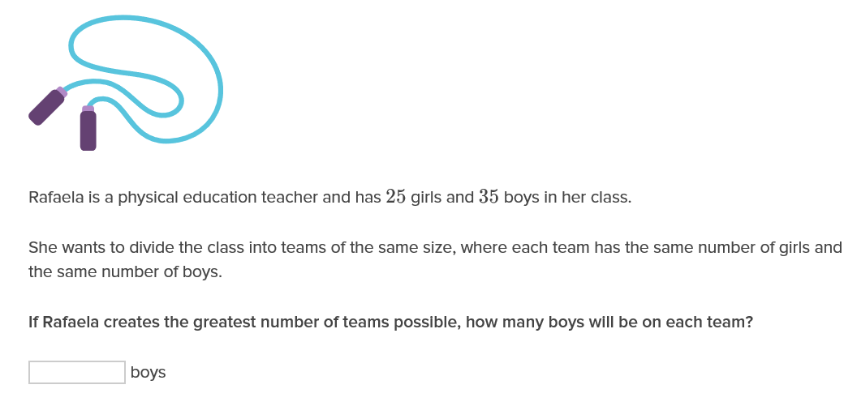
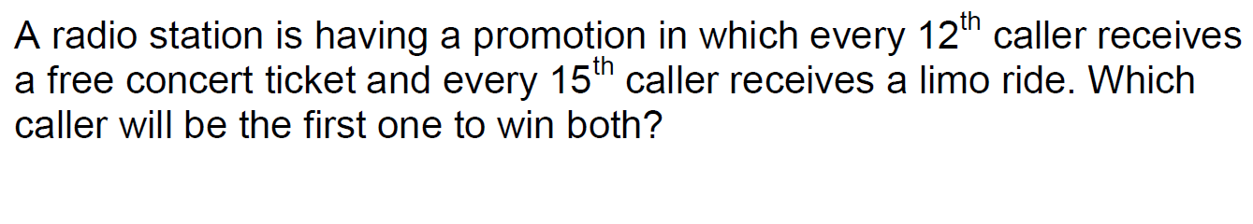
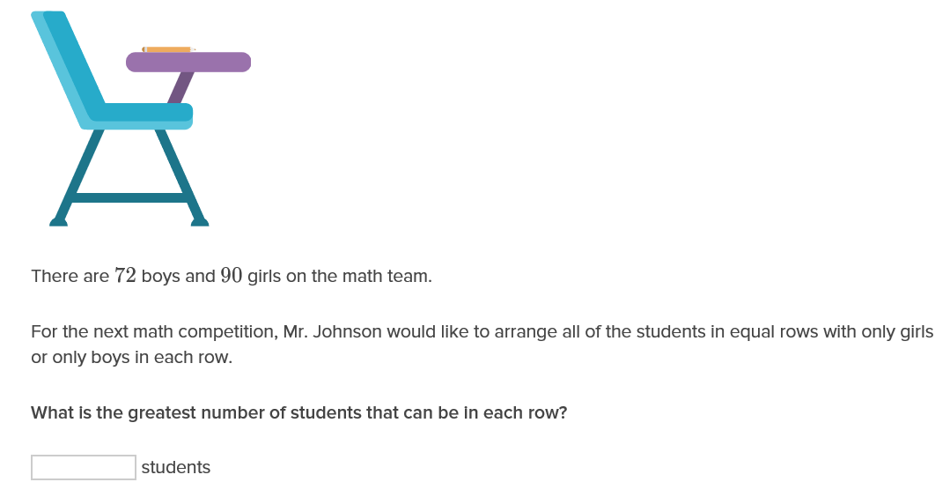

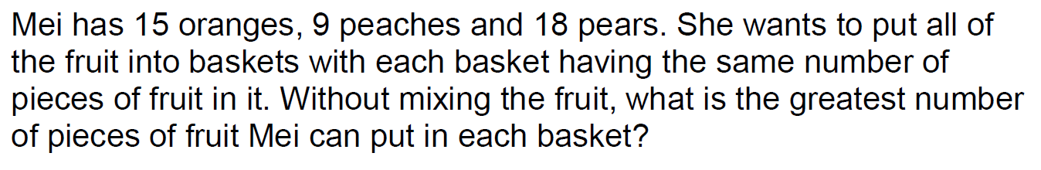

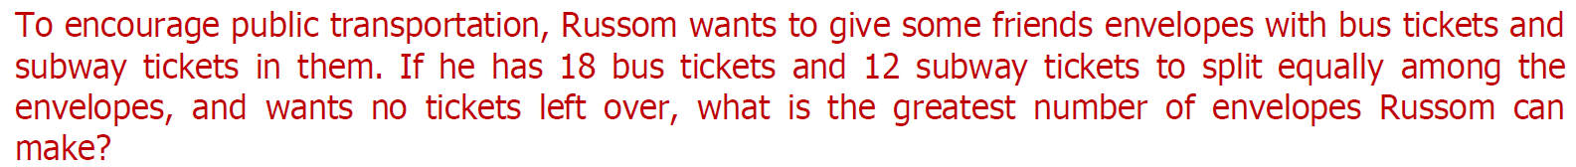

a) Tim has a bag of 36 orange-flavoured sweets and Peter has a bag of 44 grape-flavoured sweets. They have to divide up the sweets into small trays with equal number of sweets; each tray containing either orange-flavoured or grape-flavoured sweets only. If there is no remainder, find the largest possible number of sweets in each tray.
Answer: sweets
b) Martin is pasting pieces of square colored paper of equal size onto a board measuring 72 cm by 90 cm. If only whole square pieces are used, and the board is to be completely covered, find the largest possible length of the side of each square colored paper.
Answer: cm
c) Two wires with lengths of 448 cm and 616 cm are to be cut into pieces of all the same length without remainder. Find the greatest possible length of the pieces.
Answer: cm
d) Janice and Jasmine were each given a piece of ribbon of equal length. Janice cuts her ribbons into equal lengths of 2 m, while Jasmine cuts her ribbons into equal lengths of 5 m. If there was no remainder in both cases, find the shortest possible length of ribbon given to them
Answer: metres.
e) On a track for remote-controlled racing cars, racing car A completes the track in 28 seconds, while racing car B completes it in 24 seconds. If they both start at the same time, after how many seconds will they be side by side again?
Answer: seconds

Question 1:
Becky has 3 ribbons of different colours and lengths; a yellow ribbon 75cm long, an orange ribbon 375cm long and a red ribbon 135cm long. She wants to cut them up into smaller ribbons to use in a wedding decoration. They must all be the same size and there must be nothing left over. What is the greatest length, in cm, that she can make them?
Question 2:
Alfie, Noah and Amelia are rehearsing music routines. Alfie takes 22 seconds to finish his drum routine, Noah takes 176 seconds to finish his bass routine and Amelia completes her piano routine in 242 seconds. They all start practising at the same time and keep repeating their routines when completed. How long would it take before they all finish at exactly the same time?
Question 3:
Harry is decorating a square room with rectangular floor tiles. Each floor tile measures 242cm by 44cm. Harry uses the same floor tiles to cover the entire floor exactly. What is the smallest possible size of the square room?
Question 4:
Oscar is organising a party and needs to buy napkins and paper plates. Napkins come in packs of 189 and paper plates come in packs of 147. He needs exactly the same number of napkins and paper plates, with none left over. What is the minimum of each pack he must buy?
Question 5:
Charlie has 2 planks of wood, 63cm long and 147cm long. He wants to saw them into smaller pieces of wood for his crafts project. They must all be of equal length, with no wood wasted. What is the greatest length, in cm, that he can saw the planks into?

1. Joanne is campaigning for class president and plans to distribute some campaign materials: 20 flyers and 16 buttons. She wants each classroom to receive an identical set of campaign materials, without having any materials left over. What is the greatest number of classrooms Joanne can distribute materials to?
_____________________________
2. Serena wants to create snack bags for a trip she is going on. She has 6 granola bars and 10 pieces of dried fruit. If the snack bags should be identical without any food left over, what is the greatest number of snack bags Serena can make?

_____________________________
3. Matthew goes hiking every 12 days and swimming every 6 days. He did both kinds of exercise today. How many days from now will he go both hiking and

swimming again? _____________________________
4. Mandy is making emergency-preparedness kits to share with friends. She has 12 bottles of water and 16 cans of food, which she would like to distribute equally among the kits, with nothing left over. What is the greatest number of kits Mandy can make? _____________________________
5. Edeena is packing equal numbers of apple slices and grapes for snacks. Edeena bags the apple slices in groups of 18 and the grapes in groups of 9. What is the smallest number of grapes that she can pack?

_____________________________
6. A club has 16 girls and 8 boys as members. The president wants to break the club into groups, with each group containing the same combination of girls and boys. The president also wants to make sure that no one is left out. What is the greatest number of groups the president can make?

_____________________________
7. Ariel is making flower arrangements. He has 7 roses and 14 daisies. If Ariel wants to make all the arrangements identical and have no flowers left over, what is the greatest number of flower arrangements that he can make?

_____________________________
8. Wilma is thinking of a number that is divisible by both 17 and 8. What is the smallest possible number that Wilma could be thinking of?

9. Sarah’s Shipping and Ryan’s Mail Services both ship packages. Sarah’s trucks will only carry loads of 18 packages. In contrast, Ryan’s trucks will only carry loads of 11 packages. If both businesses ended up shipping the same number of packages this morning, what is the minimum number of packages each must have shipped?

_____________________________
10. Nathan is stocking bathrooms at the hotel where he works. He has 18 rolls of toilet paper and 9 bars of soap. If he wants all bathrooms to be stocked identically, with the same combination of supplies in each one and nothing left over, what is the greatest combination of bathrooms Nathan can stock?

_____________________________
11. Tayli wishes to advertise her business, so she gives packs of 13 red flyers to each restaurant owner and sets of 20 blue flyers to each clothing store owner. At the end of the day, Tayli realizes that she gave out the same number of red and blue flyers. What is the minimum number of flyers of each color she distributed?

_____________________________
12. Jackson Stationery sells cards in packs of 11 and envelopes in packs of 13. If Kina wants the same number of each, what is the minimum number of cards that she will have to buy?

_____________________________
13. Lavinia has 9 glasses and 6 mugs. She would like to set them out in identical groups, with none left over, in preparation for a dinner party. What is the greatest number of groups Lavinia can set out?

_____________________________
14. Aylin is making a scrapbook using 18 photos and 20 newspaper clippings. She wants all the pages to be set up in the same way, with the same combination of photos and newspaper clippings on every page. She also wants to make sure that no items are left over. What is the greatest number of scrapbook pages that Aylin can create?

_____________________________
15. Hay’s Linens sells hand towels in sets of 17 and bath towels in sets of 6. If the store sold the same number of each this morning, what is the smallest number of each type of towel that the store must have sold?

_____________________________
16. In preparation for a party, Brant is putting desserts onto platters. The chocolate cake is cut into 15 pieces and the cheesecake is cut into 6 pieces. If he wants to prepare identical platters without having any cake left over, what is the greatest number of platters he can prepare?

