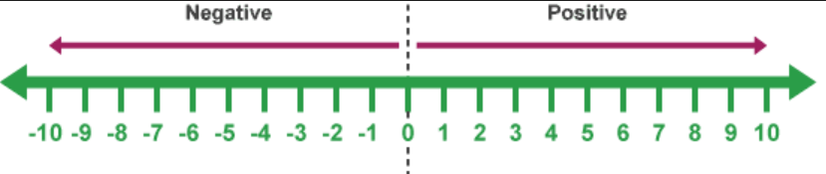
2
Use line to demo:
a) -3 + -2
b) 2 - - 5 – 4
c) 8 – (2 – 3) etc…

3

