Mark scheme

Question | Skills standard | Process | Mark | Evidence
1 | A4 | Process to find 20%  Accurate figure | 1 or  2 | 20 ÷100 x 150 (=30) oe  (£) 30
2 | R3  I6 | Process to work percentage  Correct decision from accurate figures | 1 or  2 | 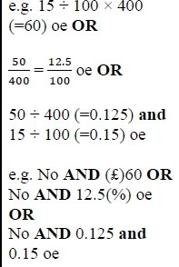
3 | R1  R2  A4  A4  I6 | 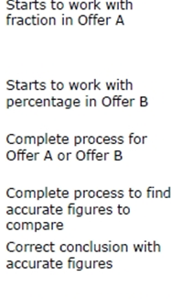 | 1  1  1 or  2 or  3 | 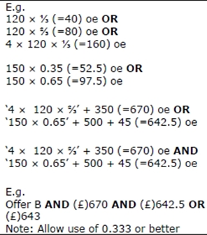
4 | R3  A4  A4  I7 | 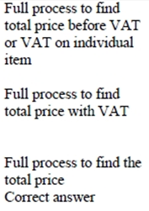 | 1 or  2 or  3  1 | 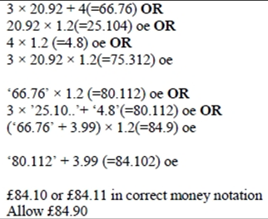
5 | R3  A4  I7 | 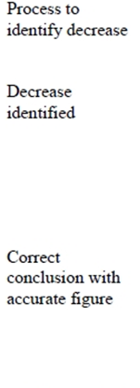 | 1 or  2 or  3 | 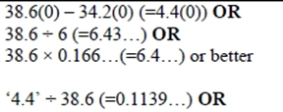  20 %  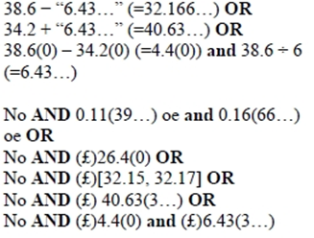
6 | R1  A4  I6 | Accurate total number of first time customers  Full process to find percentage  Accurate figure to 1dp for their acceptable percentage calculation | 1  1 or  2 | 