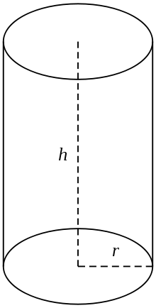
V=
V=
V=
V=
V=
V=
CYLINDERS V= pi r ² L
L2

