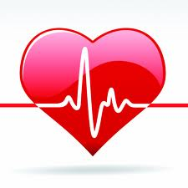
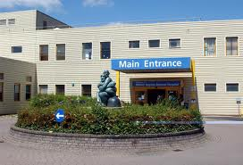
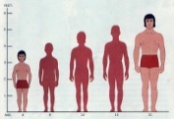
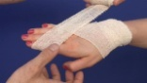
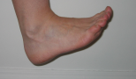
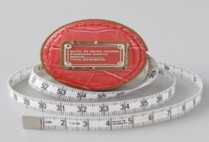




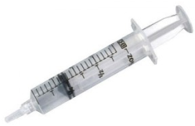
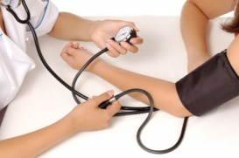
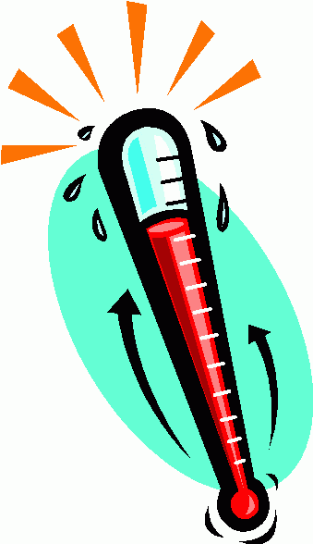
no. of beats
bpm is number of beats per minute
10s
20s
30s
15s
bpm=
F=
F=
C=
F=
C=
F=
C=
C=
Farenheit =
double Celsius then add 32
Distance to MK Hospital
km
Measure your hand
Measure your foot
Measure your height
mm
cm
m
Measure lengths
Order, and convert to a different unit eg.. 500ml = 0.5 lit
Order, and convert to a different unit eg.. 500g=0.5kg
0.201kg
1240 g
99 g
3 g
4 kg
0.052kg
9 g
4300mg
8000 g
0.6 kg
147mg
0.8 kg
29g
86 mg
1.7 kg
320g
Medical Record Card – L1
Measure weights
35ml …..
900ml ….
1.25 l ….
350ml ….
0.71 l ….
0.23 l ….
915 ml ….
Measure liquids
sec
Take a temperature
Take a pulse rate

