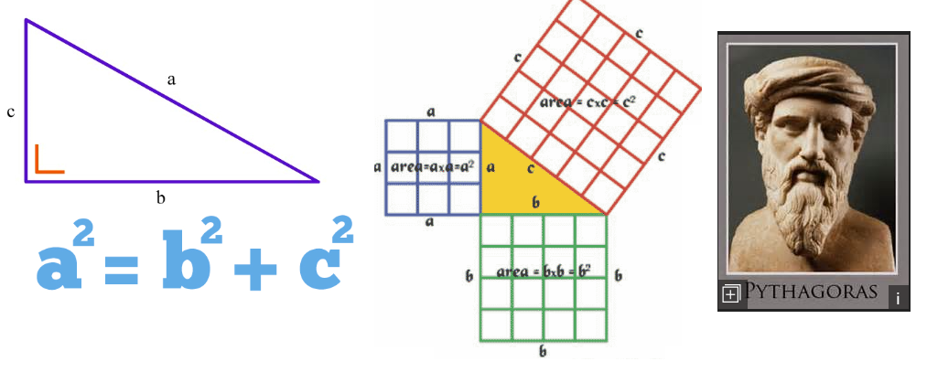
Task: Prove pythagoras theory
- Build using the cubes, 3 areas that produce triangles in their centres to explore the squaring of side lengths (see image above).
- Draw triangles and measure their side lengths showing one side can be found from the other two (use the formula).
- Use the string to measure out large triangle areas in the room from floor to ceiling, or find the longest lengths that fit inside the objects on the table.

