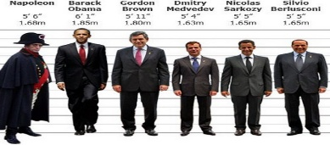
Standard Deviation(tables) Practice Sheet
This Photo by Unknown Author is licensed under CC BY
For each table, calculate the mean, variance, and standard deviation. Use midpoints multiplied by frequency to find the mean.

Q1: Heights of Students (cm)
Class Interval | Midpoint | Frequency
140-150 | 145.0 | 5
150-160 | 155.0 | 8
160-170 | 165.0 | 12
170-180 | 175.0 | 10
180-190 | 185.0 | 5

Q2: Daily Screen Time (hours)
Class Interval | Midpoint | Frequency
0-2 | 1.0 | 6
2-4 | 3.0 | 10
4-6 | 5.0 | 8
6-8 | 7.0 | 4
8-10 | 9.0 | 2

Q3: Weekly Grocery Spending ($)
Class Interval | Midpoint | Frequency
20-40 | 30.0 | 4
40-60 | 50.0 | 6
60-80 | 70.0 | 10
80-100 | 90.0 | 8
100-120 | 110.0 | 2

Q4: Commute Times (minutes)
Class Interval | Midpoint | Frequency
10-20 | 15.0 | 3
20-30 | 25.0 | 7
30-40 | 35.0 | 12
40-50 | 45.0 | 6
50-60 | 55.0 | 2

Q5: Age Distribution in a Club
Class Interval | Midpoint | Frequency
18-25 | 21.5 | 5
25-32 | 28.5 | 8
32-39 | 35.5 | 10
39-46 | 42.5 | 6
46-53 | 49.5 | 3

Answers
Q1: Heights of Students (cm): Mean = 165.5, Variance = 144.75, Std Dev = 12.03
Q2: Daily Screen Time (hours): Mean = 4.07, Variance = 5.26, Std Dev = 2.29
Q3: Weekly Grocery Spending ($): Mean = 68.67, Variance = 504.89, Std Dev = 22.47
Q4: Commute Times (minutes): Mean = 34.0, Variance = 109.0, Std Dev = 10.44
Q5: Age Distribution in a Club: Mean = 34.19, Variance = 68.71, Std Dev = 8.29

