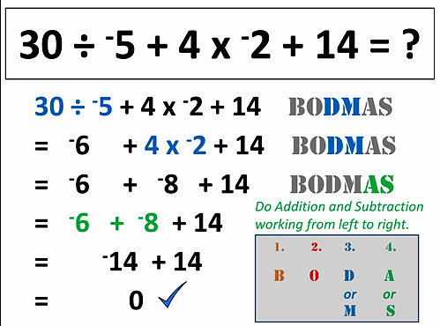


- Can you follow the bodmas example…?

- Did you get zero as your answer too..?

- Can you make your own examples and test each other..?



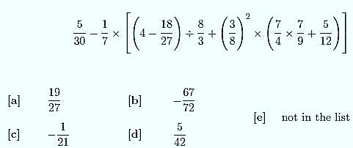

- How about a really tough BODMAS problem to try… !
- Work with someone else to pick this difficult sum apart.
- Is the answer a, b, c, d, or e ?





Your text here

What does bodmas mean?
Why do we have bodmas rules?
Does it matter if you divide or multiply first?
Does it matter if you add or subtract first?
What does the ‘O’ mean, what can it be replaced by?

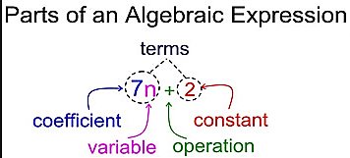

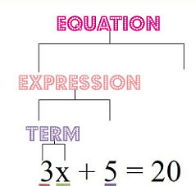
Are you clear what the terms ‘Equation’, ‘Expression’ and ‘Term’ mean?

What is the difference?

Can you write some of each down?

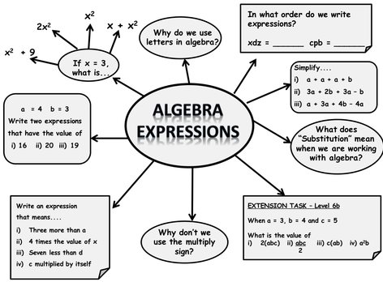

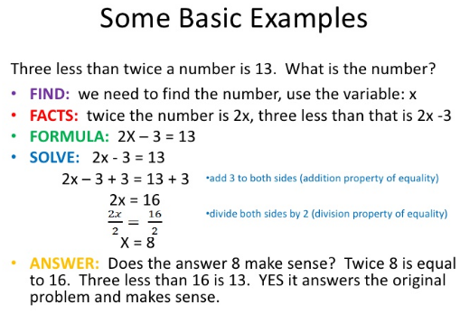



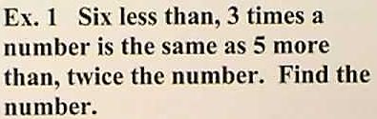

Can you solve the above?
Can you write your own word expression problems?
Try a challenging one ….!!

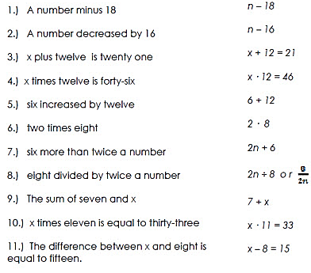

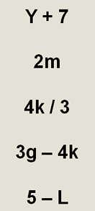


Imagine you are shopping.
Can you write word problems for each of the expressions shown?
Eg. Y+7 means ‘Seven pounds more than the yoghurts’
If you know the price of the item ‘Y’ for example, can you then work out the price when you get to the till?

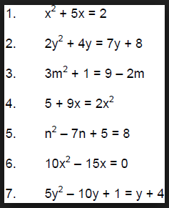
Which part of each equation is the ‘term’?
Which part is the ‘Expression’?
Can you rearrange to get a single term on one side?

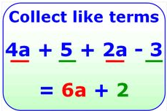
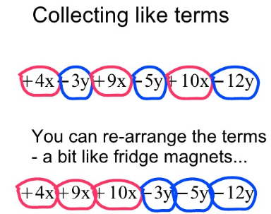

What is going on here?
What does ‘Collect Like Terms’ mean?



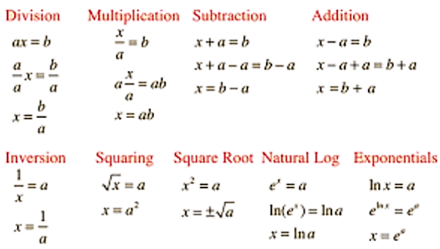
e^{x} = a
Ln (e^{x}) = Ln a
x = Ln a
x² = a
x = ±√a
√x = a
x = a²
(1/x) = a
x = (1/a)
Ln x = a
e^{Lnx} = eª
x = eª
Exponentials
x-a =
x-a+a = b+a
x = b+a
x+a = b
x+a-a = b-a
x = b-a
Addition
Natural Log
Square root
Inversion
Squaring
x/a = b
a (x/a) = ab
x = ab
Subtraction
Multiplication
Division
a x = b
(a/a) x = (b /a)
x = b/a
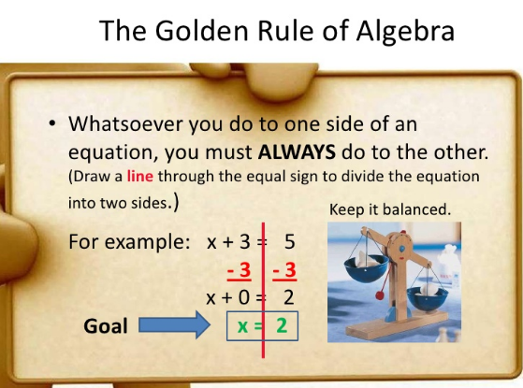
Try balancing these algebraic terms using the rule opposite…
- 4x+6 = 14
- 26/2 = x – 7
- x/5 = 18/3
- 2 √16 = 6+x




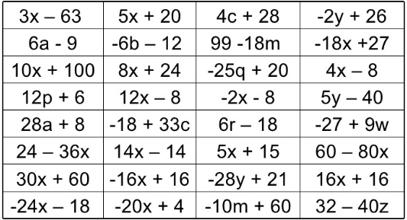


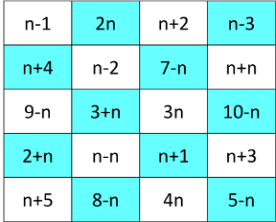
Take a value for ‘n’. Work your way through each expression in any order, can you get through the whole grid?
(Take your answer from each square and use that value for the next)
Can you simplify each expression?
Can you identify the ‘Terms’ in each expression?
Take any two that have the same letter… Can you make them equal them rearrange/balance/solve ?

