
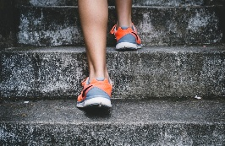
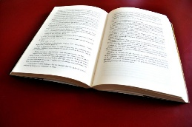
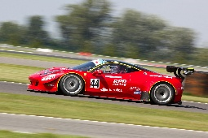
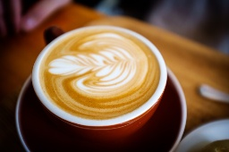
Standard Deviation Practice Sheet
This Photo by Unknown Author is licensed under CC BY-NC-ND

Q1: Exam Scores
Three students scored: 72, 85, 91 in a math test.
Find the mean, variance, and standard deviation.

Q2: Daily Coffee Sales
A café sold 45, 50, 55, 60 cups of coffee over four days.
Calculate the mean, variance, and standard deviation.

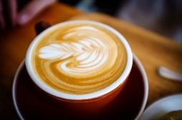
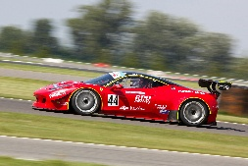

This Photo by Unknown Author is licensed under CC BY-NC-ND

Q3: Car Speeds
Speeds recorded on a highway: 65, 70, 72, 68, 75 mph.
Find the mean, variance, and standard deviation.

Q4: Book Prices
Prices of books in a store: 12, 15, 18, 20, 22, 25 dollars.
Compute the mean, variance, and standard deviation.

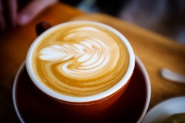

This Photo by Unknown Author is licensed under CC BY-NC-ND
Q5: Weekly Exercise Minutes
Minutes spent exercising each day: 30, 45, 50, 40, 35, 60, 55.
Find the mean, variance, and standard deviation.

Q6: Laptop Battery Life
Battery life (in hours) for different laptops: 4.5, 5, 6, 5.5, 4, 6.5, 5.2, 4.8.
Calculate the mean, variance, and standard deviation.

This Photo by Unknown Author is licensed under CC BY-NC-ND
Q7: Movie Ratings
Ratings (out of 10) for a new film: 8, 7.5, 9, 8.5, 7, 8, 9.5, 8, 7.8.
Compute the mean, variance, and standard deviation.

Q8: Monthly Rainfall
Rainfall (in mm) over 10 months: 80, 95, 100, 85, 90, 110, 105, 98, 92, 88.
Find the mean, variance, and standard deviation.

This Photo by Unknown Author is licensed under CC BY-NC-ND
Q9: Shoe Sizes
Three shoe sizes in a family: 7, 8, 9.
Calculate the mean, variance, and standard deviation.

Q10: Social Media Usage
Hours spent on social media per day: 2, 3, 4, 5, 6.
Compute the mean, variance, and standard deviation.

This Photo by Unknown Author is licensed under CC BY-NC-ND

Answers
Q1: Mean = 82.67, Variance = 62.89, Std Dev = 7.93
Q2: Mean = 52.5, Variance = 31.25, Std Dev = 5.59
Q3: Mean = 70, Variance = 11.6, Std Dev = 3.41
Q4: Mean = 18.67, Variance = 18.56, Std Dev = 4.31
Q5: Mean = 45, Variance = 100, Std Dev = 10.00
Q6: Mean = 5.19, Variance = 0.57, Std Dev = 0.75
Q7: Mean = 8.14, Variance = 0.51, Std Dev = 0.72
Q8: Mean = 94.3, Variance = 76.21, Std Dev = 8.73
Q9: Mean = 8, Variance = 0.67, Std Dev = 0.82

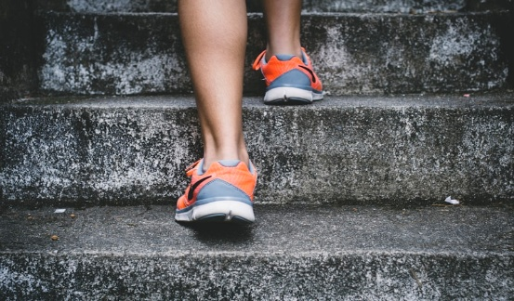
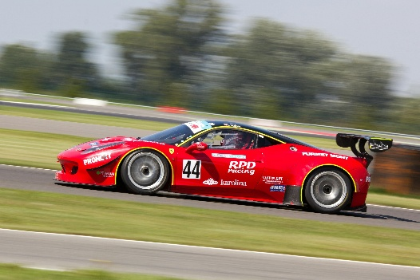
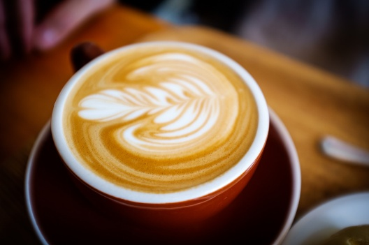
Q10: Mean = 4, Variance = 2, Std Dev = 1.41
This Photo by Unknown Author is licensed under CC BY-NC-ND

